|  |  |  |
| --- | --- | --- |
| **Clever Weather Network  City of Greater Bendigo** | | |
| The City of Greater Bendigo and La Trobe University have teamed up to create what is thought to be Australia’s densest urban weather sensor networks providing accurate real-time temperature data.  More than 60 sensors are already in place at residents’ homes, businesses and public spaces located in Bendigo and the outer suburbs.  The sensors are highly responsive and provide more accurate readings in different parts of Bendigo where temperatures can vary significantly compared to Bendigo Airport where official Bureau of Meteorology (BOM) readings for Bendigo are generated.  The network uses data from over 60 weather sensors, installed throughout the city and outer suburbs,  to reveal extreme hot spots in the summer and the coldest areas across Bendigo in winter. |  |  |

This new network will enable Council and the Bureau of Meteorology to study local variations in temperature in a way which has never been possible before in Australia.

It will also help Council to better understand where the hottest and coldest parts of cities are on hot days and how overnight temperatures vary with local topography.

Factors such as human activity, buildings, concrete and a lack of shade, which can change the temperatures in parts of the city significantly, will also be monitored as part of the network.

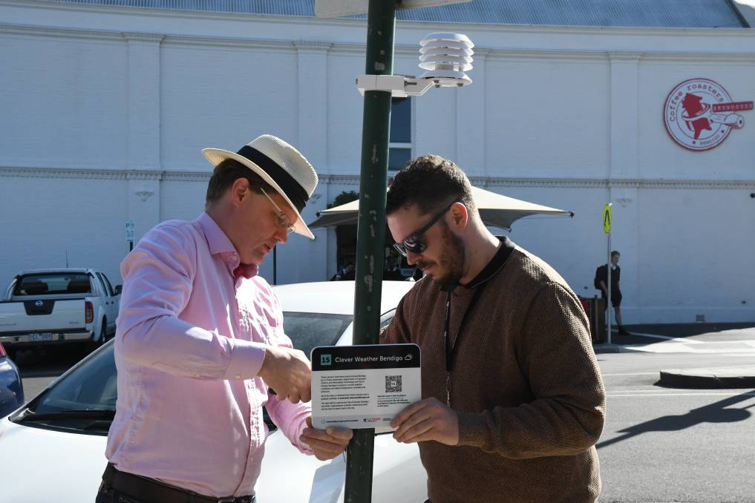

The Clever Weather sensors tap into the Internet of Things (IoT), an innovative network that enables information to be collected from sensors across Bendigo to better understand how the city functions. It acts in a similar way to WI-FI, except that the signal can travel over longer distances using far less power.

To learn more visit [bendigo.vic.gov.au/cleverweather](http://www.bendigo.vic.gov.au/cleverweather).

**Find out more about Vic Councils  
viccouncils.asn.au**

**For more information on this project:**  
Chris Rowlands, Innovation OfficerCity of Greater Bendigo   
E: [c.rowlands@bendigo.vic.gov.au](mailto:c.rowlands@bendigo.vic.gov.au)

This data could prove to be a very effective tool to help plan and improve the City’s services and projects,   
and to gain a much better understanding of how temperatures impact the way people live.