

|  |
| --- |
| EMCH Practice Note – July 2021 |
| This practice note covers a range of processes and practices to support delivery of the Enhanced MCH Program. |

## Contents

When to close an Enhanced MCH Case, and when to revise the Child and Family Action Plan 2

Recording of Key Age and Stage (KAS) consultations (when delivered alongside the Enhanced MCH Program) 3

Non engagement of families with the UMCH program, when transitioning out of the EMCH program 4

Antenatal clients in the EMCH Integrated Program 5

Recording of notes in Integrated Programs 14

Clinical supervision 15

Professional development 15

Delivering EMCH and Sleep & Settling – Outreach for the same family 16

Recording EMCH Group time as part of an Enhanced MCH Integrated Program 17

# When to close an Enhanced MCH Case, and when to revise the Child and Family Action Plan

## (change to current practice, effective 1 July 2021)

The Enhanced MCH model of care requires that on or before 20 / 22.67 hours of service, Enhanced MCH (EMCH) cases be reviewed. This should involve:

* Revising the issues and goals in the Child and Family Action Plan (CFAP)
* Determining if the family should continue to be in the EMCH program

Current practice has been that at this point, cases (previously in IRIS, now in CDIS) should always be closed. Then, if the family is to continue in the program, a new case should be created.

**New practice: As of 1 July 2021, it is expected that cases should not be automatically closed when the case is reviewed after 20 / 22.67 hours.**

Cases should now stay open until it is determined that the family should no longer be enrolled in the EMCH program. In many circumstances this may be longer than 20 / 22.67 hours.

Leaving cases open for their full true delivery length allows us to collect better data on the how many hours are used per case on average, and how long cases are open on average.

As per the Model of Care (MoC), it remains a requirement that CFAPs are revised at minimum every 20 / 22.67 hours of service.

#### How do I indicate in CDIS that I am revising the CFAP?

When revising a CFAP as part of a consultation, select the relevant option in the ‘Child and Family Action Plan’ section of the consultation screen:

* select ‘Existing Plan Reviewed’ if you are revising the plan and the enrolment is continuing; or
* select ‘Existing Plan Closed’ if your revision of the plan has resulted in the program enrolment coming to an end.

See section 4.7, pp. 17-18 of the [***CDIS Enhanced MCH Guide***](https://www2.health.vic.gov.au/primary-and-community-health/maternal-child-health/child-development-information-system) for further clarity.

#### How can I tell when a CFAP has already been reviewed?

From the ‘Case Summary Screen’ you can review the consultation records of completed consultations, and these records will show what option has been selected in the ‘CFAP’ section. You can also review consultations records from client history. At the moment these are the only ways to tell if/when plan revisions have already occurred.

The Department of Health (the department) is working on future updates to the Integrated Program functionality to provide more accessible information on plan revisions, and when they occurred.

# Recording of Key Age and Stage (KAS) consultations (when delivered alongside the Enhanced MCH Program)

KAS consultations are part of the Universal MCH (UMCH) program and are funded as part of that program. The EMCH program is funded separately and provides hours of service in addition to the KAS funded hours for each child.

*The Enhanced MCH Program responds assertively to the needs of children, mothers and families at risk of poor outcomes. It provides a more intensive level of support to those with additional needs, in the form of targeted actions and interventions. Families can access up to 20 hours of support for children up to three years of age with provisions made of rural and remote areas to receive an additional 2.67 hours.*

*This is* ***in addition*** *to the hour’s children receive in the UMCH program.*

*(*[*EMCH Program Guidelines 2018*](https://www2.health.vic.gov.au/primary-and-community-health/maternal-child-health/framework-mch)*, reissued 2019, p. 6).*

It is a requirement of service delivery that KAS consultations are recorded in CDIS under the correct consultation type, and against the record of the child. This is required even when a KAS consultation is delivered at the same appointment as an Enhanced MCH consultation.

When scheduling an EMCH consultation for delivery at the same time as a KAS consultation, you should save both appointments back-to-back in the calendar.

When delivering an Enhanced MCH consultation at the same time as a KAS consultation, you should:

* In one tab, access CDIS and open the Enhanced consultation under the lead client’s record
* In a second tab, access CDIS and open the KAS consultation under the child’s record
* Record the relevant information in the relevant consultation record
* Split the total time taken between the two records, using your best judgement to divide the time to best reflect the actual time taken on each consultation

See section 4.13, pp. 20-21 of the [***CDIS Enhanced MCH Guide***](https://www2.health.vic.gov.au/primary-and-community-health/maternal-child-health/child-development-information-system) for further information on how to schedule and record multiple consultations being delivered at the same appointment.

#### Why can’t I just record all the information in the Enhanced MCH consultation?

Recording of the KAS consultation under the child’s record allows for:

* accurate recording of the KAS consultation as part of the UMCH program
* growth and development information will be recorded against the child’s record, and the data will be recorded correctly in growth charts
* accurate recording of time taken to undertake a KAS consultation

#### How is consultation time reported?

Reporting of consultation time is taken from the Direct, Indirect and Travel fields at the bottom of Consultation screens. It is not collected from appointment lengths in the calendar.

# Non engagement of families with the UMCH program, when transitioning out of the EMCH program

For many service providers it is normal practice that KAS appointments for EMCH clients are managed/delivered by the EMCH team, and these clients are therefore not attending the UMCH program whilst involved in the EMCH program. In these circumstances it is critical that, when families end their involvement in EMCH, they are engaged/re-engaged with the UMCH program.

If families do not engage/re-engage with the UMCH Program once they have transitioned from the EMCH Program, the UMCH Program will need to attempt all avenues for engagement including home visiting, ensuring that children, at a minimum, receive all KAS consultations.

If the UMCH program cannot achieve engagement/re-engagement, the EMCH Program may need to re-open to ensure the KAS consultations for these vulnerable children are undertaken.

# Antenatal clients in the EMCH Integrated Program

There are a number of circumstances that may require MCH engagement with a family during the antenatal period.

These may include:

* As part of the continuum of care working alongside existing maternity services to instigate care planning for the parent and unborn child
* To initiate a Nursery Equipment Program (NEP) case to enable an eligible family to have a cot and car seat available for when their child is born
* For pre-birth referral into the Enhanced MCH program

Where an MCH service provider is providing a level of service or engagement antenatally, it will be necessary to:

* create or add to CDIS records for the parent/carers receiving service
* create a CDIS record for the unborn child (from 20 weeks gestation), if any information is being recorded that is relevant to that child

Examples of when an unborn child CDIS record would be required:

* a family is referred (successfully or unsuccessfully) into the Enhanced MCH program
* the hospital and/or Social Worker or child protection notify your service of a potential high-risk antenatal client

Examples of when an unborn child record would not be required:

* an existing client mother mentions to an MCH nurse that they are pregnant with another child, but there are no antenatal concerns and no MCH service delivery required for the unborn child

### Can’t I just add notes about the unborn child to the mother’s CDIS record?

No. Health record keeping requires that notes related to the child must be recorded in the child’s record.

### Can I enrol the mother in EMCH and just add the child after they’re born?

No. See previous answer.

Further to this, a client in CDIS must already be linked as the carer of a child in CDIS before the system will allow an Enhanced MCH program to be created. The system will not allow a first-time mother to enrol in the EMCH program until their child’s record has been created.

### What if we have antenatal engagement and the unborn child is not yet 20 weeks gestation?

Prior to 20 weeks gestation, all notes can be recorded in the mother’s CDIS record. After 20 weeks, once a CDIS child record is created, any relevant notes can then be copied across to the child’s record.

## Creating a CDIS record for an unborn child

As the date of birth of the unborn child is not known, the unborn child **must** be assigned a CDIS record in the following way.

1. Commence a new record as per the CDIS birth notification process (December 2020) found at <https://www2.health.vic.gov.au/primary-and-community-health/maternal-child-health/child-development-information-system>

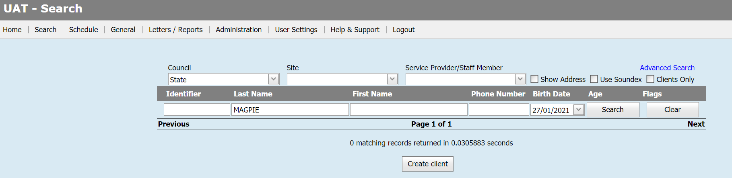

1. Create client

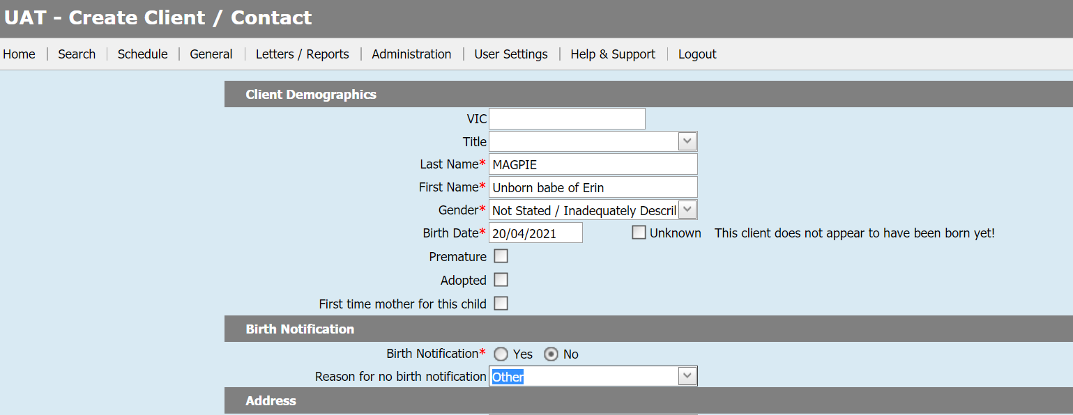

Last name: Family name of antenatal client (the pending birth mother)

First name: Unborn babe of (first name of mother)

Gender: Not stated/Inadequately Described

Birth date: Expected date of delivery (EDD) – a message will appear that the client does not appear to have been born as yet – **ignore this message**

Birth notification: **No**

Reason for no birth notification: Other

**This ensures that the number of birth notifications for the MCH service provider is correct**.

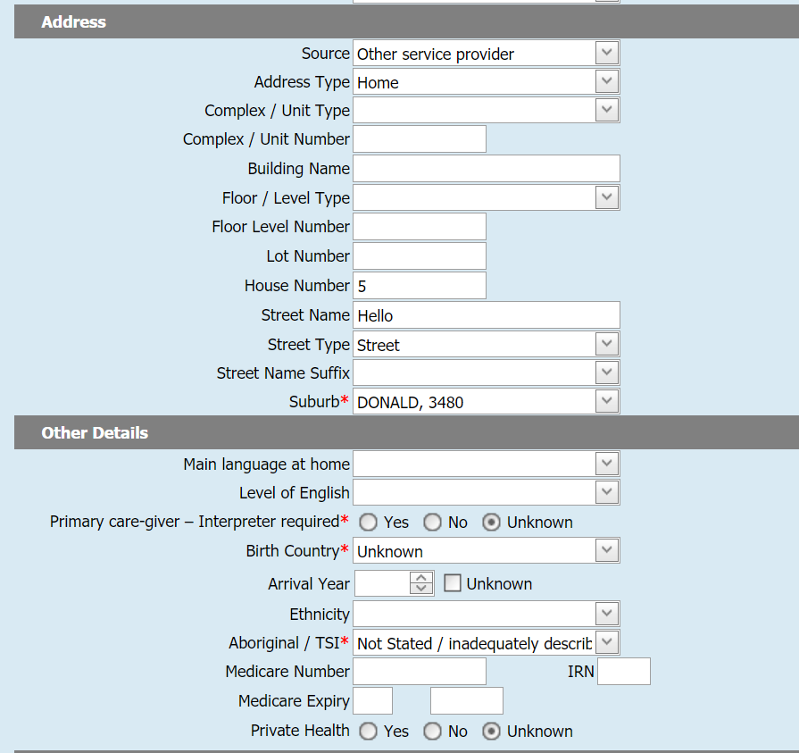

1. Continue completing all mandatory data fields
2. Unless you have information there is an interpreter required or the child is Aboriginal and/or Torres Strait Islander, **use the not stated/inadequately described data choices**.
3. Use the Green Cross to add the relationship of the mother to the unborn child by creating a CDIS record for the mother if the mother is not already on CDIS.
4. If the mother has other children and therefore has a CDIS record, add the mother’s CDIS record to the unborn child.

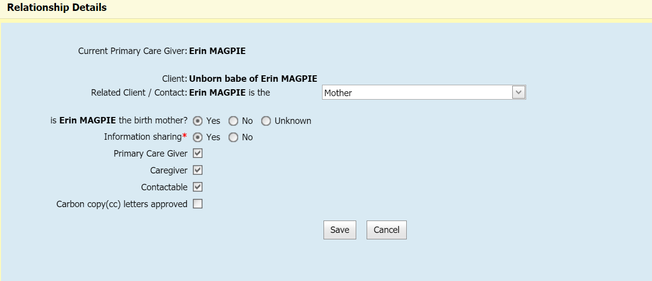

1. Choose the mother as the birth mother and information sharing as yes.
2. Always tick mother as the Primary care giver and Contactable.

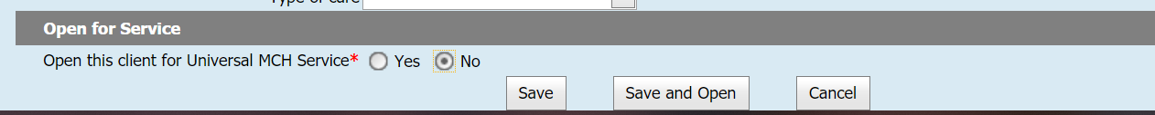

1. Ensure the mother is open for service
2. You do not have to open the child for service
3. No Birth notice date will be present in the unborn child’s CDIS record.

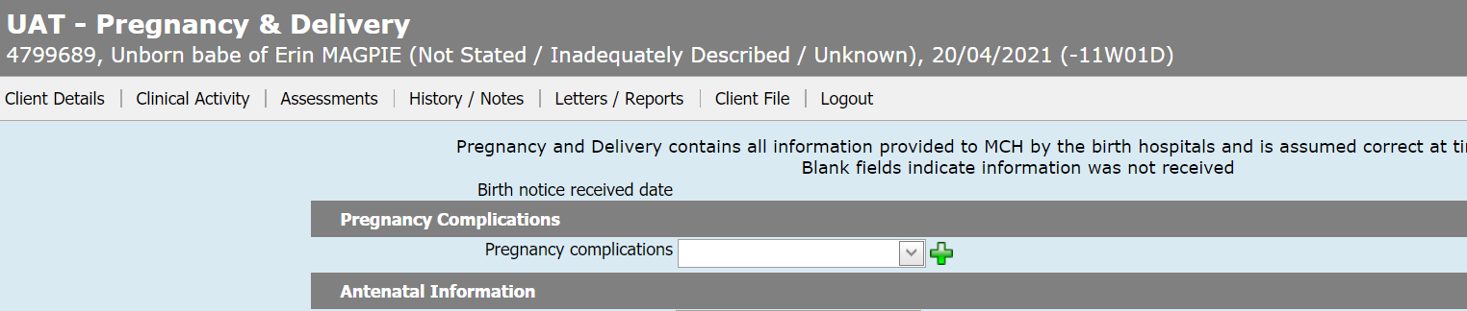

## Mother with a CDIS record and other children under school age

If the mother already has a CDIS record, the unborn child CDIS record must still be created (process as above) even if other children in the family will also be part of the EMCH program. This ensures that specific goals for the primary carer in relation to the unborn child are addressed within the EMCH program.

## Referral to the EMCH program

Once a mother and the unborn child have a CDIS record, an internal referral to the EMCH Program can now be made.

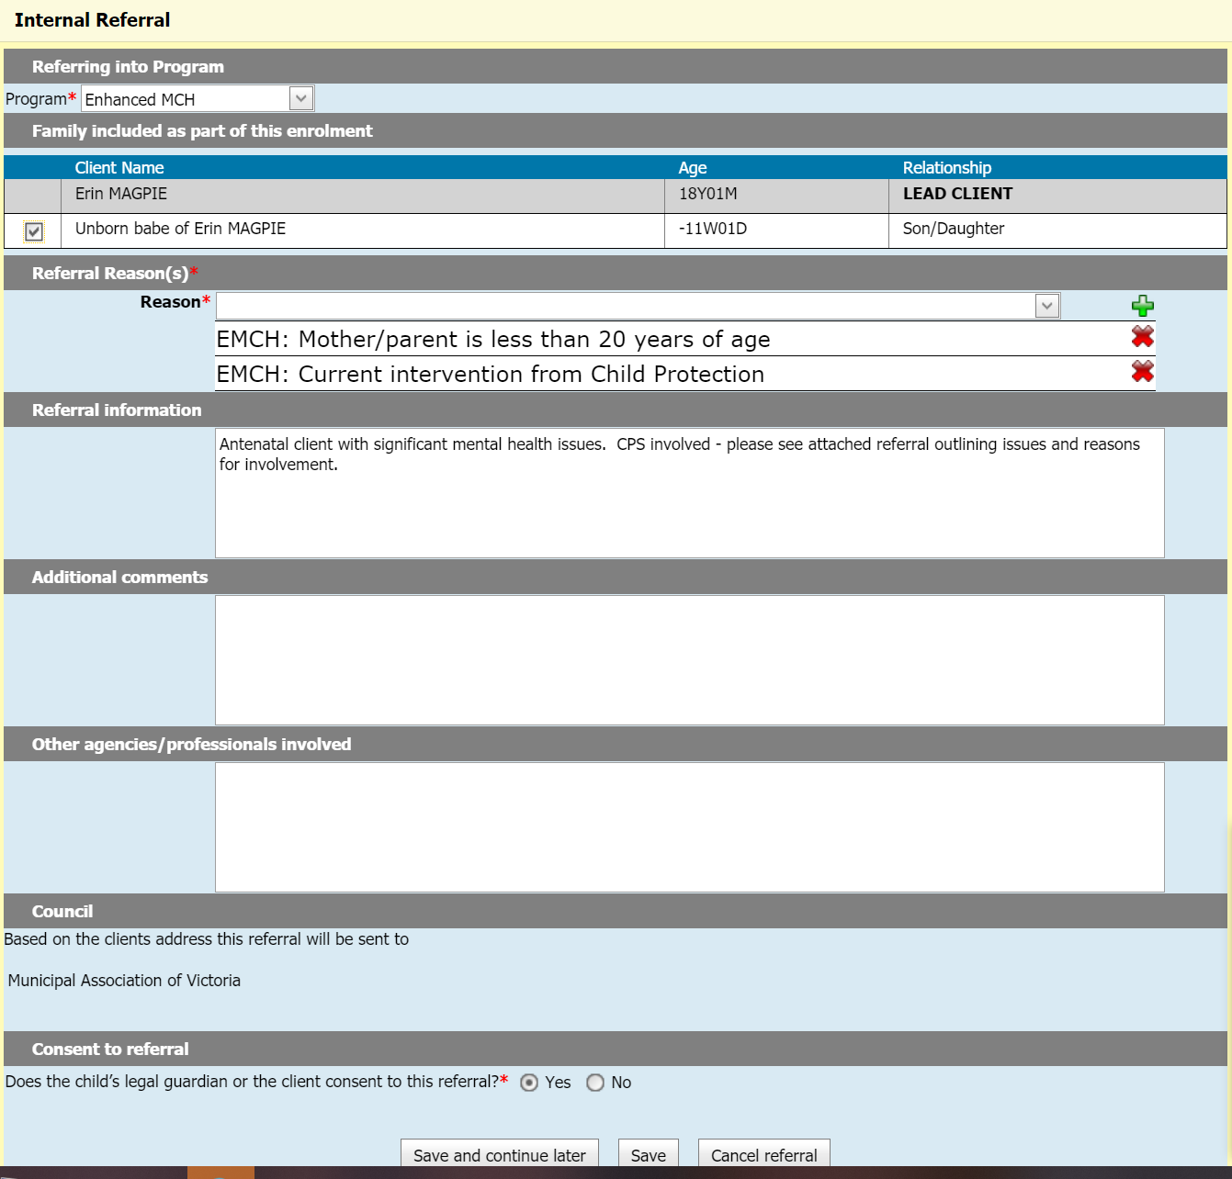

Once the referral has been accepted the case is active with the antenatal mother as lead carer of the unborn child.

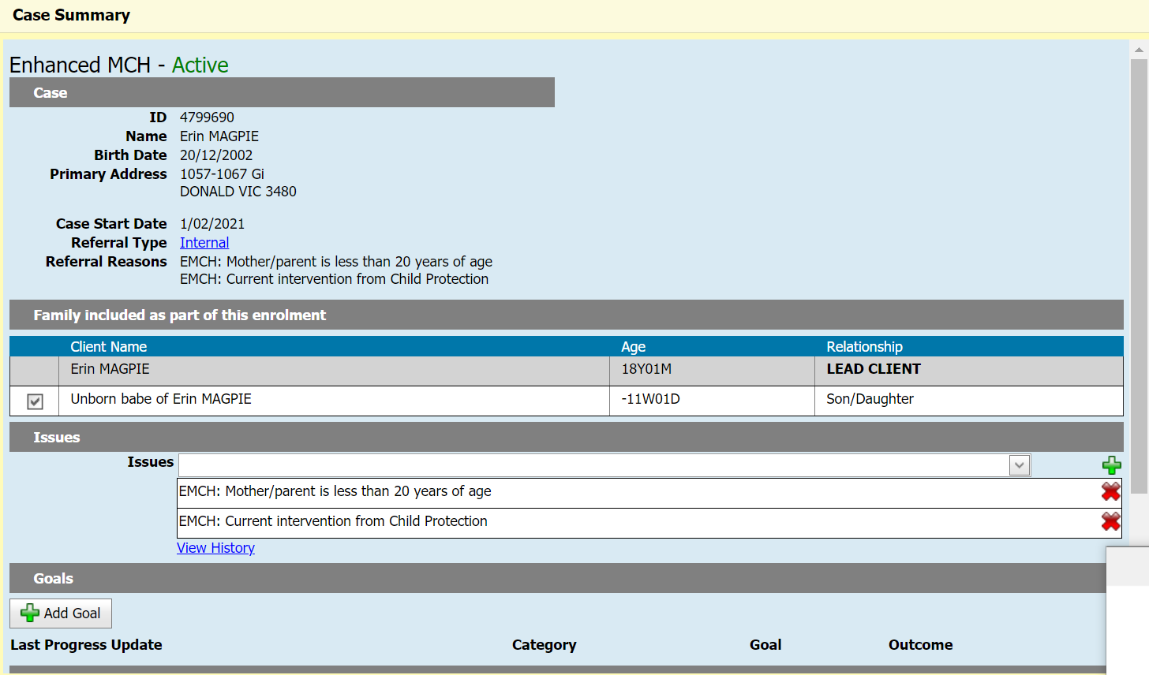

## Birth Notification received for the unborn child

1. When the child is born and a Birth Notification is received, the child must have **a second** CDIS record made with the correct details from the Birth Notification included.

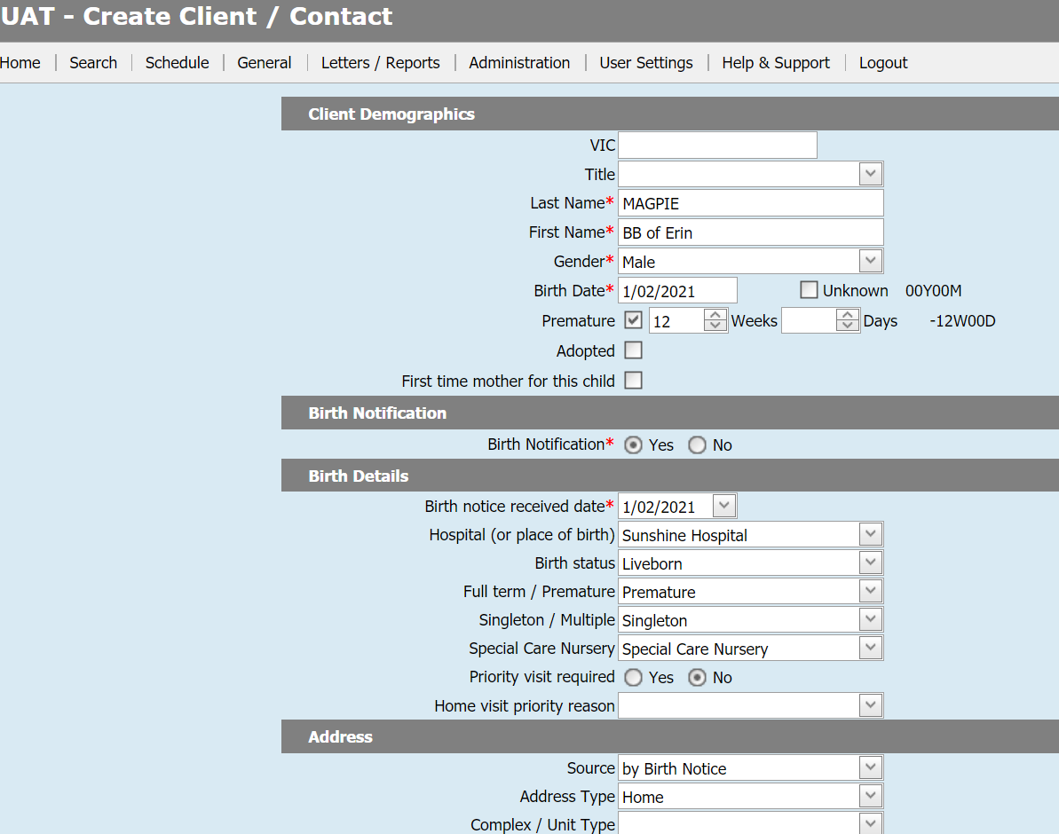

1. Open child to service in correct MCH Centre matching their residential address.
2. The Birth notice received date will show in the actual child’s CDIS record. This ensures that data on the number of Birth Notifications received for the MCH Service is correct.

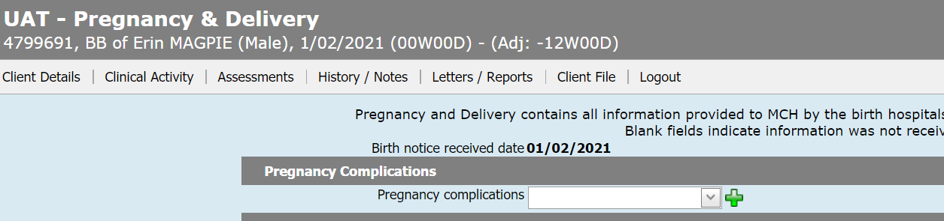

1. The mother’s CDIS record will now show two children related to the same singleton pregnancy – ‘unborn baby of’ and ‘baby of’
2. The CDIS records of the two children must be now merged.

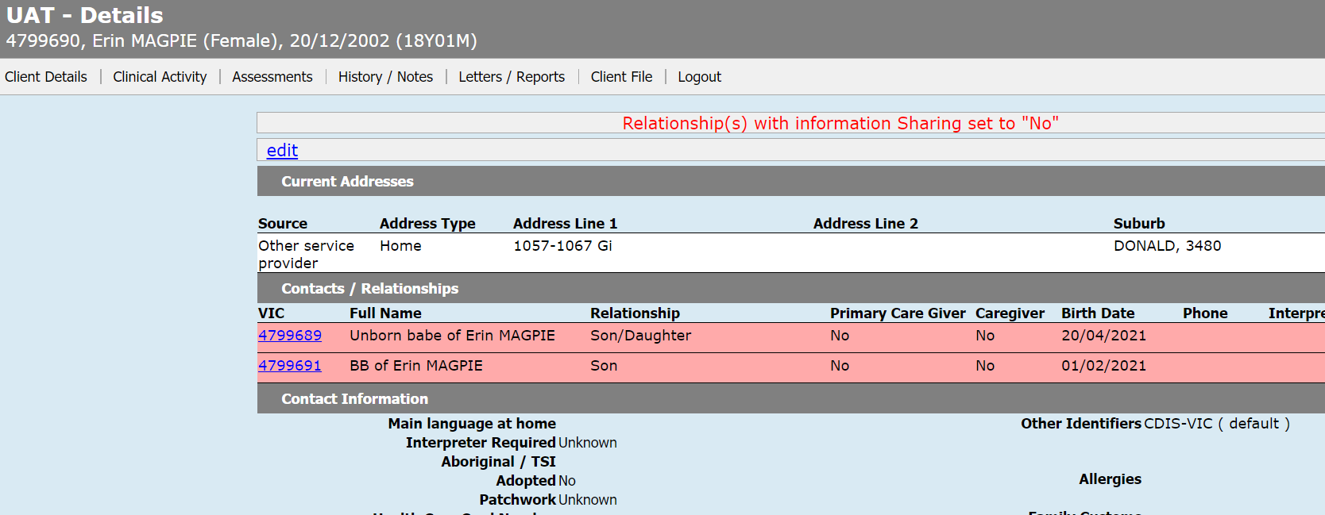

1. As the Birth Notification child CDIS record is the correct record, **this needs to be the main CDIS record for the merge.**

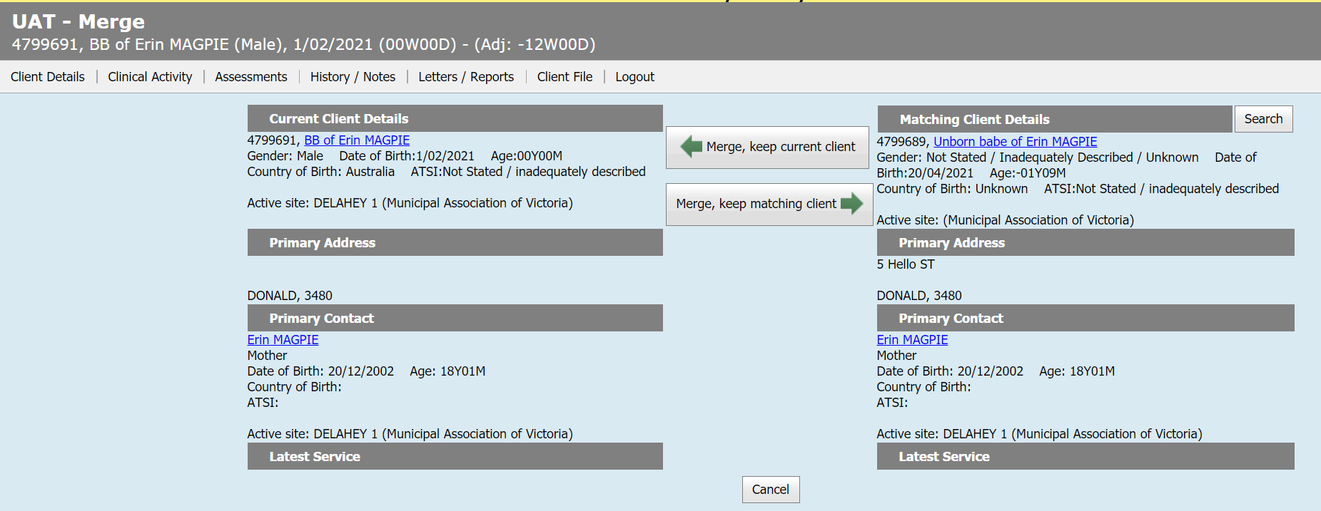

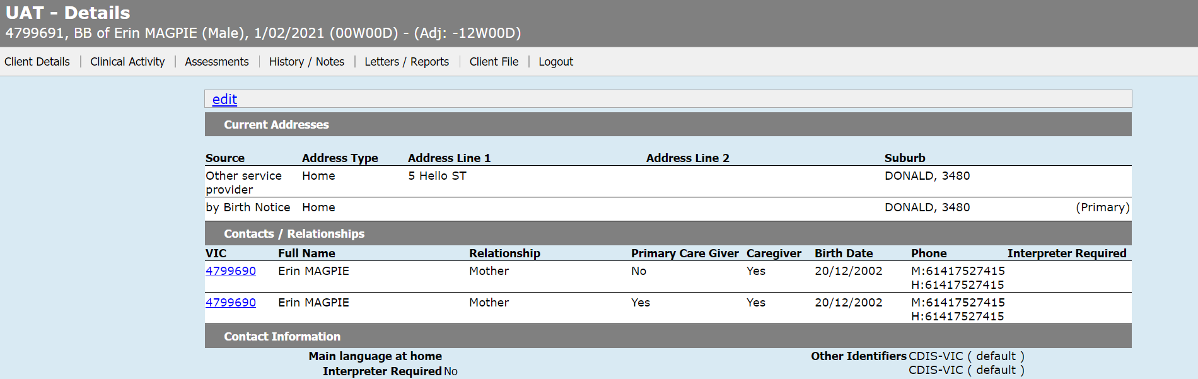

1. Remove the second/duplicate link for mother using the Relationship screen. **NB:** To make it simpler keep the mother CDIS record where the mother is the primary carer.

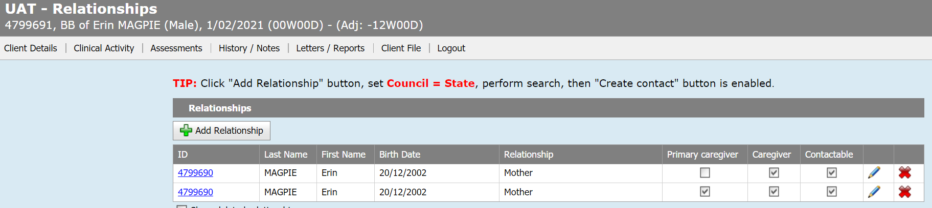

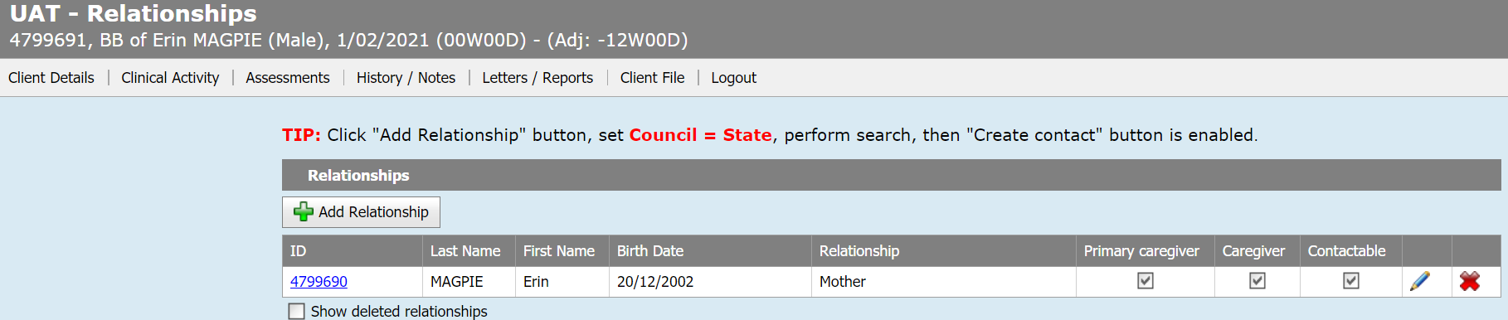

1. The EMCH program will now show in both the Birth Notification CDIS record as well as the mother/lead client record.

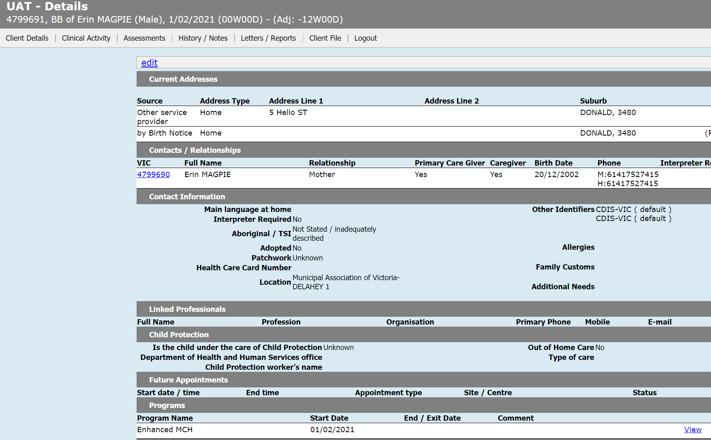

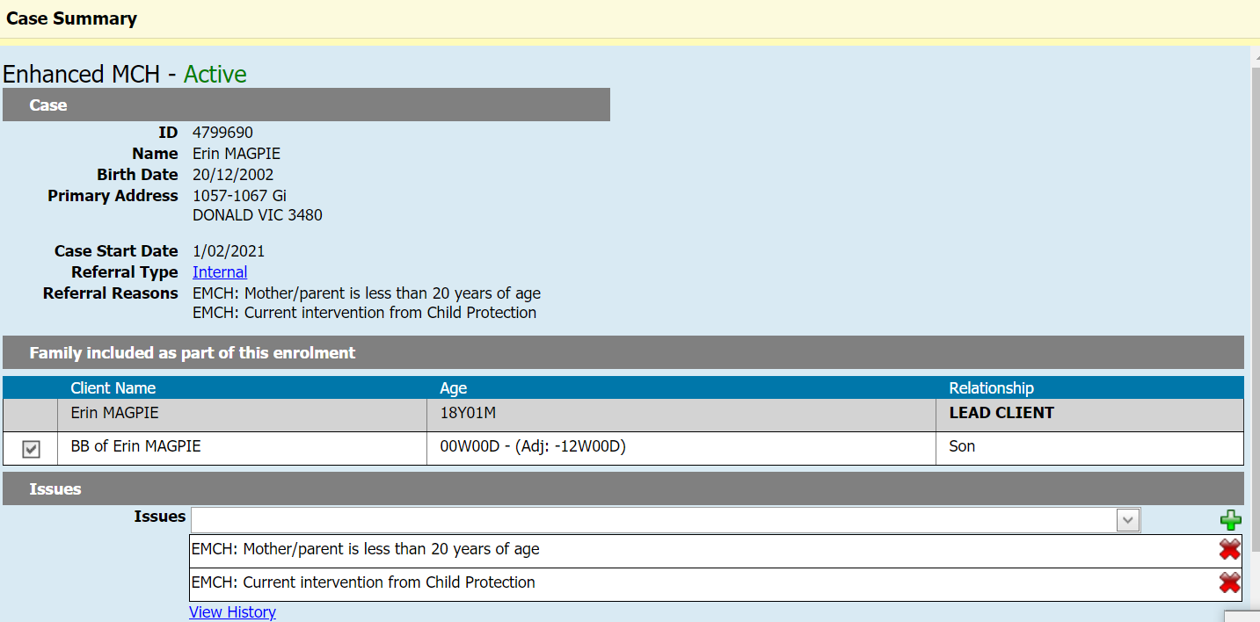

## Antenatal clients within MCH programs

There is a need for Administration/MCH staff to ensure that they always search for a mother if a birth notification is received as part of the Child Development Information System Birth Notification Process –

<https://www2.health.vic.gov.au/primary-and-community-health/maternal-child-health/child-development-information-system>

The unborn child will be visible in the birth mother relationships. The Administration/MCH staff will need to follow the service provider guidance as to how the CDIS record of the newborn child for whom a birth notification has been received and the unborn child are merged. The process above outlines the way this should be done.

A concern has been raised about unborn child records being “lost” within CDIS. Using the report Universal Active List and doing a search on first names of each child will enable staff to locate any unborn children CDIS records where they have not been correctly merged.

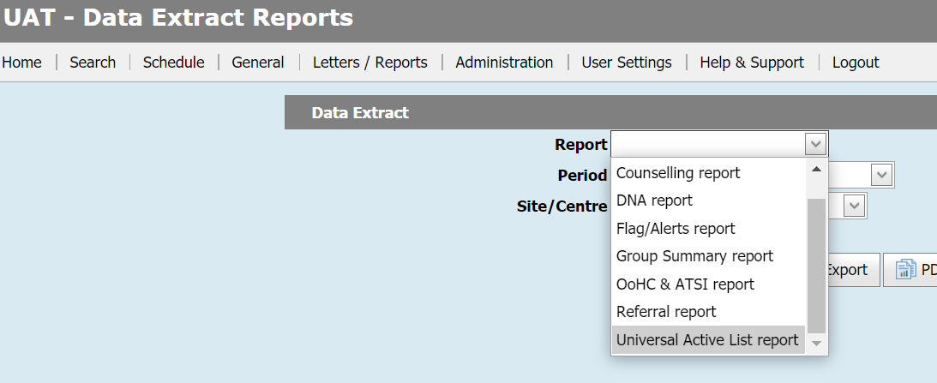

If this report is completed regularly every three (3) or six (6) months then it will ensure data accuracy.

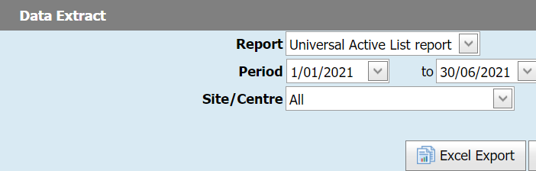

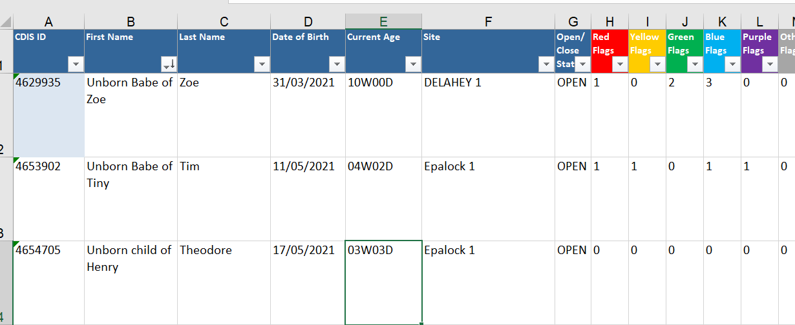

# Recording of notes in Integrated Programs

Integrated Program consultations automatically stamp consultation records into the history of all lead and non-lead clients.

There are situations when having specific consultation notes stamped in all EMCH case members histories is not considered to be appropriate.

If you wish to record information that:

* Relates only to a specific family member; and
* Is not related to the Issues and Goals of this case

then that information should be recorded either in a different consultation record, or in a note added directly to the notes / history of the relevant client.

For guidance on how to record information in an adjacent consultation record, see section 4 of the [CDIS Enhanced MCH Guide](https://www2.health.vic.gov.au/primary-and-community-health/maternal-child-health/child-development-information-system), specifically sections:

* 4.5 Weight and Growth
* 4.6 Nutrition
* 4.9 Counselling
* 4.10 Referrals from this assessment
* 4.11 Notes
* 4.13 Delivering multiple consultation types at the same appointment

If you just wish to add a text note to a specific record, you should not need to create an adjacent consultation (as above). Instead, you can simply go to the record of the relevant client, and add a text note directly to their notes / history.

The department is working on future updates to the Integrated Program functionality to make it easier to add notes to specific program members from within an Integrated Program consultation.

# Clinical supervision

There will be times when clinical staff discuss individual cases within the EMCH program with their colleagues for direction and management. This activity **is included** in the hours recorded for the EMCH program. It is recorded under ‘Client Not Present’ (CNP) – refer to [CDIS Enhanced MCH Guide](https://www2.health.vic.gov.au/primary-and-community-health/maternal-child-health/child-development-information-system), p. 21.

Clinical supervision that is outside individual case discussion and management, **is not** recorded in CDIS as Client Not Present. Clinical Supervision that forms part of activities associated with professional development, quality and staff wellbeing are outside direct, indirect and travel time associated with clinical activity and are not recorded in CDIS.

# Professional development

Professional Development is not a client-based activity and therefore is not recorded in CDIS. There are hours per week/month that are allocated to team meetings, professional development and clinical supervision that are not recorded in CDIS as they are not part of direct, indirect or travel time related to delivery of client service.

# Delivering EMCH and Sleep & Settling – Outreach for the same family

CDIS will only allow a client to be the lead client in one case of any Integrated Program type, at any given time. For example, if a client is the lead client in an active Enhanced MCH case, CDIS will not allow that client to be the lead in a second Enhanced MCH case at the same time. However, clients can be enrolled as non-lead clients in multiple cases of the same Integrated Program type at the same time. (Refer to [CDIS Enhanced MCH Guide](https://www2.health.vic.gov.au/primary-and-community-health/maternal-child-health/child-development-information-system), p. 5).

A client can technically be enrolled as the lead client in the EMCH Program and the Sleep & Settling – Outreach program at the same time. There is nothing to prevent this occurring in CDIS. However, in almost all circumstances, best practice would see a family enrolled in one but not both of these programs at the same time.

## When to use the EMCH program

If a lead client is actively participating in the EMCH program and sleep and settling issues are identified as part of the family assessment, these are to be included in the CFAP. As an example, the CFAP would identify under the domain of ‘Child health, wellbeing, safety learning and development’ – ‘Sleep and settling support, sleep management plans’.

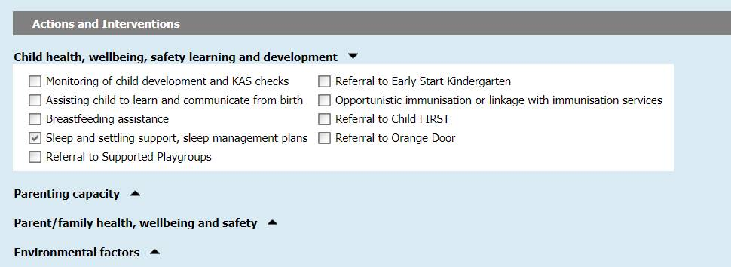

Addressing sleep and settling issues as part of the CFAP within the EMCH program provides continuity of care for the client and integrates the management of sleep and settling alongside other issues that have been identified during the family assessment.

## When to use the Sleep & Settling – Outreach program

Assessment of a family’s suitability for the Sleep & Settling – Outreach is undertaken by the MCH nurse within the UMCH program. As outreach places are limited, access to the program will need to be managed by the MCH service. Families with more complex issues, such as multiple risk factors and limited protective factors are likely to need to step up to the EMCH program and other secondary services such as an early parenting centre programs or be referred to health or family support services ([Sleep and settling model of care: guide for maternal and child health services](https://www2.health.vic.gov.au/primary-and-community-health/maternal-child-health/sleep-settling), p. 17).

Sleep & Settling – Outreach **should** be reserved for those families within the UMCH program who need additional support with sleep and settling and there are no other risk factors identified that would require them to **step up** to the support of the EMCH program.

Families, on the EMCH program with sleep and settling issues, should have these addressed within the MoC of the EMCH program.

# Recording EMCH group time as part of an Enhanced MCH Integrated Program

There is currently no way to accurately attribute EMCH group time to the EMCH cases for EMCH clients.

From the CDIS systems’ perspective, currently, the time spent providing Groups is captured within the Flexible Capacity Activities data in the Annual Report and reflects the UMCH program.

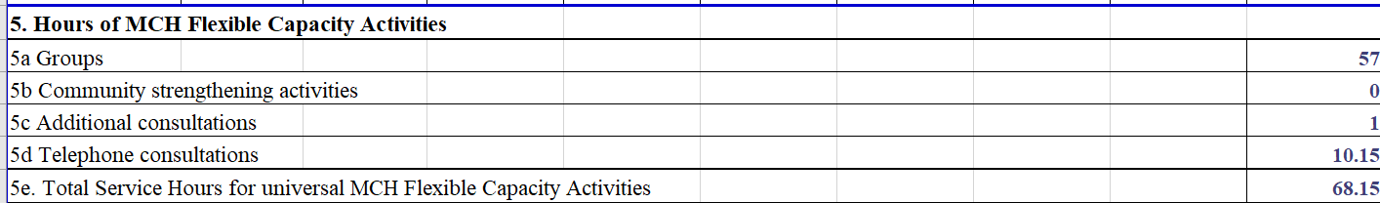

The issue of Groups in the EMCH program is acknowledged, however currently there is no method of capturing the data. If management require data concerning attendance at a specific Enhanced Group, this data is able to be obtained using the Group Attendance Outcome Report. This requires a specific Enhanced group title/name to ensure that the data can be captured for the Enhanced groups.

