Summary of the Local government guide for preventing family violence and all forms of violence against women
OFFICIAL

Accessibility
To receive this document in another format, email the Free from Violence Program <freefromviolence@dffh.vic.gov.au>.

Copyright
Authorised and published by the Victorian Government, 1 Treasury Place, Melbourne.
© State of Victoria, Australia, Department of Families, Fairness and Housing, April 2023.

Disclaimer
This publication is provided for information purposes only. No claim is made as to the accuracy or authenticity of the information contained herein. Information is provided on the basis that all persons accessing the information undertake responsibility for assessing its relevance and accuracy.
The Department of Families, Fairness and Housing (DFFH) makes no representations, either expressed or implied, as to the suitability of the said information for any particular purpose and disclaims all liability for any error, loss or other consequence which may arise from you relying on any information in this publication.

Acknowledgement of Country
The Department of Families, Fairness and Housing proudly acknowledges the Traditional Owners of the lands across Victoria and pays its respects to all First Peoples. This is Aboriginal land; always was, always will be. We recognise and value the ongoing contribution of Aboriginal people and communities to Victorian life.

Please note
Except where otherwise indicated, the images in this document show models and illustrative settings only, and do not necessarily depict actual services, facilities or recipients of services. This document may contain images of deceased Aboriginal and Torres Strait Islander peoples. The Victorian Government acknowledges the diverse and distinct cultures of Aboriginal peoples and Torres Strait Islanders. In these guidelines, ‘Aboriginal’ refers to both Aboriginal and Torres Strait Islander people.

Thank you to the co-design contributors
Thank you to everyone who gave their time, ideas, insights and experiences in the co-design of the guide and to your organisations for supporting your involvement. Without you, creating the guide would not have been possible.
ISBN 978-1-76130-112-4 (pdf/online/MS word)
Available at MAV’s Local government guide for preventing family violence and all forms of violence against women page <https://www.mav.asn.au/PFVguide>.
(2111136)

Contents
Introduction – welcome 4
How does the guide help? 4
Local government’s role in primary prevention of family violence and all forms of violence against women 5
What is family violence? 5
What is violence against women? 5
What is primary prevention? 6
What are the drivers of family violence and violence against women? 7
The role of local government in primary prevention 8
The whole-of-council model for primary prevention 9
Whole-of-council model 9
Councils’ domains of influence 12
Overview of the guide 15
Structure of the guide 15
User journeys through the guide 16
Glossary 17

Introduction – welcome
Thank you for taking the time to read and engage with this document – a summary of Victoria’s Local government guide for preventing family violence and all forms of violence against women.
In Australia, the rates of family violence and violence against women present an urgent need for change. Research tells us:
- one in two women have experienced sexual harassment in their lifetime
- one in five women have experienced sexual violence (sexual assaults or threats) since the age of 15
- one in three women have experienced physical violence by a partner or other known person or stranger since the age of 15
- one in four women have experienced emotional abuse by a current or previous partner
- on average, one woman a week is killed by their current or former partner.
There are also parts of our population that are at even greater risk. LGBTIQ women, women with complex mental health conditions or alcohol and drug issues, Aboriginal and Torres Strait Islander women, older women and women with disabilities all experience unique, greater, or compounding forms of violence. For some women, experiences of violence are complicated or compounded by racism, immigration processes, language barriers, religious beliefs or culturally specific norms about gender and relationships.
Research shows that family violence is preventable. By addressing gender inequality and the underlying drivers and reinforcing factors of violence, we can prevent it from happening in the first place.
Councils are uniquely placed to be effective in primary prevention work through their connection to residents across their entire lifespan. Everyone in your council has a role to play in preventing family violence and all forms of violence against women. This includes councillors, executive leaders, managers, prevention specialists and people working at all levels in council from front-line service staff and technical roles to policy officers and administrators – and everyone in-between.

How does the guide help?
The guide uses educative content, practical exercises and real-life examples to help you understand your role in primary prevention and take action. It draws on best practice but, as importantly, it has been co‑designed with:
- local government employees from across Victoria, representing both primary prevention subject matter experts and staff from all areas of council
- services that support people who experience family violence and other forms of violence
- women with lived experience.
This summary of the guide covers:
- local government’s role in primary prevention of family violence and all forms of violence against women
- the whole-of-council model for primary prevention
- overview of the guide.
You can find the full guide and supporting tools on the MAV’s Local government guide for preventing family violence and all forms of violence against women page <https://www.mav.asn.au/PFVguide>.

Local government’s role in primary prevention of family violence and all forms of violence against women

What is family violence?
Family violence, as described in Ending family violence: Victoria’s plan for change, occurs when a person exercises power and control over another person. It involves using coercive and abusive behaviours to intimidate, humiliate, undermine and isolate another person or persons, resulting in fear and insecurity.
It can include physical, sexual, psychological, emotional and spiritual violence, and financial or economic abuse and control. Intimate partner violence by men against women is the most common form of family violence. It is also important to recognise that family violence is often a pattern of behaviours and not necessarily one isolated incident.
The Family Violence Protection Act 2008 also defines family violence as any behaviour by a person that causes a child to hear or witness, or otherwise be exposed to the effects of family violence behaviours.
Note
Family means different things to different people. In the guide we use ‘family’ as an all-encompassing term. It acknowledges the variety of relationships and structures that can make up family units and kinship networks, and the range of ways family violence can be experienced, including through family-like or carer relationships and other interpersonal relationships, and across all genders and sexualities.

What is violence against women?
The United Nations Declaration on the Elimination of Violence against Women (1993) defines violence against women as any act of gender-based violence that causes or could cause physical, sexual or psychological harm or suffering to women, including threats of harm or coercion, in public or in private life.
Violence against women occurs across cultures and communities. It affects women’s well-being and prevents them from fully participating in society. In Australia, violence against women includes family violence, intimate partner violence, sexual assault and sexual harassment.
Note
The guide uses language inclusively. When the guide refers to ‘woman’ or ‘man,’ it refers to all female or male identifying people. The guide also uses the term ‘gender diverse people’ who may identify as non-binary, trans, agender, genderqueer, genderfluid or with any other term.

What is primary prevention?
Primary prevention is different to the things you might initially think about when preventing family violence or violence against women is discussed – such as counselling, intervention orders, women’s shelters or better lighting in parks.
There are four levels of action that work together to contribute to a healthier, safer society. By stopping violence before it happens, primary prevention reduces the need for the other levels of action.
Figure 1: The levels of action for a healthier, safer society
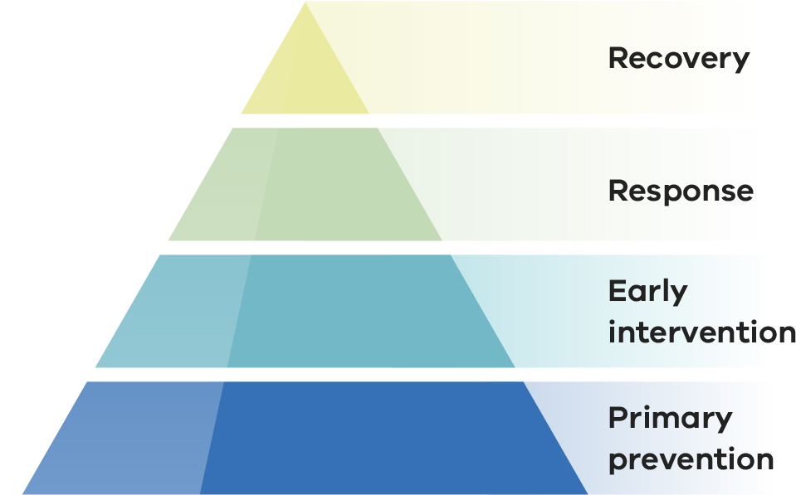
Recovery is an ongoing process that enables victim-survivors to find safety, health, wellbeing, resilience and to thrive in all areas of their life.
Response (or tertiary or crisis response) supports victim survivors of family violence and violence against women, and holds people who use violence to account. This is done with the aim of preventing recurring violence or minimising its long-term impacts.
Early intervention (or secondary response) aims to reduce the risk of violence recurring or escalating by responding to the early signs of family violence and violence against women and targeting high-risk individuals and groups.
Primary prevention aims to stop violence from happening at all through social change that addresses the underlying drivers of why it occurs.

What are the drivers of family violence and violence against women?
Drivers are the social conditions that lead to violence. Established international evidence shows that there are four main gendered drivers that lead to violence against women. Family violence and violence against women is not caused by any one factor, but as more of these drivers are present, the probability of violence does too.
These drivers may manifest differently across the diverse range of cultures, background and faiths in the community.
Discrimination in all forms – ableism, racism, ageism, homophobia and others – create an environment where power is not equally shared and leaves some groups more likely to experience violence.
An intersectional approach recognises that overlapping structures and forms of oppression create different forms and patterns of violence and can add up to greater severity or frequency of violence against some people.

Gendered drivers of violence against women, ,
- Condoning of violence against women.
- Men’s control of decision making and limits to women’s independence in public life and relationships.
- Rigid gender roles and dominant forms of masculinity.
- Male peer relationships and cultures of masculinity that emphasise aggression, dominance and control.

Reinforcing factors that make family violence and violence against women more likely
- The condoning of violence in general in our society.
- Experience of or exposure to violence.
- Factors that weaken prosocial behaviour.
- Backlash and resistance.

The role of local government in primary prevention
Councils have a responsibility to their community to do work that will prevent family violence and all forms of violence against women before it happens. Local government is uniquely positioned to do this through their deep-rooted community connections, and many councils have been undertaking primary prevention work for a long time.
Councils:
- are often one of the largest employers in their community, with the ability to influence their employees directly and set an example for other employers
- deliver services – many of them face-to-face – across the community to residents from birth to old age and across many settings and sectors
- have strong community connections as the arm of government closest to the community, including with individuals, businesses, community groups and other organisations
- are community leaders, especially in regional and rural settings.
Local government’s role in primary prevention is further recognised through legislated obligations. The pieces of legislation that are relevant to primary prevention are:
- Gender Equality Act 2020
- The Charter of Human Rights and Responsibilities Act 2006
- The Local Government Act 2020
- The Public Health and Wellbeing Act 2008
- Child Wellbeing and Safety Act 2005
- Family Violence Protection Act 2008
- Fair Work Act 2009
- Equal Opportunity Act 2010
- Occupational Health and Safety Act 2004.
Councils are not alone when it comes to primary prevention. Local government is part of a network of primary prevention that involves organisations ranging from entire government agencies to not-for-profits and individual advocates.

The whole-of-council model for primary prevention
The guide is based on a whole-of-council model. Whole-of-council means that primary prevention is built into every part of the council, from policies and enterprise agreements to the physical and cultural environment, through to council services and community work. Everyone in council understands and plays their part in elevating opportunities to prevent family violence and all forms of violence against women and make a difference in their community. Figure 2 illustrates the whole-of-council model.

Whole-of-council model

Characteristics of a whole-of-council approach to primary prevention
A shared understanding of purpose and goals positions primary prevention as an expectation, not an option. It sets the foundation for a coordinated approach to achieve long-term change in the organisation and community. A primary prevention strategy that aligns with internal and external (statewide or regional) plans ensures the work gets done while also contributing to wider prevention efforts.
Leadership commitment to primary prevention sets clear expectations, enables people to act and holds council to account for progress towards its goals.
Organisational fluency in primary prevention is achieved when all council staff understand their role in primary prevention, and it is part of their day-to-day role and act on that understanding.

Councils' domains of influence
Councils have a critical role to play in preventing family violence and violence against women.
Councils as a workplace and employer (teal quadrant in Figure 3) can lead by example by:
- embedding primary prevention in all aspects of how they operate
- ensuring that they meet their obligations as an employer by providing and maintaining a safe workplace.
Councils as a service provider (orange quadrant) engage with residents across their entire lifespan, which provides an opportunity to address the drivers of violence in their delivery of core services.
Council as a connector (red quadrant) can use their community knowledge to bring together diverse groups and organisations to increase awareness, commitment and action for primary prevention.
Councillors as leaders and decision makers (purple quadrant) can model behaviours that promote gender equality and primary prevention to set an example in their community and support changes in social norms and expectations.
Figure 3 includes example actions across the four domains to address the drivers of family violence and violence against women.
Each council should choose relevant focus areas based on need, existing strengths and community preferences.

Monitoring, evaluation and dissemination
Monitoring, evaluation and dissemination are critical for ongoing improvement. Developing a consistent approach to these activities will provide councils with a 'common language' to celebrate success and build a robust evidence base.
Monitoring and evaluation does not have to be a complex exercise. There are opportunities to build on the strong foundation of existing tools, guidance and resources.

Critical elements required for successful primary prevention

Internal communication and engagement
Aligning internal stakeholders by effectively framing and communicating the council's primary prevention work is fundamental. An ongoing conversation about primary prevention will reinforce the culture change and celebrate success.

Community communication and engagement
Clear communication and active engagement help tailor primary prevention to the local context, builds a sense of shared ownership of the initiatives and goals, and brings the community along the change journey with you.

Aboriginal self-determination
Self-determination is an 'ongoing process of choice' to ensure that Aboriginal peoples can meet their social, cultural and economic needs. When councils do primary prevention work that will impact Aboriginal peoples, representatives from Aboriginal communities and services should be involved early (not as an add-on).

Applying intersectional practice and inclusion of diverse groups
An intersectional approach considers how people's social identities (such as race, gender, sexuality, religion, disability, age) can overlap to create different experiences.
It's important to recognise that there is no 'one-size-fits-all' solution in primary prevention. We need to continuously engage with diverse groups to understand their perspectives and tailor solutions to meet their needs.

Inclusion of people with lived experience
Including the perspectives of people who have experienced violence, such as the Victim Survivors Advisory Council (VSAC), leads to better outcomes for victim survivors and communities. Through this engagement, councils demonstrate their commitment to ensuring their initiatives address real-life challenges.

Anticipation and response to resistance and backlash
As with many shifts in social progress, there may be backlash or resistance to primary prevention from some segments of the community, including council colleagues. It is essential to be prepared for this and develop counterstrategies to respond and ensure initiatives are successful.

Connection to the response sector and support for victim-survivors
Primary prevention must be linked to the broader system of early intervention and crisis response - this includes having protocols in place to appropriately respond to staff and residents who disclose they are experiencing or perpetrating violence.

Support from specialists
While primary prevention is part of everyone's role, engaging internal and external specialists in primary prevention ensures that initiatives are aligned with contemporary evidence.

Internal and external partnerships
Partnering across council departments and with external organisations creates a shared understanding of primary prevention objectives, mutually reinforcing activities and consistent messages across the community. Partnerships reduce duplication and increase the depth, breadth and reach of primary prevention work.
Figure 2: Whole-of-council model
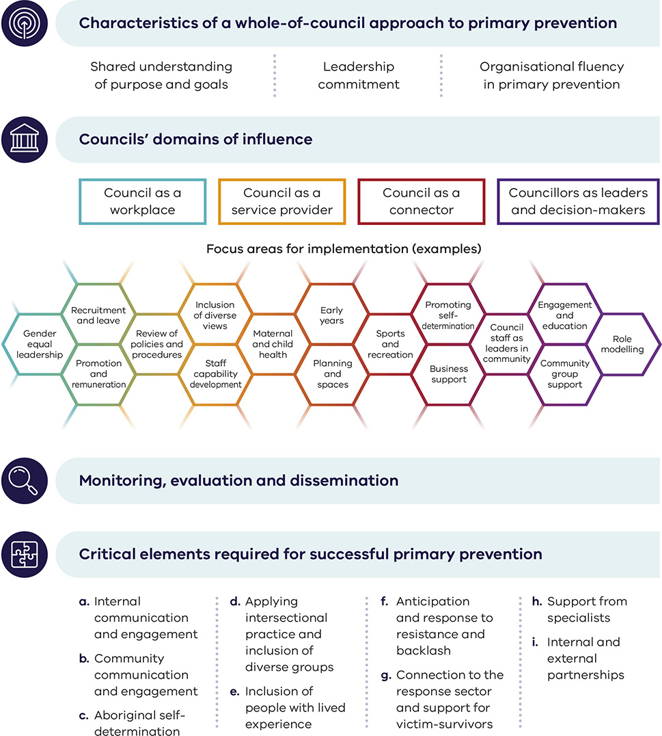

Councils’ domains of influence
This section shows example actions for each domain of influence.
Figure 3: Councils’ domains of influence
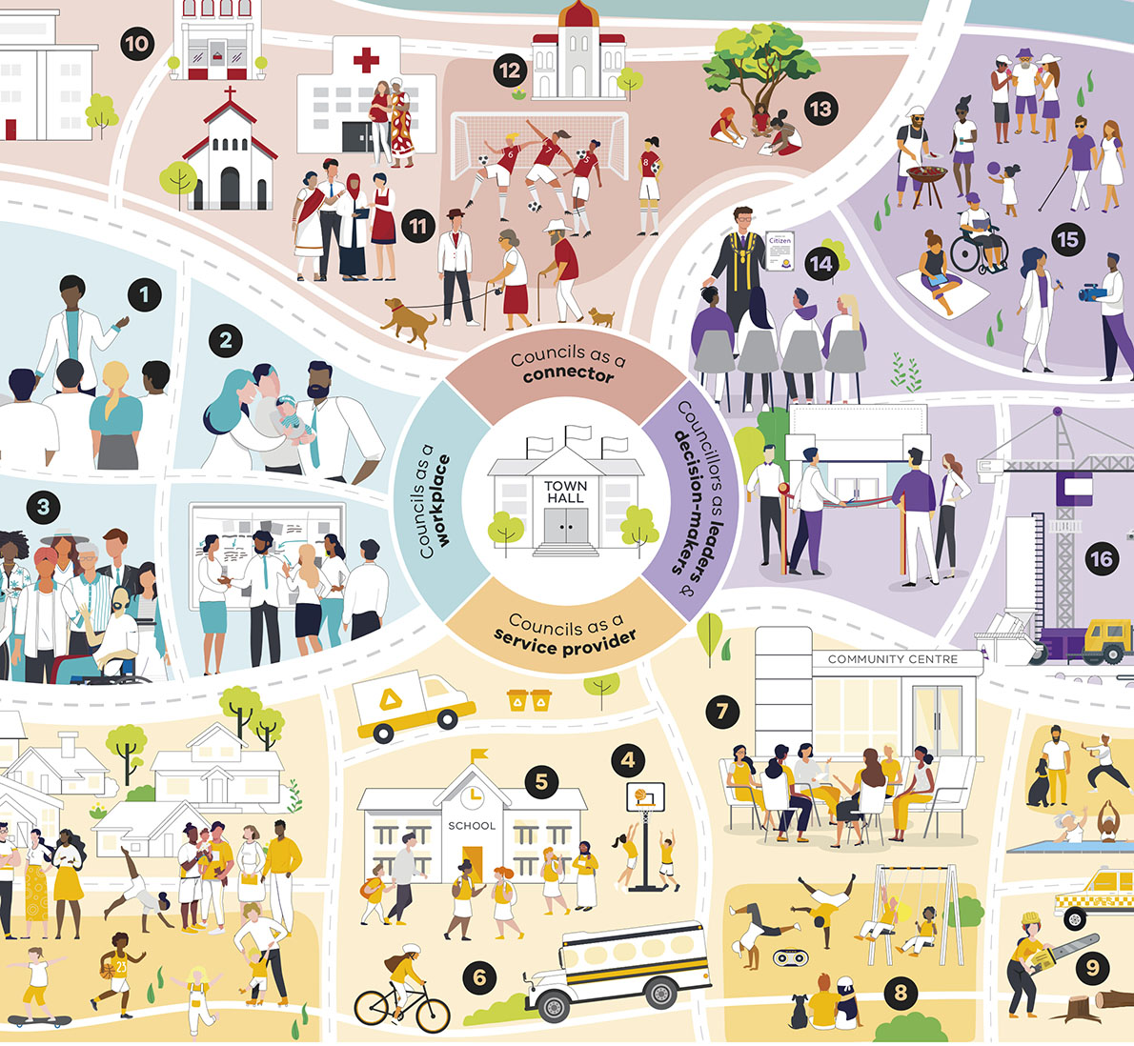

Councils as a workplace
Number | Example action | Illustration
1 | Gender equal and diverse leadership | A leader speaks to a team of four.
2 | Equitable leave entitlements | A parent holds their baby and introduces them to two work colleagues.
3 | Targets for equitable recruitment | A diverse group of people, including age, disability, gender, and cultural and linguistic diversity.

Councils as a service provider
Number | Example action | Illustration
4 | Gender equal access to sports facilities | Two young people play basketball.
5 | Education on respectful relationships | Children outside the front of their school building.
6 | Promoting independence and access of all groups | A child arrives by bicycle. A school bus approaches the school.
7 | Building networks with a sense of belonging | A group of women sit on chairs in a circle outside a community centre.
8 | Inclusive social and physical spaces | A park where two people play on swings, and a couple and their dog watches two people breakdancing in front of a stereo.
9 | Challenging gender stereotypes | A woman holds a chainsaw after having cut down a tree.

Councils as a connector
Number | Example action | Illustration
10 | Partnering with local services and businesses | Buildings housing local services and business.
11 | Seeking diverse perspectives | Someone surveying a group of three people from different cultural backgrounds.
12 | Connecting community organisations | A building for a community organisation.
13 | Enabling self-determination of First Nations people | Three First Nations people doing an activity outside under the shade of a tree.

Councillors as leaders and decision makers
Number | Example action | Illustration
14 | Civic leadership and role modelling | A councillor presenting at a local citizenship ceremony.
15 | Balanced support for events focused for different genders and groups | A diverse range of people attending an outdoor community event.  A man behind a barbeque prepares a plate for a waiting woman watching a small child play with a ball.  A family enjoys ice creams.  A vision-impaired person uses an aid as they walk with their partner.  A woman sits on a blanket while someone using a wheelchair reads a book.  A woman holds a microphone and talks to camera, being held by a man.
16 | Funding projects that create equitable and accessible space | A building construction site, with a large crane, truck and a dumpster for construction waste.

Overview of the guide

Structure of the guide
This guide is designed to help you make the whole-of-council model come to life in your council. Please note, real life and good practice are messier than a model on a page – some elements, such as organisational fluency, are developed throughout multiple sections.
Table 1 shows how the contents of the guide relate to the whole-of-council-model.
Table 1: Whole-of-council model and the guide
Section | Relevant part of model | Description
1: Health check | - | See the ‘bigger picture’ – understand how you compare to the whole-of-council model and identify possible focus areas.
2: Council responsibilities and engagement approaches | Characteristics of a whole-of-council approach | Understand the different roles that people across council can play and build support for primary prevention work.
3: Strategy integration | Characteristics of a whole-of-council approach | Define a strategy for primary prevention work and consider how to integrate it with existing plans.
4: Building organisational capability | Characteristics of a whole-of-council approach | Understand the who, what, when and where of capability development for primary prevention work.
5: Embedding this work into everyone’s roles | Domains of influence | Identify actions to embed primary prevention into day-to-day work for each functional area of council.
6: Tailored action plans | Domains of influence | Plan for a successful primary prevention initiative.
7: Monitoring, evaluation and dissemination | Monitoring, evaluation and dissemination | Undertake monitoring and evaluation of your primary prevention work and share your learnings with other councils.
Throughout the guide | Critical elements | Guidance about the critical elements appears throughout the guide to help you embed them into your practice.

User journeys through the guide
Everyone in council has a role but not everyone needs to play every role. Each section of the guide includes action-focused guidance to support development of each model component in your council. You can engage with the most relevant sections of the guide for your role and context. There are four journeys that you can take through the guide. Depending on your council, one person may follow multiple journeys.
Table 2: User journeys and relevant sections of the guide
Role | Summary | Description | Relevant sections
Doer | I am a Doer who wants to understand how primary prevention relates to my role and day-to-day work. | You are one of the many staff at council whose work isn’t specifically in the family violence or gender equality space, but who still has a role to play in primary prevention. You might be a team member working to deliver services to the community, managing the delivery of new works or working in finance.  The guide will help you understand your role in primary prevention and how you can embed it into your everyday work. | 2, 5, 6
Leader | I am a Leader in my team or department who wants to plan and embed primary prevention work. | As a leader, you are well-placed to embed primary prevention into your team’s work and enable them to learn more about It. You might be a team leader supporting your people to thrive, an executive leader responsible for outcomes or a Councillor leading your organisation and community.  The guide will help you understand your role in primary prevention, plan initiatives to embed it in the work your area does and support others to learn and engage in primary prevention. | 2, 3, 5, 6, 7
Specialist | I am a Specialist who wants to support teams and individuals on their primary prevention journey. | As a specialist in gender equality or primary prevention, you can support people across council to build their skills and take primary prevention action. You might already be working in a dedicated primary prevention role or be promoting gender equality in your area of council.  The guide will help you support others to understand their role in primary prevention and equip them to plan and conduct their own initiatives. | 2, 3, 4, 5, 6
Strategist | I am a Strategist who wants to get a council-wide view and help my organisation be more strategic about primary prevention. | You might be an officer in the CEO or Community Planning office or a primary prevention expert who is looking to identify all the primary prevention work happening in council, highlight gaps and opportunities. and lead your organisation towards a whole-of-council approach.  The guide will help you understand the distinct roles your council colleagues play, integrate primary prevention into governance documents, assess current work and monitor progress. | 1, 2, 3, 7

Glossary
Term | Definition
Ableism | Ableism is a set of practices and dominant attitudes in society that devalue and limit the potential of persons with disability, in favour of people without disability. An ableist society is said to be one that treats non-disabled individuals as the standard of ‘normal living’, which results in public and private places, services, and policies that are built to serve 'standard' people, thereby inherently excluding people with disability.
Ageism | Ageism refers to the stereotypes (how we think), prejudice (how we feel) and discrimination (how we act) towards others or oneself based on age.
Backlash | The resistance, hostility or aggression that gender equality or violence prevention strategies are met with by some groups.  From a feminist perspective, backlash can be understood as an inevitable response to challenges to male dominance, power or status – and is often interpreted as a sign that such challenges are proving effective.
Class | A system of structured inequality based on unequal distributions of power, education, wealth and income that determine social position and status.
Emotional or psychological violence | Can include a range of controlling behaviours such as control of finances, isolation from family and friends, continual humiliation, threats against children or being threatened with injury or death.
Gender | The socially learnt roles, behaviours, activities and attributes that any given society considers appropriate for men and women – gender defines masculinity and femininity.  Gender expectations vary between cultures and can change over time.
Gender-based violence | Any form of violence targeting a person based on their gender or gender presentation. It is recognised that gender-based violence disproportionality affects women.
Gender equality | As defined in the Gender Equality Act 2020: equality of rights, opportunities, responsibilities and outcomes between persons of different genders.
Gender equity | Entails the provision of fairness and justice in the distribution of benefits and responsibilities based on gender. The concept recognises that people may have different needs and power related to their gender and that these differences should be identified and addressed in a manner that rectifies gender-related imbalances.
Homophobia | Homophobia includes prejudice, discrimination, harassment and acts of violence brought on by fear and hatred of people who are homosexual or thought to be homosexual. (See also: transphobia)
Intimate partner violence | Any behaviour within an intimate relationship (including current or past marriages, domestic partnerships or dates) that causes physical, sexual or psychological harm.  This is the most common form of violence against women.
Lived experience | Lived experience is defined as ‘personal knowledge about the world gained through direct, first-hand involvement in everyday events rather than through representations constructed by other people.’  It also includes ‘the experiences of people on whom a social issue or combination of issues has had a direct impact,’ such as a sibling of a woman killed through an act of intimate partner violence.
Racism | Racism is when a person is treated worse, excluded, disadvantaged, harassed, bullied, humiliated or degraded because of their race or ethnicity (including people’s colour, nationality, citizenship, and ethnic or national origins).
Transphobia | Transphobia is the fear, hatred, disbelief, or mistrust of people who are transgender, thought to be transgender, or whose gender expression doesn’t conform to traditional gender roles. (See also: homophobia)

Department of Premier and Cabinet (Vic, 2016). Ending family violence: Victoria’s plan for change. Available on the Victorian Government’s Ending family violence: Victoria’s 10-year plan for change page <https://www.vic.gov.au/ending-family-violence-victorias-10-year-plan-change>.
Department of Premier and Cabinet (Vic, 2017). Free from violence: Victoria’s strategy to prevent family violence and all forms of violence against women.
Family Violence Protection Act 2008
Department of Premier and Cabinet (Vic, 2017). Free from violence: Victoria’s strategy to prevent family violence and all forms of violence against women.
The United Nations Declaration on the Elimination of Violence against Women (1993)
Adapted from Our Watch (2021). Change the story: A shared framework for the primary prevention of violence against women and their children in Australia (Second edition).
Our Watch (2021). Change the story: A shared framework for the primary prevention of violence against women and their children in Australia (second edition)
Safe and Equal & Partners in Prevention (unknown). Unpacking the gendered drivers of violence tip sheets.
Our Watch (2015). Change the story: A shared framework for the primary prevention of violence against women and their children in Australia
Our Watch (2021). Change the story: A shared framework for the primary prevention of violence against women and their children in Australia (second edition)
Our Watch (2021). Change the story: A shared framework for the primary prevention of violence against women and their children in Australia (second edition).
Our Watch (2021). Change the story: A shared framework for the primary prevention of violence against women and their children in Australia (second edition)
Our Watch (2021). Change the story: A shared framework for the primary prevention of violence against women and their children in Australia (second edition).
About family violence section of MARAM practice guides: Foundation knowledge guide. Available on the Victorian Government’s About family violence page <https://www.vic.gov.au/maram-practice-guides-foundation-knowledge-guide/about-family-violence>
Department of Premier and Cabinet (Vic, 2017). ‘Free from violence: Victoria’s strategy to prevent family violence and all forms of violence against women.’
Our Watch (2021). Change the story: A shared framework for the primary prevention of violence against women and their children in Australia (second edition)
Chandler, D., and Munday, R. (2016). ‘Oxford: A dictionary of media and communication’ (2nd ed.)
Sandu, B. (2017). ‘The value of lived experience in social change: The need for leadership and organisational development in the social sector.’

