Council cost pressures outstripping rate rises

25 June 2011

Draft local government budget data collated annually by the Municipal Association of Victoria (MAV) confirms that
Victorian council rates are budgeted to rise an average of 5.9 per cent or $82 this year.

Cr Bill McArthur, MAV President said that in response to cost of living pressures, local government rates would rise
less than councils‟ combined costs of doing business, the payment of State levies and the superannuation shortfall.

“The Local Government Cost Index, released last month, forecast that it will cost councils an average 3.6 per
cent more to deliver the same services as last year. This CPI-equivalent measures price movements in councils‟
construction, material and wage costs rather than household goods and services.

“Councils must also pay a $71 million shortfall to the closed Defined Benefits superannuation scheme, which
represented more than two per cent of total local government rate revenue for the coming year.

“In a spectacular show of double standards, Federal and State Government defined benefit schemes had
accumulated unfunded liabilities worth billions of dollars following the market downturn between 2008 and 2010.

“Unbeknown to ratepayers, councils must also pass on more than $63 million in State landfill and fire services
levies, or 1.8 per cent of total rate revenue collected, to fund State agencies and programs. This was taxation by
stealth, and people deserved to know what portion of rates don‟t stay in their municipality.

“Despite these cost pressures, councils continued to boost spending to maintain and renew $55 billion of ageing
community assets to ensure future generations won‟t be burdened with prohibitive asset replacement costs.

“While the annual infrastructure renewal gap had shrunk from $310 million to $100 million in the past five years,
the gap between government grants and delivery costs for vital community services continued to grow,” he said.

Councils have increasingly become the „funder of last resort‟ to redress an ongoing decline in Commonwealth and
Victorian Government contributions to ensure programs such as home and community care, kindergartens, public
libraries, and school crossings continued to meet community expectations.

Cr McArthur said that core financial assistance provided through Commonwealth tax distribution to local
government had halved from 1.2 per cent of federal revenue in 1993 to just 0.62 per cent in 2011.

“In addition, the continued failure of other levels of government to provide adequate funding to match service
delivery costs meant that councils were increasingly reliant on ratepayer revenue to make up the shortfalls.

“The cumulative impacts of under-funding and the erosion of financial assistance left councils in the untenable
position of choosing between unpopular rate rises or explaining to frustrated communities why demand for kinder
places, meals on wheels and other important community programs could not be met.

“It‟s a double-edge sword. Achieving a balance of affordable rates without cutting services was an ongoing
challenge as rising living costs placed a strain on household budgets and increased demand for council services.

“Pensioners and other residents facing financial hardship are urged to contact their council to discuss their
options. Please speak with your council if you need assistance,” he said.

Rates data for 71 of 79 Victoria councils is available at: www.mav.asn.au/finance/rates#resources

Contact MAV President,
Cr Bill McArthur on 0437 984 793 or
MAV Communications on 03 9667 5521.
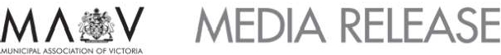

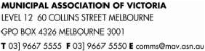

2011-12 Victorian Local Government Rates Survey

Total budgeted rate
revenue, municipal charge
& waste management
charges for 2011-12
Budgeted total
revenue for
2011-12
Total rate
revenue as a
proportion of
total revenue
2011-12
Total rate
revenue as a
proportion of
total revenue
2010-11
Average rates,
municipal
charge &
garbage
charge 2011-12
per
assessment
Change in
rates,
municipal
charge &
garbage
charge per
assessment
Average rates,
municipal
charge &
garbage
charge 2011-12
per head of
Change in
rates,
municipal
charge &
garbage
charge per
head of

population
population

Alpine (S)
$ 11,922,946.00
$ 1,457
$107
$923
$ 68

Ararat (RC)
Ballarat (C)
Banyule (C)
Bass Coast (S)
$ 11,746,396.00
$ 69,436,321.00
$ 66,239,125.00
$ 37,228,092.00
$ 27,635,000
$ 129,954,000
$ 110,462,408
$ 63,593,000
42.51%
53.43%
59.97%
58.54%
47.94%
50.06%
57.58%
61.23%
$ 1,701
$ 1,512
$ 1,298
$ 1,317
$125
$33
$69
$85
$981
$701
$545
$1,182
$ 71
$ 22
$ 31
$ 55

Baw Baw (S)
$ 34,999,426.00
$ 1,572
$131
$831
$ 67

Bayside (C)
$ 65,987,471.00
$ 94,985,000
69.47%
68.16%
$ 1,606
$88
$676
$ 35

Benalla (RC)
Data not provided

Boroondara (C)
Brimbank (C)
$125,894,000
$ 104,679,053.00
$ 170,194,000
$ 155,835,000
73.97%
67.17%
71.35%
67.94%
$ 1,780
$ 1,438
$84
$66
$737
$545
$ 36
$ 27

Buloke (S)
Draft budget yet to be considered

Campaspe (S)
Cardinia (S)
$ 29,517,966.00
$ 52,115,404.00
$ 66,959,000
$ 81,745,000
44.08%
63.75%
46.80%
61.86%
$ 1,484
$ 1,618
$97
$77
$754
$696
$ 49
$ 31

Casey (C)
Data not provided

Central Goldfields (S)
Colac-Otway (S)
Corangamite (S)
Darebin (C)
East Gippsland (S)
$ 9,937,592.00
$ 21,737,376.00
$ 15,943,143.00
$ 87,760,372.00
$ 39,059,192.00
$ 31,044,153
$40,469,000
$ 37,106,000
$ 130,311,000
$ 81,451,000
32.01%
53.71%
42.97%
67.35%
47.95%
29.33%
51.31%
40.20%
65.90%
54.76%
$ 1,248
$ 1,504
$ 1,683
$ 1,384
$ 1,322
$100
$91
$77
$70
$81
$772
$973
$910
$611
$863
$ 63
$ 52
$ 44
$ 28
$ 49

Frankston (C)
$ 80,533,587.00
$ 1,373
$82
$623
$ 44

Gannawarra (S)
Glen Eira (C)
Glenelg (S)
Golden Plains (S)
Greater Bendigo (C)
Greater Dandenong (C)
Greater Geelong (C)
Greater Shepparton (C)
Hepburn (S)
Hindmarsh (S)
$ 9,530,320.00
$ 77,047,907.00
$ 21,498,432.00
$ 13,541,213.00
$ 72,700,108.00
$ 87,481,869.00
$ 148,736,675.00
$ 53,179,371.00
$ 14,651,000.00
$ 6,093,348.00
$22,088,212
$ 118,838,000
$ 42,501,000
$ 25,923,191
$ 140,535,000
$ 150,668,000
$ 247,663,000
$ 102,083,000
$ 23,783,000
$ 15,862,324
43.15%
64.83%
50.58%
52.24%
51.73%
58.06%
60.06%
52.09%
61.60%
38.41%
38.19%
65.09%
49.33%
50.01%
51.24%
60.19%
57.97%
51.15%
38.62%
37.56%
$ 1,422
$ 1,293
$ 1,543
$ 1,396
$ 1,399
$ 1,491
$ 1,414
$ 1,829
$ 1,413
$ 1,215
$90
$71
$87
$82
$57
$70
$68
$89
$91
$96
$815
$573
$1,005
$718
$691
$618
$662
$824
$975
$984
$ 52
$ 23
$ 57
$ 40
$ 29
$ 27
$ 33
$ 44
$ 65
$ 79

Hobsons Bay (C)
Data not provided

All data have been provided by individual councils and collated by the MAV. It is based on DRAFT budget information for 2011-12.
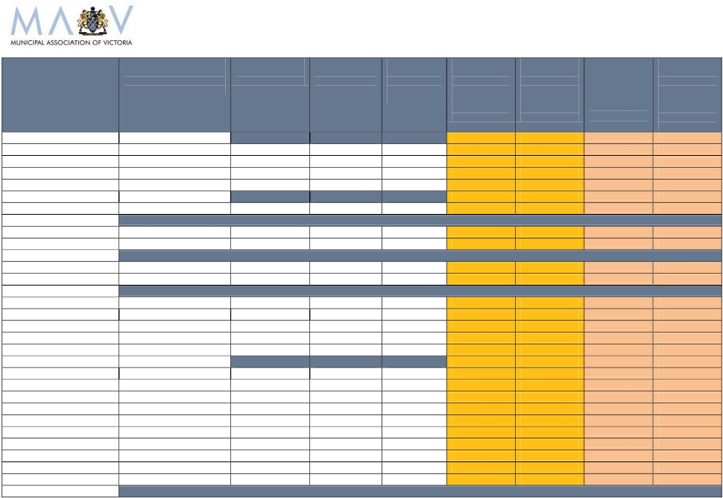

2011-12 Victorian Local Government Rates Survey

Total budgeted rate
revenue, municipal charge
& waste management
charges for 2011-12
Budgeted total
revenue for
2011-12
Total rate
revenue as a
proportion of
total revenue
2011-12
Total rate
revenue as a
proportion of
total revenue
2010-11
Average rates,
municipal
charge &
garbage
charge 2011-12
per
assessment
Change in
rates,
municipal
charge &
garbage
charge per
assessment
Average rates,
municipal
charge &
garbage
charge 2011-12
per head of
Change in
rates,
municipal
charge &
garbage
charge per
head of

population
population

Horsham (RC)
Hume (C)
Indigo (S)
Kingston (C)
$ 17,685,475.00
$ 101,522,045.00
$ 11,324,300.00
$ 99,451,300.00
$ 49,957,629
$ 200,113,000
$25,314,636
$ 153,900,000
35.40%
50.73%
44.73%
64.62%
38.18%
48.41%
39.61%
62.73%
$ 1,521
$ 1,527
$ 1,406
$ 1,459
$107
$88
$99
$87
$870
$561
$709
$663
$ 59
$ 35
$ 44
$ 35

Knox (C)
$ 83,980,972.00
$ 1,353
$83
$539
$ 34

Latrobe (C)i
Loddon (S)
Macedon Ranges (S)
Manningham (C)
Mansfield (S)
$ 58,319,000.00
$ 7,675,492.00
$ 32,811,173.00
$ 72,678,256.00
$ 9,810,620.00
$ 102,760,000
$ 27,487,230
$ 57,633,799
$101,688,000
$16,635,000
56.75%
27.92%
56.93%
71.47%
58.98%
50.94%
21.18%
55.48%
68.77%
36.28%
$ 1,587
$ 1,015
$ 1,630
$ 1,614
$ 1,381
$91
$49
$114
$77
$81
$769
$954
$764
$611
$1,226
$ 46
$ 51
$ 59
$ 33
$ 59

Maribyrnong (C)ii
$ 65,122,189.00
$95,210,000
68.40%
63.31%

Maroondah (C)
$ 61,868,339.00
$94,585,000
65.41%
63.71%
$1,339
$56
$573
$26

Melbourne (C)
Does not participate in survey

Melton (S)
Mildura (RC)
Mitchell (S)
Moira (S)
Monash (C)
Moonee Valley (C)
Moorabool (S)
Moreland (C)
Mornington Peninsula (S)
Mount Alexander (S)
$ 68,412,693.00
$ 48,347,539.00
$ 24,431,972.00
$ 25,321,000.00
$ 81,798,000.00
$ 74,903,525.00
$ 22,421,160.00
$ 98,170,009.00
$ 114,483,030.00
$ 15,383,350.00
$ 117,493,000
$ 93,007,000
$43,496,000
$44,517,000
$ 151,446,000
$ 110,533,000
$ 39,910,942
$ 138,375,000
$ 174,050,000
$ 27,766,000
58.23%
51.98%
56.17%
56.88%
54.01%
67.77%
56.18%
70.94%
65.78%
55.40%
61.53%
55.87%
48.05%
53.99%
55.82%
65.60%
56.50%
71.50%
60.27%
50.71%
$ 1,547
$ 1,752
$ 1,450
$ 1,528
$ 1,122
$ 1,537
$ 1,551
$ 1,452
$ 1,205
$ 1,436
$113
$102
$108
$120
$67
$86
$76
$88
$99
$104
$582
$902
$687
$829
$453
$659
$751
$642
$761
$828
$ 39
$ 55
$ 60
$ 66
$ 27
$ 23
$ 34
$ 38
$ 61
$ 61

Moyne (S)
Data not provided

Murrindindi (S)
Nillumbik (S)iii
Northern Grampians (S)
Port Phillip (C)
Pyrenees (S)
Queenscliffe (B)
South Gippsland (S)
$ 13,714,239.00
$ 44,960,050.00
$ 12,659,300.00
$ 88,744,540.00
$ 6,653,748.00
$ 5,332,561.00
$ 29,237,538.00
$46,194,171
$ 69,028,000
$ 38,805,000
$ 153,814,000
$ 21,411,000
$ 8,685,000
$ 48,840,226
29.69%
65.13%
32.62%
57.70%
31.08%
61.40%
59.86%
17.90%
52.73%
37.63%
57.31%
21.74%
54.25%
57.73%
$ 1,447
$ 2,010
$ 1,381
$ 1,380
$ 1,162
$ 1,774
$ 1,550
$124
$113
$99
$76
$59
$74
$62
$1,015
$709
$1,030
$932
$997
$1,635
$1,025
$ 93
$ 39
$ 76
$ 55
$ 48
$ 71
$ 41

All data have been provided by individual councils and collated by the MAV. It is based on DRAFT budget information for 2011-12.
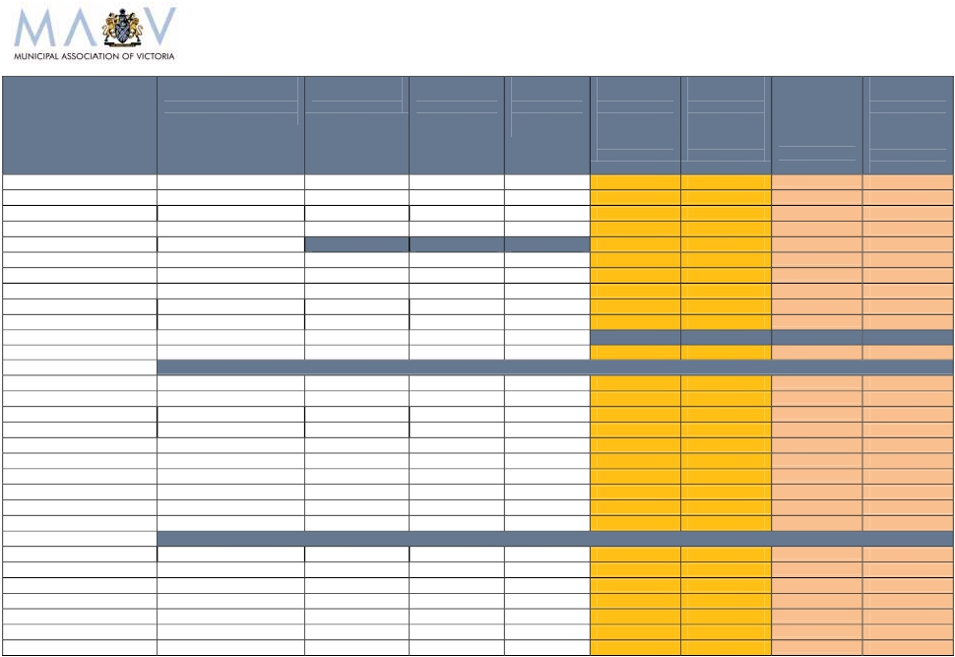

2011-12 Victorian Local Government Rates Survey

i
ii

Note includes payment in lieu of rates made by electricity generators. Rates per assessment are $1,357 if these payments are excluded.
Note the high incidence of industrial and commercial assessments within the municipality means average residential rates per assessment are $1,549.

iii
Note the limited commercial and industrial activities in the municipality increase the average rates per assessment.

All data have been provided by individual councils and collated by the MAV. It is based on DRAFT budget information for 2011-12.

 | Total budgeted rate  revenue, municipal charge  & waste management  charges for 2011-12 | Budgeted total  revenue for  2011-12 | Total rate  revenue as a  proportion of  total revenue  2011-12 | Total rate  revenue as a  proportion of  total revenue  2010-11 | Average rates,  municipal  charge &  garbage  charge 2011-12  per  assessment | Change in  rates,  municipal  charge &  garbage  charge per  assessment | Average rates,  municipal  charge &  garbage  charge 2011-12  per head of  population | Change in  rates,  municipal  charge &  garbage  charge per  head of  population
Southern Grampians (S) | $ 14,116,664.00 | $ 34,776,580 | 40.59% | 40.19% | $ 1,310 | $80 | $786 | $ 50
Stonnington (C) | $76,169,209 | $126,796,000 | 60.07% | 58.40% | $ 1,411 | $54 | $762 | $ 29
Strathbogie (S) | $ 13,109,889.00 | $ 24,646,000 | 53.19% | 48.66% | $ 1,888 | $154 | $1,259 | $ 65
Surf Coast (S) | $ 35,445,869.00 | $ 55,376,000 | 64.01% | 57.86% | $ 1,841 | $99 | $1,261 | $ 49
Swan Hill (RC) | $ 20,817,870.00 | $ 52,033,945 | 40.01% | 42.38% | $ 1,781 | $77 | $925 | $ 42
Towong (S) | Draft budget yet to be considered
Wangaratta (RC) | $ 21,710,933.00 | $ 52,493,000 | 41.36% | 42.20% | $ 1,487 | $70 | $747 | $ 23
Warrnambool (C) | $ 26,160,939.00 | $ 62,238,000 | 42.03% | 39.95% | $ 1,655 | $113 | $768 | $ 49
Wellington (S) | Data not provided
West Wimmera (S) | $ 4,937,949.00 | $ 17,812,533 | 27.72% | 27.04% | $ 1,069 | $94 | $1,139 | $ 109
Whitehorse (C) | $ 79,969,884.00 |  |  |  | $ 1,195 | $90 | $515 | $ 43
Whittlesea (C) | $ 93,776,350.00 | $ 150,462,203 | 62.33% | 61.22% | $ 1,432 | $63 | $564 | $ 26
Wodonga (RC) | $ 30,861,081.00 | $ 66,274,000 | 46.57% | 46.59% | $ 1,837 | $107 | $839 | $ 49
Wyndham (C) | $ 116,148,801.00 | $331,322,324 | 35.06% | 29.20% | $ 1,619 | $89 | $711 | $ 39
Yarra (C) | $ 74,937,000.00 | $ 132,115,000 | 56.72% | 55.06% | $ 1,703 | $61 | $951 | $ 27
Yarra Ranges (S) | $ 98,530,777.00 | $ 149,921,000 | 65.72% | 63.16% | $ 1,596 | $94 | $666 | $ 42
Yarriambiack (S) | $ 8,624,390.00 | $ 19,693,000 | 43.79% | 35.02% | $ 1,278 | $76 | $1,161 | $ 85
Total | $3,481,738,725 | $ 5,850,089,750 | 59.52% | 57.05% | $ 1,472 | $82 | $686 | $ 38
Change in local government revenue | 3.1%
Change in rates, municipal charges and waste charges per assessment | 5.9%
Change in rates, municipal charges and waste charges per head | 5.8%
Average change in rates, municipal charges and waste charges per assessment | $82
Average change in rates, municipal charges and waste charges per head | $ 38
Average rates, municipal charges and waste charges per assessment | $ 1,472
Average rates, municipal charges and waste charges per head | $ 686

HOW COUNCIL RATES DATA IS PRESENTED

Rates per assessment

The MAV has used average rates, municipal charges and garbage charges per assessment to
measure rate movements in 2005, 2006, 2007, 2008, 2009, 2010 and 2011.

Average rates per assessment are an estimate of the average rate bill received by all ratepayers.

Demographic characteristics and the economic and industry profile of the community affect the
quantum average rates per assessment.

For example, councils with high levels of commercial and industrial businesses tend to have higher
rates per assessment than other councils, irrespective of the residential rates. For these councils,
the residential rates per assessment are likely to be lower than the municipal wide average.

Likewise, councils with little or no commercial and industrial activities and with large households
will also tend to have higher rates per assessment.

In addition, a single farm enterprise may include several assessments, which will skew the data.

Rates per head of population

The MAV has adopted average rates, municipal charges and garbage charges per head of
population to measure rates for 2006, 2007, 2008, 2009, 2010 and 2011.

Average rates per head are a good measure of the comparative tax burden placed on the
communities with other levels of government. Many of the taxes levied by the
Commonwealth and State Government are compared on a per head basis; this measure
enables a valid comparison with these figures.

It is also a useful measure in gaining a clearer picture of the rates structures of councils that
have little or no industrial activities and large households.

Rates per head is an increasingly useful measure of local government rates as the services
provided by councils expand from property-based to human based services.

Further Information:
Council rates data for 2003, 2004, 2005, 2006, 2007, 2008, 2009, 2010 and 2011 is available
on the MAV website at: www.mav.asn.au/finance/rates#resources

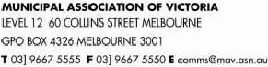

VICTORIAN LOCAL GOVERNMENT SNAPSHOT

Local Government Facts

Victoria has 79 municipalities:

o
o
o
o
o
31 metropolitan (including eight Interface councils)
48 rural and regional (including 10 regional cities)
Populations range from 3 200 to more than 253 000
Land area varies from 8 sq km to 22 000 sq km
Each also varies in rate base, needs, infrastructure and resources

Each municipality manages significantly different budgets:

o
o
Rural council budgets average $45.6 million (smallest is approx $8 million)
Metropolitan council budgets average $133.1 million (largest is approx $340 million)

Governed by 620 democratically elected councillors
Employs 42 500 people
Annual revenue of $6.1 billion
Responsible for $55 billion in community infrastructure and assets

Service Delivery Statistics

Local government in Victoria:

Services 129 201 kilometres of roads (approximately 85 per cent of Victoria’s total road network)
Provides 606 800 maternal and child health consultations a year
Delivers 306 600 immunisations to preschool and secondary school children a year
Delivers 3.8 million meals a year to home care recipients
Provides 4 million hours of home assistance, property maintenance, personal and respite care a year
Spends over $50 million on public street lighting each year
Loans 52 million items from 316 public and mobile libraries to 2.5 million registered users a year
Provides internet access for more than 3.4 million bookings a year (up from 2 million in 2006-07)
Processes more than 55 800 planning applications a year
Maintains more than 1 000 grassed sports surfaces
Collects 1 million tonnes of kerbside garbage a year
Collects 608 000 tonnes of recyclable materials a year
Collects 270 000 tonnes of organic waste a year
Over 18 500 visits to tobacco retailers, eating establishments and licensed premises a year
Register more than 45 000 food businesses a year

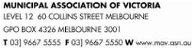

LOCAL GOVERNMENT COST PRESSURES

A range of cost pressures influence the decisions each council makes about its annual budget
and the rates it needs to collect.

1. COST SHIFTING
Cost shifting occurs when Commonwealth and State programs transfer responsibilities to local government
with insufficient funding, or grants that don’t keep pace with service delivery costs. Council rates are
commonly used to cover growing funding shortfalls to meet increasing service demands and rising costs.

Home and Community Care
Unique to Victoria, councils are the largest public sector provider of home and community care (HACC)
programs. While the Commonwealth and states have joint responsibility for funding of HACC, councils have
subsidised the costs of aged care services by $100 million a year due to a failure of government funding to
reflect actual service delivery costs and the increasing demands from our ageing population.

Kindergartens
Councils own more than two-thirds of facilities that deliver 1 200 State Government kindergarten programs to
four-year olds, which are mostly community-run. Victoria requires 50 per cent more facilities costing an
estimated $600 million and 400 extra teachers to deliver national reforms to increase this vital early learning
program from 10 to 15 hours per week by 2013. If Commonwealth funding is not provided, other options
include ceasing three-year old programs, increasing rates and/or parent fees to fund new and expanded
facilities, or introducing waiting lists.

Emergency Management
Local government roles in emergency management continue to grow beyond legislated responsibilities,
particularly in the areas of community relief and recovery following an event. Natural disaster reimbursement
arrangements do not accurately reflect council responsibilities, and recurrent State funding is needed to
ensure councils can implement post-Black Saturday bushfire reforms, and meet their expanding obligations.

Public Libraries
Public libraries are the most commonly utilised facility in Victoria, increasingly used as a gateway to online
services and resources, and as learning centres and social hubs. Local government provided $142.7 million in
2009-10, while the State contributed $35.3 million. State funding has declined from a high of 50% in the 1970s
to 18.7%. Local government needs $10 million in recurrent funding each year to help enhance libraries’ IT
capacity and respond to community expectations for DVDs, CDs, e-books and other emerging technologies.

2. INFRASTRUCTURE RENEWAL GAP
Victorian councils are responsible for ageing community infrastructure worth $55 billion. Councils have
significantly increased capital works budgets in recent years to reduce the $280 million annual shortfall in
spending identified in 2007 to maintain and renew ageing local assets. In 2010, the annual renewal gap was
calculated at $100 million. However, as councils face limited capacity to raise the required revenue, they must
use a range of options such as rate rises, lower service levels, asset rationalisation and borrowings. If
infrastructure is not adequately maintained, the replacement costs will be much higher for future generations.

3. LOCAL GOVERNMENT COST INDEX
The MAV Local Government Cost Index forecasts any change in costs for a council to deliver the same level
and range of services as the previous year. In 2011, it will cost local government an average 3.6 per cent
more than in 2010. A ‘basket’ of council services is affected by the growth in construction, material and wage
costs, not changes in household goods and services as measured by CPI. The majority of council expenses
are staff to deliver human services; and staff and materials to construct and maintain community assets.

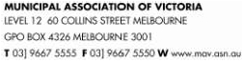

4. SUPERANNUATION SHORTFALL

In 2011, Victorian councils are required to pay a $71 million shortfall to the Local Authorities Superannuation
Fund (LASF) Defined Benefit Scheme – the legacy of a superannuation plan that’s been closed since 1993.

A downturn in global financial markets between 2008 and 2010 has left current LASF assets below the level
required to meet the prescribed retirement benefits owed to scheme members. Unlike accumulation super
schemes which operate today, defined benefit plans require the employer to shoulder the investment risk.

Other levels of government are not required to fully fund their defined benefit scheme liabilities. The Victorian
Government’s unfunded superannuation liability is $21.7 billion - up by 50 per cent since 2005; while the
Commonwealth’s $129.5 billion superannuation liability is only partly covered by its $56.1 billion Future Fund.

5. DECLINING GOVERNMENT GRANTS
Local government nationally collects 3.5 per cent of the $333.4 billion total taxes raised by all three levels of
government. Core financial assistance through Commonwealth tax distribution to local government has
declined from 1.2 per cent of Commonwealth revenue in 1993-94 to 0.97 per cent in 1996-97 and 0.62 per
cent in 2011-12. Commonwealth and State Government grants to local government are usually indexed to
CPI or less. This means that grants are lower each year than actual council cost movements to deliver the
service, leaving councils to fund the gap from rates revenue.

5. STATE LEVIES
The Victorian Government requires local government to collect State levies - including the Fire Services Levy
and Landfill Levy, which are funded through property taxes. These levies are paid by ratepayers, but must be
passed on in full by the council to fund State agencies and programs.

The fire services levy contribution required from 25 metropolitan councils in the MFB area was $35.7 million
in 2010 – equal to 1.5 to 2 per cent of total annual rates revenue for those municipalities.

A phased increase in State landfill levies commenced in 2010, with municipal levies for Melbourne and major
provincial cities rising from $9 per tonne (2009) to $53.20 per tonne by 2014; and rural levies from $7 per
tonne (2009) to $26.60 per tonne by 2014. These levies are collected from ratepayers through garbage
charges for kerbside collection services and gate fees to dispose of waste at landfills/transfer stations. Over
four years, Victorian councils will be required to collect an estimated $110 million in State landfill levies.

6. REGULATIONS & REPORTING

Regulations imposed on local government are onerous and often unfunded. New regulations placing
additional costs onto councils without any State funding include compliance with the 2010 Electric Line
Clearance regulations, and incoming regulations reducing staff-to-child ratios in child care centres.

An investigation by the Essential Services Commission has confirmed there are also more than 100 reporting
requirements for Victorian councils to at least 17 different State agencies. Many requirements provide little or
no direct benefit to ratepayers, but result in increased council costs and a diversion of council resources.

A proposed new Performance Reporting Framework could cost councils an additional $3.1 million to $7.1
million, with rural municipalities to bear a disproportionately higher cost burden.

7. CAPPED USER FEES AND CHARGES
Capping of many user fees and charges by the Victorian Government leaves councils unable to recover the
actual cost of delivering services such as planning and building, heritage protection, home care and public
libraries. Instead, rate revenue must be used by the council to cross-subsidise the delivery of these services.

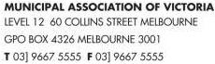

State Levies collected through Council Rates

A number of Victorian Government levies are collected through local government property taxes. These levies
are funded through rate revenue but must be passed on in full to help fund State agencies and programs.

Fire Services Levy
In Metropolitan Fire Brigade (MFB) areas, municipalities must fund 12.5 per cent of the MFB’s budget based
pro-rata on each council’s share of the state-wide net annual value (NAV) of rateable properties.

Each council raises its contribution through the general rate in the dollar applied to the valuation system used for
rating purposes. Councils in CFA areas currently play no direct role in collecting State levies to fund fire services.

In the past three years, the fire services levy contribution required from 25 metropolitan councils was
$32.9 million (2008), $34.3 million (2009) and $35.7 million (2010) – equal to 1.5 to 2 per cent of total
annual rates revenue for those municipalities.

Local government supports the Bushfires Royal Commission recommendation to replace the current fire
services levy on insurance and councils with a property-based model for funding of Victoria’s fire services. This
would shift the contribution from only those who insure to all Victorian properties in both CFA and MFB areas.

However, the collection of a property-based levy through council rates is opposed. The State Revenue Office
has both the capacity and capability to collect the State’s proposed new property-based fire levy.

Landfill Levy

The Victorian Government places a levy on all waste going into landfill, which councils pay on municipal waste.
Councils collect this State levy from ratepayers through garbage charges for kerbside collection services and gate
fees to dispose of waste at landfills/transfer stations.

In 2010 the State increased landfill levies, with municipal levies for Melbourne and major provincial cities rising
from $9 per tonne (2009) to $53.20 per tonne by 2014; and rural levies from $7 per tonne (2009) to $26.60 per
tonne by 2014. The 2011 State Budget announced an additional $43 million would be collected in landfill levies
over four years, by bringing forward each of the progressive annual increases by 12 months.

These combined landfill levy increases impose an additional $71.6 million on ratepayers over four
years, with Victorian councils to collect and pass on an estimated $110 million to the State Government.

Transparent Collection needed for State Levies

Local government raises 3.5 per cent of the total taxes collected by all levels of government nationally. The MAV
does not support local government being used as a collection agency for Federal or State taxes or levies due to:

Lack of transparency by the Government and lack of clarity for ratepayers
Creation of additional cost and administrative burdens for councils and ratepayers
Limitations it places on councils to generate sufficient rate revenue to fund local community priorities.

The MAV has encouraged all councils to separately list State levies on rates notices so communities understand
the portion of their rates bill that will not remain in the municipality to fund local infrastructure and service needs.

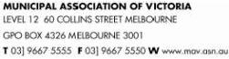

FUNDING OF LOCAL GOVERNMENT

Australian Taxation System

The Australian Constitution unequally divides taxation powers and expenditure responsibility
between the Commonwealth and state governments
As a result, the Commonwealth collects around 80.1 per cent (including GST) and the states
around 16.4 per cent of the total taxes collected in Australia
Local government collects 3.5 per cent of the total taxes collected by all levels of government
To equalise taxation revenues and spending responsibilities, the Commonwealth makes a series
of grants to the states and local government.

Local Government Income Sources

There are several sources of funding for local government in Victoria:

Rates on property

Fees, fines and charges (eg. swimming pool and gymnasium entry fees, waste depot fees,
planning permit fees, parking fees and fines)

Specific purpose grants from State and Commonwealth Governments, for funding specific
projects or programs

General purpose grants from the Commonwealth Government not tied to a specific purpose

Other sources: borrowings (eg. to pay for large infrastructure projects), asset sales, donations,
contributions, reimbursements and interest earned.

Local Government Funding Sources

The total funding for local government in Victoria in 2009-10 from all sources was $6.1 billion including:

$3.45 billion or 56.3 per cent in rates
$1.05 billion or 17.1 per cent in fees, fines and charges
$560 million or 9.2 per cent in specific purpose grants
$450 million or 7.4% per cent in untied revenue from general purpose grants
$610 million or 10 per cent from other sources

Local government collects around 3.5 cents of every $1 raised in Australian taxes. The
Commonwealth collects approximately 80.1 % of total taxation revenue and the States collect 16.4%.

LOCAL GOVERNMENT RATING PRINCIPLES

Property Taxation System

Property taxes (rates) are a wealth tax charged by local government municipalities
Local councils can also apply a municipal charge (of not more than 20 per cent of their total rate revenue); a
waste management charge; and other special rates and charges as appropriate within the legislation
Exemptions from rates apply to crown land, charitable land, land used for religious purposes, and land
used exclusively for mining and forestry
Rate revenue comprises 56.3 per cent of Victorian councils’ total revenue
Council rates do not represent a direct user pays system because local government provides services
and infrastructure for public benefit .

PRINCIPLE: Those with a higher valued property relative to others within a municipality generally
contribute a larger amount in rates.

Rating Equity

Rates are distributed between ratepayers based on the relative value of properties within a municipality
Properties are revalued every two years to maintain a fair distribution of the rates burden between
property owners within a municipality
There is a direct relationship between property holdings and disadvantage – less wealthy people tend to
own lower valued housing stock
Property owners with higher valued assets generally have a greater capacity to pay
Property taxes do not take into account individual debt levels or income received by owners – there are other
taxes applying to income and expenditure which should be considered when assessing tax equity.
Differential rates can be used by a council to help determine a fair contribution from each type of property.
Eg residential, commercial, industrial, farm.

PRINCIPLE: There is no connection between the amount of rates paid and the level of council
services received by individuals.

Municipal Charges

A municipal charge may be used by a council to collect a portion of revenue not linked to property value
but paid equally by all ratepayers
Farm owners with multiple property assessments for rates only attract a single municipal charge.
User fees imposed by councils (such as municipal and waste management charges) help to redistribute the
burden of rates as they are paid equally by all ratepayers and reduce the total property rates required by a
council to fund its annual budget.

PRINCIPLE: The use of a municipal charge reduces the amount that needs to be collected in the
form of rates attached to the value of a property.

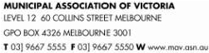

COUNCIL RATES EXPLAINED

Australia’s tax system uses the payment of taxes to fund a variety of programs, services and
infrastructure by all levels of government for the public benefit of all.

Property Tax

Council rates are a property tax. Councils use property values as the basis for calculating how much each
property owner pays in rates.

In Victoria, council rates can comprise up to three components:
municipal charge (of not more than 20 per cent of a council’s total rates revenue)
waste management (garbage) charge
rate in the dollar.

Exemptions from rates apply to crown land, charitable land, land used for religious purposes, and land used
exclusively for mining or forestry.

There is no connection between the amount of rates paid by a property and the level of council services
received.

PRINCIPLE: Those with a higher valued property relative to others within a municipality will
contribute more in rates that those with a lower valued property

Rate Process

Once a council has identified the total amount it needs to collect in rates (as determined by its prescribed
budget process), rates and charges can be calculated. A council begins its rate process each year by
determining any municipal and waste management charges that may be needed to recover part of the
administrative cost and the cost of providing waste collection and disposal services respectively.

Once these discretionary charges have been accounted for, a council establishes its rate in the dollar by
dividing the balance of required budget revenue by the total value of all rateable properties in the municipality.

The rate in the dollar is then multiplied by the value of a property (using one of three valuation bases) to
establish the amount to be paid by each property owner. This amount is known as the general rates.
General rates are added to any municipal and waste management charges set by a council to determine
the total rates payable on a property.

Example: Calculating General Rates

The total value of rateable properties within a municipality is $10,000,000,000 and council needs to collect

$40,000,000 in rates. The rate in the dollar is 0.004 (40,000,000
10,000,000,000). The rates payable on a

property valued at $320,000 would be $1280 ($320,000 x 0.004).

An increase in property values does not cause a rate rise. Council budgets are pre-determined to
meet expenditure requirements, and include any potential rate rise. Property valuations are
revenue neutral – they are used to distribute how much each ratepayer will pay, according to the
value of their property compared to other properties within the municipality.

SETTING A COUNCIL BUDGET

Council Plan

Victoria’s 79 councils operate as separate entities with different local issues, costs and service provision needs.

All councils identify in their Council Plan the needs and issues to be dealt with in their municipality.

This Plan is a statutory requirement which describes the strategic objectives and strategies to be
implemented by a council for the coming year, as well as the following four years.

Each council issues a public notice seeking community input to its draft plan for 14 days, before the plan is
finalised and adopted by council for submission to the Minister. It must be completed by 30 June each year.

Strategic Resources Plan

A Council Plan must include a Strategic Resources Plan, which sets out the financial and human resources
required to achieve its objectives over five financial years.

The Strategic Resources Plan is updated annually.

Council Budget

Each council’s budget is different to reflect its local community needs and priorities. However, there is a
common legislated framework for setting a budget that each council must follow.

The budget process involves a council setting its priorities, identifying measures and allocating funds that
will show how the key strategic objectives outlined in its Council Plan are to be achieved in the coming year.

Through the budget process a council also specifies the annual maintenance, upgrade and renewal needs
of its assets and any new or replacement infrastructure; as well as the community services and facilities it
will provide in the next financial year, and how much these will cost.

A council budget also estimates the revenue to be collected from other sources such as State and Federal
Government funding and from loans. By using these estimates a council can determine the amount it needs
to collect in rates revenue to meet its financial responsibilities for the coming year.

This information is adopted as a draft budget, which is advertised and open to public comment for a
minimum of 14 days.

All councils are required to submit their budget to the Minister before 31 August each year.

Local government has an open and transparent budget-setting process that seeks community
discussion and input to the development of council spending initiatives and priorities for the
coming year.

PROPERTY VALUATIONS

Biennial Property Valuations

Victoria has more than 2.6 million properties valued at $1.26 trillion. Local government uses property values
to apportion the council rates payable for each individual property.

As property values change, a council must periodically reassess the valuation of all properties within its
municipality. A valuation determines the market value of a property, at a specific date and in accordance
with relevant legislation and legal precedent.

All Victorian properties underwent valuations on the prescribed date of 1 January 2010. To work out how
much each property is worth, council valuers analyse property sales and rental data trends, as well as
consider other factors such as the highest and best use of the land; house value and other site
improvements; and land shape, size and location.

Each council uses this valuation data to apportion the amount of rates to be paid by each property owner in
the 2010-11 and 2011-12 financial years. The next valuations are due on 1 January 2012.

Up-to-date valuations are critical for ensuring property owners pay a fair and equitable share of rates. Two-
yearly revaluations assist in delivering rating equity by redistributing the rate burden within a municipality
according to property price movements.

Revaluation Facts VS Myths

FACT: Councils use property valuations to determine how much each ratepayer will pay in rates
MYTH: Councils do not generate extra revenue as property values increase or are revalued.

A council budget determines how much a council collects in rates – property valuations are
revenue neutral for councils. Increased property values do not increase the amount of money
a council collects in rates - it redistributes the amount of rates paid between individual
properties. Some ratepayers will pay more and some will pay less, depending on the new
value of their property relative to other properties in their municipality.

Role of Valuer-General Victoria

While the property valuation and rating process is the responsibility of local government, the Valuer-General
Victoria (VGV) independently oversees this process to ensure statutory requirements and best practice
standards have been met.

Only qualified valuers - professionals holding recognised tertiary qualifications and with the required practical
experience - can perform municipal valuations.

Once the VGV certifies that a council’s general valuation meets required standards, the Minister may
declare that the valuation is suitable to be adopted and used by council.

Ratepayer Rights

Ratepayers have rights under the Valuation of Land Act 1960 to object to the valuation of their property.

COUNCIL RESPONSIBILITIES

Role of Local Government

Victoria’s 79 councils provide for the peace, order and good government of their municipal area, deliver
services and facilities for their community, and manage the resources of the district.

Local government must operate in accordance with the Local Government Act 1989 and has responsibility for
implementing many diverse programs, policies and regulations set by the State and Federal Government.

As councils have to respond to local community needs, they also have powers to set their own regulations
and by-laws, and to provide a range of discretionary services.

Local laws developed by councils deal with important community safety, peace and order issues such as
public health, management of council property, environment and amenity. Local laws often apply to noise,
fire hazards, abandoned vehicles, parking permits, disabled parking, furniture on footpaths, graffiti, burning
off, animals in public spaces and nuisance pets.

Services and Infrastructure

Each Victorian municipality is different – its community may be young or old, established or still developing,
rural or urban, and its population may vary from fewer than 3 300 people to more than 255 000.

Each council collects rates from property owners in its municipality to help fund its local community
infrastructure and service obligations. Rural council budgets average $45.6 million (the smallest is $8 million),
while metropolitan council budgets average $133.1 million (the largest is $340 million).

Victorian councils are responsible for $55 billion of infrastructure including roads, bridges, town
halls, recreation and leisure facilities, drains, libraries and parks. They also provide over 100 services
for local communities from the cradle to the grave. Every time a person leaves their house they are
using services provided by local councils.

Road assets:

Community assets:

local roads, drains, bridges, foot and bike paths, public street lighting, litter bins,
school crossings, bus shelters, parking spaces.

libraries, internet services, sporting facilities, community halls, parks and gardens,

swimming pools, playgrounds, animal shelters, public toilets, public art, cemeteries.

Community services: community banking, public tips, removal of dumped rubbish, youth and family
counselling, baby capsule hire, childcare programs, playgroup, preschools and
kindergartens, school holiday programs, immunisations, food safety inspections,
planning advice and approvals, street cleaning.

In-home services:

Family day care, parenting and baby health advice by maternal and child health nurses,
multilingual telephone services, recycling and hard waste collections, home
maintenance, meals on wheels, gardening services and respite care.

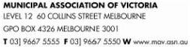

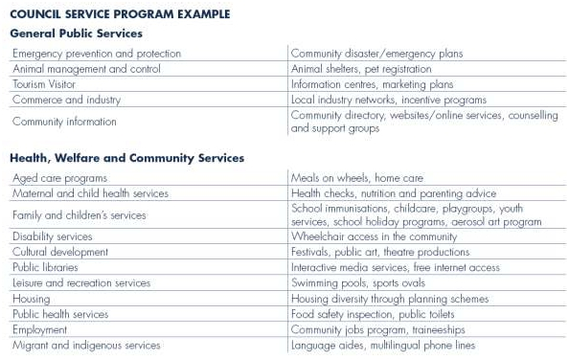

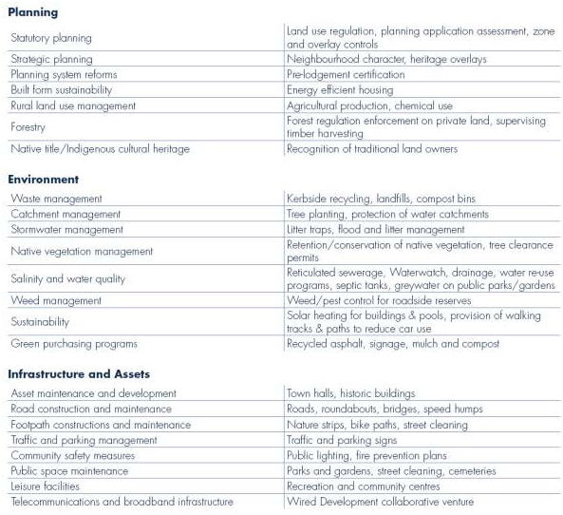

COUNCIL RATING BASES

Each Victorian council chooses one of three valuation bases for their municipality - Capital Improved
Value (CIV), Site Value (SV), or Net Annual Value (NAV).

The common process for calculating each of the three valuation bases is as follows:

Every two years council valuers have a statutory requirement to conduct a review of property
values based on market movements and recent sales trends
The last revaluation is based on levels as at 1 January 2010
Council valuers undertake a physical inspection of a sample of properties
The total value of property in a municipality is used as the base against which that council strikes
its rate in the dollar
The rate in the dollar is multiplied by the CIV, SV or NAV value of the property to determine the
general rates due on each property
The Valuer General is responsible for reviewing the total valuation of each municipality for
accuracy before he certifies that the valuations are true and correct.

Capital Improved Value

CIV refers to the total market value of the land plus the improved value of the property
including the house, other buildings and landscaping

Site Value

SV refers to the unimproved market value of the land

Net Annual Value

NAV is the annual rental a property would render, less the landlord’s outgoings (such as insurance,
land tax and maintenance costs) or 5 per cent of the CIV for residential properties and farms
The value is higher for commercial/industrial and investment properties.

