Appendix 1 - Contract and Supplier Management Plan
1.1 Contract Summary

Contract Name
Start and Finish Dates
Contract Value

1.2 Owners / Key Representatives

Nominated contact | Role | Responsibility
 | Procurement
 | Contract Manager
Supplier details

1.3 Level of Management required
Use the Contract and Supplier Management Assessment tool to determine whether the level of management required for the contract and supplier should be HIGH / MEDIUM / LOW. The assessment considers the potential impact on business based on criticality, dependency and the number of expected customers.

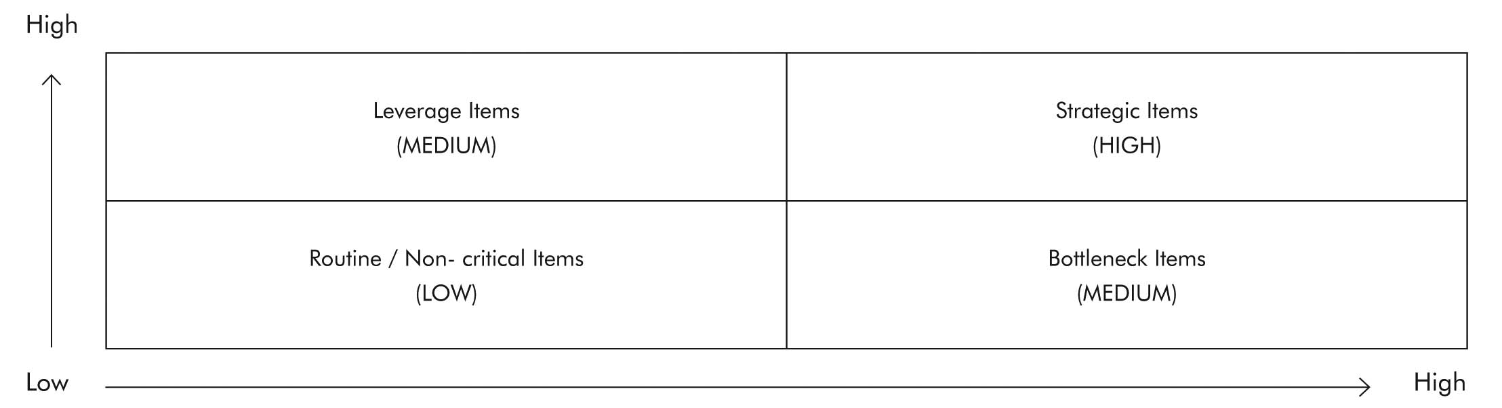

  - Contract Objectives

  - Risk Assessment
Risk Ref. | Risk | Consequence | Likelihood | Risk Mitigation Action | Responsible | Date

  - Performance Management Framework – KPIs and SLAs

  - Mobilisation Plan

  - Variations Process

  - Contract Compliance

  - Escalation Process

  - Exit Plan

  - Review Meetings
Proposed dates | Actual Dates

Appendix 2 - Contract and Supplier Management Plan
This checklist is intended as a guide for all Contract Managers however some contracts will not warrant all steps to be applied. The checklist must be read in conjunction with the Contract Management Guidelines. Should there be any queries contact the Procurement Department for further advice.
Contract Name:  Contract No:  Contract Manager: | Legend:  CM Contract Manager  PD Procurement Department  RM Risk Management Department  Con Contractor

Pre-Commencement Stage
Actions | Who | Completed  Yes No | Date Completed | Comment
1. Contract Documents
Prepare and send letter of acceptance | PD
Prepare contract documents and arrange signing and sealing | PD
Arrange for contract files | PD
Develop appropriate administration files | CM
Read and understand both specification and terms and conditions of contract | CM
2. Transition Plan
Implement transition plan by convening a  meeting with incoming and outgoing contractors to discuss roles and responsibilities | CM
Prioritise all transition activities and confirm  timeframes and milestones with all parties | CM
Involve and communicate with all relevant  parties as per nominated transition activities | CM
3. Contract Management Plan [CMP]
Prepare CMP, sign off and file | CM
4. Insurance
Obtain all required Insurance Certificates of  Currency as per tender document | PD
5. Security / Retention
Obtain undated Irrevocable Bank Guarantees for amounts as per tender document
Confirm retention amounts and set up in
payment schedules

Actions | Who | Completed  Yes No | Date Completed | Comment
6. Key Performance Indicators [KPIs]
Read contract for requirements | CM
Develop auditing system using KPI’s and  measuring matrix | CM
Ensure staff are familiar with system and  auditing process | CM
Forward copy of proposed auditing system to Contractor | CM
7. Risk Assessment and OH&S Plan
Obtain copies of Contractor’s Risk Management & OH&S Plans | CM
Consult with OHS dept. re audit process for Contractor OH&S | CM/RM
Set OH&S audit process and ensure staff are familiar with process | CM/RM
Develop OH&S audit template | CM/RM
Use risk management system to develop a contingency plan based on nominated and other risks | CM/RM
8. Contract Meeting
Facilitate a contract management meeting to discuss all pre-commencement requirements | CM/ Con
Document all agreed outcomes of the contract management meeting | CM/ Con
Determine the agenda and frequency for future meetings in consultation with contractor | CM/Con
Ensure that the contractor has the appropriate specifications/drawings e.g. correct versions etc. | CM/Con
9. Induction Program
Conduct an induction program in association with contractor | CM/Con
Arrange with Finance and Risk Management to be included in Induction process. | CM/Con

Post Contract Commencement Stage
Actions | Who | Completed  Yes No | Date Completed | Comment
1. Audit Contractor OH&S Compliance
Undertake an OH&S compliance audit of contractor | CM
Forward copy of audit results to Contractor and record any non-conformances | CM
Notify Risk Dept. of any breaches and determine appropriate actions | CM / RM
Meet with contractor to discuss non-conformances and agree on remedial actions | CM / RM
Prepare agenda and forward invitation and agenda to contractor | CM
Record minutes of meetings including any subsequent actions to be carried by either party | CM
Forward copy of minutes of meeting to contractor | CM
2. Contract Meetings
Prepare agenda and forward invitation and agenda to contractor | CM
Record minutes of meetings including any subsequent actions to be carried by either party | CM
Forward copy of minutes of meeting to contractor | CM
3. Payment Claims
Upon receipt of claims ensure that works completed are in accordance with claims. | CM
For construction works – ensure that you comply with the requirements of the Building & Construction Security of Payments Act 2002 | CM
Ensure that payments are made in accordance with Finance Dept. procedures | CM

Actions | Who | Completed  Yes No | Date Completed | Comment
4. Performance Auditing
Conduct regular contractor performance audits in accordance with specification | CM
Record audit results and provide a copy to contractor | CM
As an agenda item for Contract Meetings discuss outcomes and how any under-performances may be improved | CM
Conduct annual review of nominated KPI’s with Contractor to ensure continued relevance to delivery of services including any changes to scope etc | CM/Con
5. Contract Extensions
With service contracts, be aware of nominated notification periods to contractor as to Council’s intentions to extend or not. | CM
Collate all audit outcomes and generate a report on overall performance with extension options and recommendation for consideration by appropriately authorised manager | CM
Notify contractor in writing of Council’s intention regarding extension | CM
Engage the contractor to discuss any variations either party may seek for additions/reductions to service delivery | CM
Undertake a final contract review with incumbent contractor and key stakeholders to recognise any opportunities for future improvement | CM
Record all minutes of the meeting and provide contractor with copy. | CM
If option to extend is awarded revise and amend Pricing Schedule/s to reflect any variations that have been imposed on extension of contract | CM
Get sign off of amendments by appropriately authorised senior manager. | CM
Notify relevant departments [e.g. Procurement, Finance] of expenditure changes | CM
Notify contractor in writing of providing updated copy of revised Pricing Schedules | CM

Actions | Who | Completed  Yes No | Date Completed | Comment
6. Contract Expiry/Transition Out
Develop transition out plan in conjunction with contractor | CM/Con
Conduct contract meeting to consolidate actions, responsibilities and timeframes | CM/Con
Engage incumbent contractor in any relevant transition meetings with new contractor | CM/Con
Take receipt of all intellectual knowledge belonging to Council | CM/Con
Conduct exit audit with outgoing and incoming contractors to identify outstanding work and overall standard of relevant assets | CM/Con
Carry out de-briefing meeting to determine positive and negative aspects of services/works. This meeting should include contract management staff, procurement, contractor and other stakeholders | CM/PD/ Con
Negotiate any final payments based on incomplete or sub-standard works | CM/Con
Make arrangements for any Securities to be returned to outgoing contractor | CM/Con
Pay out security at Practical Completion based on specified percentages as per contract | CM
Return remaining securities upon completion of defects liability period | CM

Appendix 3 - Contract Variation Form
Contract No
Contract Title
Contractor
Superintendent

Variation number: |  | Date: / /
Description of proposed variation and reason:

Will the variation be at an additional cost to original contract amount? | Yes |  | No
If yes – date quotation for variation is to be received by:
Contractor’s Response

Description of variation

Costings: *Remove whichever does not apply
Original contract value | $
*Time/*Works Variation cost | $
Other variation adjustments to cost | $
Revised contract Value | $
Contract Dates:
Original Practical Completion | / /
Additional time required due to variation | / /
Other variation adjustments to time | / /
New Date of Practical Completion | / /
Signed on behalf of the Contractor:

Date

Council Response | Yes | No
Purchase Order No:
(Contractor to quote P/O and Variation numbers on tax invoice)
Is the variation within budget?
If not, then proceed to appropriate Manager for approval.
Does the variation substantially change the original scope of the contract?
If Yes, a new procurement process is required
Is there a change in the risk of the contract as a consequence of the variation?
If so alter any risk management plans in place.
Approval:  (As per Financial Delegation Authority) | Date
Manager | / /
Procurement/Manager: | / /
Group Manager / CEO: | / /

