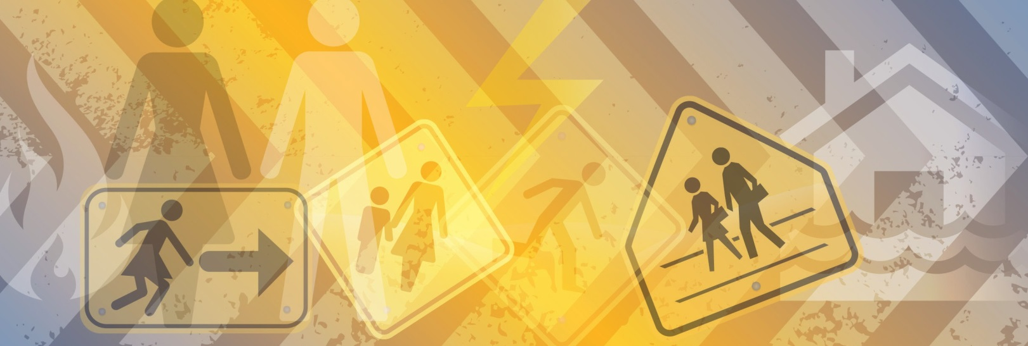
Flood Preparation: Gender & Decision Making Case study

Faye is married to John and they have three children aged between 3 and 13 years. When the SES doorknocked at her home, Faye learnt that her house lies within a flood zone and there is a high risk that her home could be inundated in a storm. The SES explained to Faye that there are a number of specific actions that she can take to reduce the consequence of flooding to her family property. These included getting flood insurance for the property and securing gas cylinders and other large items in the backyard.
When Faye discussed the flood risk and mitigation options with her husband, she was met with resistance. John argued that the SES were scaremongering: he considered the flood risk to be low despite the local flood information material left with Faye by the SES. John told Faye that they could not afford the insurance and that he was too busy to secure the large items in the backyard.
Faye believes that the flood risk is real. She wants to take action but doesn’t have access to funds and doesn’t have her husband’s approval.
How can women with little decision-making power within their household be empowered to make choices and implement decisions to improve emergency preparedness without creating domestic and personal conflict?

Research tells us
- Women and men perceive risk differently¹.
- Men often make decisions relating to risk without the necessary knowledge or capacity2.
- Decision making with respect to emergencies lies predominately with the men in the home³.

- On average women earn less than men and have less economic resources than men⁴.
- Flood insurance can be prohibitively expensive for low-income families⁵.
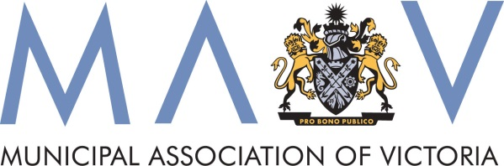
- Advice provided by emergency services is not always gender sensitive or supported with tools to take action⁶.

Flood Preparation: Gender & Decision Making

Case study

Action local government can take
- Partner with agencies such as SES and develop new activities or alter existing programs to ensure they are gender sensitive and more inclusive of women and children.
- Women-specific planning and preparation for disasters. There are a number of tools available including:
  - Women Gathering Toolkit (http://www.whealth.com.au/publications_resources.html)
  - Weathering the Storm (http://www.nrwc.com.au/Projects/WeatherTheStorm)
  - Through Women’s Eyes process (http://www.whealth.com.au/).
- Promote SES storm kits – through everyday services such as positive aging ambassadors, HACC services, libraries, schools and childcare.
- Work with neighbourhood houses and men’s sheds to improve communications and community engagement.
- Look at incorporating gender and children into the Municipal Emergency Management Plan.

Resources available
- The Gender and disaster pod website (www.genderanddisaster.com.au/)
- Neighbourhood Houses think big (www.emv.vic.gov.au/our-work/neighbourhood-houses-think-big/)

¹ AJEM Volume 28 Number Two, April 2013- Gender edition (www.em.gov.au/ajem)
² Eriksen, C. (2014) Gender and Wildfire: Landscapes of Uncertainty. New York: Routledge
³ ibid
⁴ Australian Bureau of Statistics, 4125.0 - Gender Indicators, Australia, Feb 2014
⁵ VCOSS, Disaster and disadvantage: Social vulnerability in emergency management (http://vcoss.org.au/documents/2014/06/VCOSS_Disadvantage-and-disaster_2014.pdf)
⁶ Bushfire CRC Fire Note 101, Gender and Bushfire (www.bushfirecrc.com/resources/firenote/gender-and-bushfire) and Gender mainstreaming in emergency management: a training module for emergency planners, Elaine Enarson, 2009
