|  |  |  |
| --- | --- | --- |
| **SILO ART TRAILYarriambiack Shire Council** | | |
| The Silo Art Trail began in 2015 as a community project by the Brim Active Community Group and artist Guido van Helten. The entire trail stretches over 200 kilometres linking Brim with neighbouring towns Lascelles, Patchewollock, Rosebery, Rupanyup and Sheep Hills.  As a tribute to the spirit of the Wimmera Mallee, the trail celebrates the region’s history through large-scale mural portraits painted onto grain silos – many of which date back to the 1930s.  A team of renowned artists from Australia and across the world visited the region, met with the local community and transformed each grain silo into an iconic work of art – with each piece telling a unique story about the host town and its residents.  The bees will be housed using innovative Flow Hive technology which allow the honey to be harvested just by turning on a tap with minimal disturbance to the bees.  The Silo Art Trail is Australia’s largest outdoor gallery, stretching over 200 kilometres.  It was established as a partnership between Yarriambiack Shire Council, international street art agency  Juddy Roller, the Victorian Government, Australian Government and GrainCorp who donated the silos. |  |  |

The project began with Juddy Roller Studios and artist Guido van Helten approaching the local community and Council to pitch the idea of creating public works that could provide benefits to the drought-afflicted region. The State and Federal governments contributed $200,000 each into this venture, with $50,000 each from Council and Grain Corp.

Historically, silos were a way for farming communities to come together during harvest and reconnect with old friends while unloading grain. Recent changes in the agricultural industry have led to many communities losing active silo sites.

The trail has provided an opportunity to reinvigorate decommissioned sites and celebrate local communities, Indigenous culture and farming history.

**Find out more about Vic Councils  
viccouncils.asn.au**

**For more information on this project:**  
If you’d like to know more about the silo art trail and the shire, please refer to the [Facebook page](https://www.facebook.com/siloarttrail/), or you can also [email](mailto:siloarttrail@gmail.com) or phone Yarriambiack Shire Council in Warracknabeal on (03) 5398 0100.

The Silo Art Trail was conceived in 2016 after the success of the first silo artwork in Brim.   
It has received widespread local and international media coverage, while also raising awareness of the Wimmera and Mallee region’s history and investments in tourism for the drought-afflicted local community.

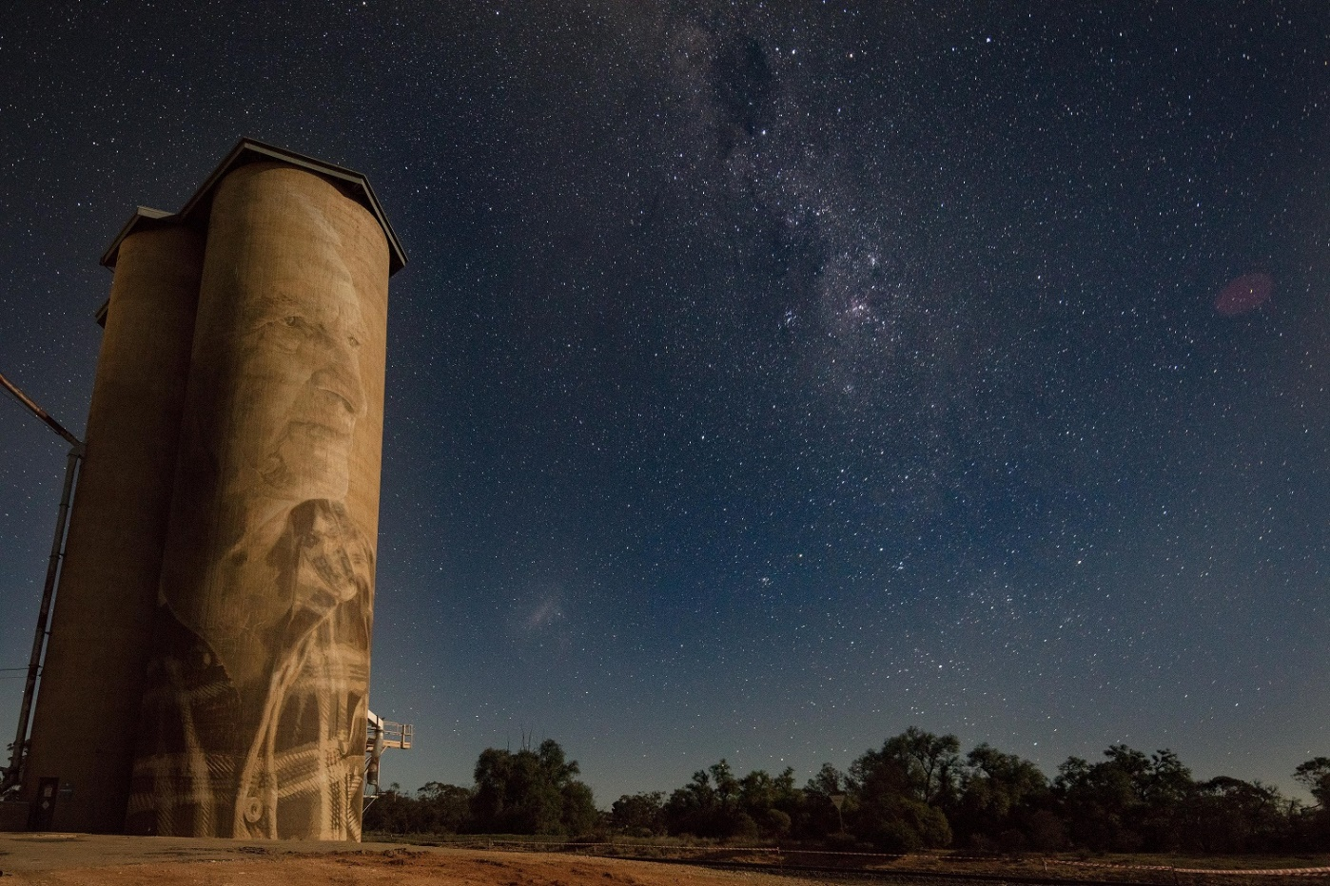

To travel the entire 200-kilometre Silo Art Trail from one end (Julia Volchkova’s Rupanyup) to the other (Fintan Magee’s Patchewollock), it should take a little over two hours. Visitors are recommended to stay the night in one of the neighbouring towns and to organise their stay in advance, as it may be hard to find accommodation late at night. [Visit the website](http://siloarttrail.com/) for more.