Future of Local Government

Council plan good practice guide

DOCUMENT CONTROL
CT Management Group P/L  PO Box 1374  GEELONG VIC 3220  Mobile: 0418 107 304  Email: admin@ctman.com.au  Web: www.ctman.com.au | Document: Council Plan Good Practice Guide October 2016
 | Project Manager: Michael Courtney
 | Author: Michael Courtney
 | Date: October 2016
 | Synopsis: A document to assist Council staff to prepare their 2017/2021
CONSULTANTS DISTRIBUTION SCHEDULE
Version No. | Date | Distribution | Reference
1 | 10/11/16 | Municipal Association of Victoria | JH
SCHEDULE OF ADOPTION
Version No. | Date | Comment | Reference
© CT Management Group Pty Ltd 2016
Except as provided by the Copyright Act 1968, no part of this publication may be reproduced, stored in a retrieval system or transmitted in any form or by any means without the prior written permission of the publisher.
Disclaimer and Information Statement
This report is issued by the CT Management Group Pty Ltd and the information in this report is current as at the date of publication. The information and/or the recommendations contained in this report have been compiled and based on the information, records, data and any other sources of information supplied by you. Accordingly, the accuracy of the information and/or recommendations in this report relies entirely upon the information and material supplied by you. Whilst we have exercised all due care and skill in compiling the report, you should confirm the accuracy and reliability of the information and material we have relied upon in producing the report.

The information contained in this report is confidential and you should only read, disclose, re-transmit, copy, distribute or act in reliance on the information if you are authorised to do so. This report may also contain information, systems or data which is the property of the CT Management Group Pty Ltd. In these circumstances, the property referred to will remain the property of CT Management Group Pty Ltd and the CT Management Group Pty Ltd has in no way waived or altered in any way its ownership rights, or provided consent for use by the report recipient, unless expressly provided in the report.

Contents
1. INTRODUCTION 4
2. WHAT IS A COUNCIL PLAN? 4
3. THE ROLE OF THE COUNCIL PLAN 5
4. HOW DOES THE COUNCIL PLAN FIT WITH OTHER PLANNING DOCUMENTS? 6
5. THE STRUCTURE OF A COUNCIL PLAN 6
5.1 Executive Summary 7
5.2 Introduction 7
5.2.1 Council Vision 7
5.2.2 Council Purpose and Values 8
5.3 Background Information 8
5.4 Discussion of challenges and opportunities facing the Council 8
5.4.1 External (Global/Societal) Issues 8
5.4.2 Internal (Community Well‐Being) Issues 9
5.5 Council Plan Fit 9
5.6 Strategic Section 10
5.6.1 Grouping of issues by themes 10
5.6.2 Objectives 10
5.6.3 Strategies 10
5.6.4 Key Priority Activities 10
5.6.5 Strategic Performance Indicators and Targets 10
5.6.6 Supporting Strategic Plans 11
6. COUNCIL PLAN DEVELOPMENT PRINCIPLES 11
7. KEY LINKAGE 12
8. EMERGING ISSUES 13
9. Conclusion 13
10. ANNEXURES 14
10.1 Annexure A - Example of Typical Performance Measures 14
10.2 Annexure B - Glossary of Terms 15
10.3 Resources 17

INTRODUCTION
An incoming Council inherits the prior Council’s legacy as well as other longer term strategic projects.
The initial months of a new Councillor’s term are spent experiencing the induction, meeting and understanding fellow Councillors and communicating his/her own priorities.
The Council team must, within 8 months of being elected, develop a Council Plan that reflects their priorities and vision for the community. An early challenge for Councillors is to seek agreement as to the priorities for their Council Plan over the coming four years.

WHAT IS A COUNCIL PLAN?
Each council is required to prepare and adopt a Council Plan by 30 June in the year following a general election (general elections are currently conducted in November every four years). In some cases the Minister for Local Government may extend the period within which a council may adopt its Council Plan.
(2) A Council Plan must include—
(a) the strategic objectives of the Council;
(b) strategies for achieving the objectives for at least the next 4 years;
(c) strategic indicators for monitoring the achievement of the objectives;
(d) a Strategic Resource Plan containing the matters specified in section 126;
(e) any other matters which are prescribed by the regulations.

Source: s 125 (1) LG Act 1989
Before adopting its Council Plan, a council must give public notice of its intention to adopt the plan and invite public submissions. Members of the public may make written submissions within 28 days of the notice and, if they so desire, request to be heard in support of their submission.
A council may review and update its Council Plan at any time, following the same process as for the original plan. At least once every year a council must consider whether the Council Plan requires any adjustment in respect to the remaining period of the plan. If a Council Plan is to be adjusted, the adjustments must also be subject to the public consultation process.

Source: s 125 (3A) LG Act 1989
The most recent planning and reporting requirements were introduced as part of the Local Government Amendment (Performance Reporting and Accountability) Act 2014. This includes a requirement for Councils to undertake annual mandatory performance reporting and to ensure their Strategic Resource Plans take into account all resources to implement any plan a Council formally adopts.

THE ROLE OF THE COUNCIL PLAN
According to the Future of Local Government Program, a Council Plan should be a strategic document reflecting where the Council (and community) wants to be in 2020/21 in the context of longer term planning (eg. 10 year LTP) and how it will achieve those outcomes
The Council Plan is a ‘Peak’ Plan for Council that clearly identifies what the Council is planning to achieve in the next 4 years as part of longer term journey)

Figure 1: Role of Council Plan

HOW DOES THE COUNCIL PLAN FIT WITH OTHER PLANNING DOCUMENTS?
The Council Plan is a medium term planning document. It is informed by long term documents such Community Plans and Council vision statements and service strategies that may have been developed within Council or regionally (e.g. Regional Waste Strategy). It then informs short term planning document such as the annual budget and department business plans.

Figure 2: Integrated Planning Framework

THE STRUCTURE OF A COUNCIL PLAN
The structure of the Council Plan is really up to the preferences of the individual Council. Some Councils may wish to keep it brief, with supporting documents to supplement it.
Others might want a “one stop shop” and have a single document to encapsulate the vision, the strategy and the action plan.
Whichever way Council decide to go, there are a number of elements that are critical to the readability and transparency of your Council Plan. A sample format is shown below.
Council Plan
Executive Summary
Introduction
Council Vision
Purpose
Values

Background information
Where are we – description of location
Our community – some general details about the community
Who we are – Key decision makers of the Council – Councillors & Executive team
What we are – Brief details about the organisation
What we do – Brief summary of what the Council does
Discussion of challenges and opportunities facing the Council
Where the Council Plan fits within the Council’s Integrated Planning Framework.
Strategic Section (grouped by Themes/Pillars/Key Directions)
Themes /Pillars /Key Directions
  - Objectives/Aims of the Theme
Key Strategies to achieve the objectives
Four year Key Priority Actions (High Level)
Performance Indictors/Targets
    - Output Indicators
    - Outcome indicators
Supporting Strategic Plans
Strategic Resource Plan
The Strategic Resource Plan (SRP) forms part of a Council Plan and must be adopted no later than 30 June each year. The SRP outlines the financial and non financial resources that Council requires to achieve the strategic objectives described in the Council Plan. It must also take into account the resources required to deliver services and initiatives outlined in any other plan adopted by Council.
Council must have an SRP that covers at least the next four years so this makes it a rolling plan that must be undated every 4 years. The MAV program ensures alignment of the Council Plan to the SRP.
A summary of each section is detailed below.

Executive Summary
This may be all that some people read of the document so it should concisely summarise:
The unique aspects of the community
The long term vision for the Council vs current reality
The major challenges & opportunities being faced (identify priorities)
How is the Council planning to respond to close the ‘gaps’?
Will it be business as usual or how will Council implement strategic change?

Introduction

Council Vision
The Council vision is a statement of the “future state” for the municipality. It should not be confused with the Community Plan but should clearly relate to it.
The vision may be a short, memorable phrase e.g. “The most liveable city” or it might be a “pen portrait” picture of how life might be in the municipality in the future. It is recommended to keep this down to a maximum of 1 – 2 paragraphs.

Council Purpose and Values
Statements of the purpose of Council and its Corporate Values

Background Information
The Council Plan is not the annual report and should not dwell on recent Council activities. However, in order to set the scene it is useful to provide a brief description of the profile of the municipality and highlight any unique features such key industries, geographic constraints or demographic abnormalities.
This section may also include an overview of the Mayor, Councillors, Senior Leadership Team and the role of the Council.

Discussion of challenges and opportunities facing the Council
Having set the scene, it is appropriate to present the challenges and opportunities facing the Council, now and into the future. These might be issues that are challenging all councils such as financial sustainability, impact of rate capping, service planning or online service delivery or they may be specific to the region such as local job losses or water management issues.

External (Global/Societal) Issues
External influences are impacting on Local Governments capacity to deliver services in an ongoing sustainable manner. The Council Plan should be developed recognizing these influences. Some of the external influences which may affect your Council include:
Demographic changes – Ageing population, Gen X, Y …,
Environment challenges ‐ Low carbon future, peak oil, climate change, ‘green’ focus
Changing community and social expectations
The community wanting more control or influence over decisions made by Council
Skills replacement & knowledge retention challenges associated with an aging workforce or remote locations.
Community demands for higher levels of service and infrastructure improvements
Staying abreast of the rate of change (Communications, transport, legislative, etc)
Tighter public sector funding in the future
Pressure on Councils to retain their identity and independence
Cost shifting by other levels of government
$2.3 billion unfunded community infrastructure gap
Future superannuation liabilities
Criticism from external agencies (such as VAGO) regarding poor performance reporting
Impacts of rate capping on capacity to provide services or manage assets.

Internal (Community Well‐Being) Issues
The community and the Council will have expectations in relation to outcomes they want to achieve. As a result of the elections, new Councillors may have a platform to achieve certain outcomes, there will also be legacy issues that remain outstanding from the previous Council, as well as ongoing programs that will need to be delivered.
Where they have a significant impact on the development of the Council Plan they should be discussed and key issues identified.

Council Plan Fit
It is important to clearly articulate where the Council Plan fits in Council’s integrated planning framework. This shows the status of the Plan to the reader and provides the linkages and connections to other Council strategies and documents. An example of an Integrated Planning Framework at a high level:

Figure 3: Integrated Planning Framework – High Level

Strategic Section

Grouping of issues by themes
Given the enormous range of responsibilities of local government it is necessary to break the document down into chapters or “themes”. These might reflect:

The Directorates of the Councils
    - Sustainability, Community Development, Assets, Governance, etc
Community or services focused to reflect the key strategic objectives of the vision
    - Healthier communities, Accessibility, Sustainability, Leadership, Economic Development, etc.
The number of themes is dependent upon the Council. Experience indicates that there can be as few as four or as many as ten.
Whatever themes or headings the Council chooses to use there will need to be one that deals with “how the Council conducts its business” or Corporate Governance. This will pick up internal issues of development of social media, regional collaboration, online service delivery and innovative financial strategies.

Objectives
Each theme should have one clear strategic objective describing the future outcome Council seeks in that area.

Strategies
As Themes or Pillars cover a range of Council activities it is appropriate to list a number of strategies under each Theme area of the Council Plan. These will be high level but give a clear indication of how Council plans to achieve its objective.
Objectives describe the future, Strategies describe how it will be achieved.

Key Priority Activities
Under each theme Council will identify a number of Key Priority Activities which will be in addition to business as usual and will most contribute to the achievement of the Objective.
Some Councils identify one year priority activities which are reviewed each year of the 4 year Council Plan whilst other Councils identify Key Priority Activities which may cover the full 4 years of the Plan. Either are acceptable.

Strategic Performance Indicators and Targets
Performance Indicators included in the Council Plan should be framed to monitoring progress towards achieving Council’s Objectives and Strategic Outcomes.
Council should consider incorporating two types of performance indicators into each themed area which can be used to monitor progress against the achievement of the objective.

Output Indicators
Output indicators show the results of the program inputs. Indicators published in the Council
Plan should be predominantly output indicators.

Outcome Indicators
Outcome indicators show progress towards achieving the objective

Targets
A target is a pre‐determined set level of performance which the Council wishes to achieve during the period of the Plan. It is good practice to explain the logic of the target.

Supporting Strategic Plans
A summary of the Strategies and Plans which were used as supporting information during the development of the Council Plan should be referenced in the Plan

COUNCIL PLAN DEVELOPMENT PRINCIPLES
When preparing the Council Plan it is important to keep in mind some key considerations. It is the Peak Plan for Council so it should clearly identify:
  - What the Council is planning to achieve in the next 4 years and beyond including defining the outcomes
  - How the Council will takes into account the community priorities
  - The linkages between the Council Plan and other key plans of Council such as the Municipal Public Health Plan, Strategic Resource Plan, Long Term Financial Plan, Budget and Strategic Service Plans as well as community planning and regional input
  - Key priorities for the Council to address in the next four years (including financial sustainability and organisational capacity)
  - How the Council will deliver better services to the community
  - How will Council do more with less (productivity)
  - What innovations are proposed
  - How performance will be measured
In drafting the Council Plan keep in consideration that it:
  - Is a Plan for the future
  - States Councils strategic response to identified challenges and priorities
  - Should reflect the leadership and change management roles of Councils
  - Provides direction for Council decisions
  - Communicates to the community and accountability for performance is evident
  - Should be achievable
  - Should have measurable outcomes – see Annexure A for KPI examples
  - Does not adversely impact on the Councils long term sustainability
Annexure B has a glossary of terms for reference.

KEY LINKAGE
In developing the Council Plan it is important to ensure that all Activities are costed and included in the Long Term Financial Plan. Council needs to understand the financial impact of commitments it makes when drafting the Council Plan and how they affect Councils long term financial sustainability.
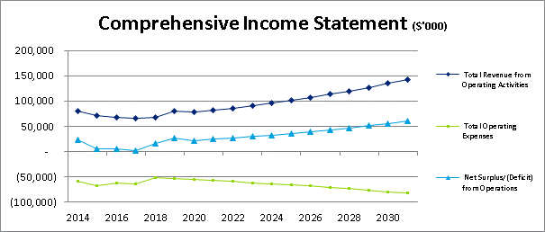 | 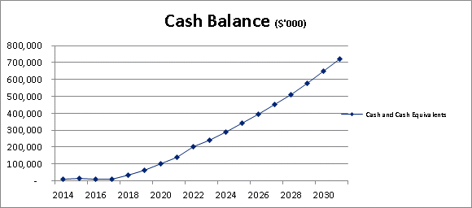
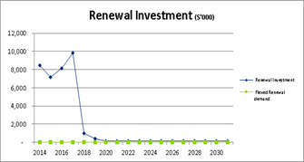 | 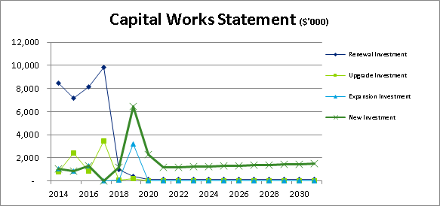
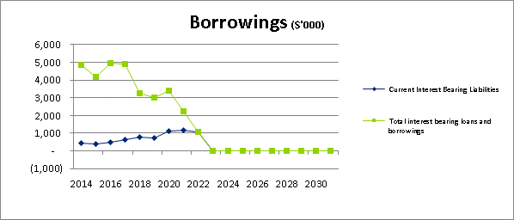 | 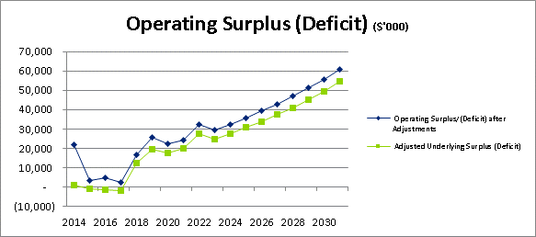
Chart 1: Extract of Long Term Financial Plan

EMERGING ISSUES
With the consultation underway with the new Local Government Act, it is appropriate for Council to consider potential and proposed legislative requirement that may emerge prior to 2021.
Many Victorian Councils have developed Community Plans and long term financial plans that provide a 10 year outlook.
Much of Council’s infrastructure has lives beyond 60 years so a longer term financial outlook is more appropriate in terms of managing that infrastructure.
Councils that develop long term community plans believe there is improved alignment between medium term objectives of the elected Council and the long term vision and aspirations of its community.
The Australian Centre of Excellence (ACLEG) in a comparative study between jurisdictions, found that most jurisdictions require Councils to have integrated 10 year financial plans. As Councils move into a more stringent rating environment, long term financial sustainability and delivery programs that detail the services that are affordable over the long term will be a key focus. A plan that projects 4 years may be insufficient to assess long term financial sustainability.
Councils may therefore be required post the proclamation of the new Local Government Act develop:
Workforce Plan - providing the community with information about how the Council Plan manages issues such as ageing workforce, skills shortages and competition.
Asset Management Plans – Allowing Council to properly engage with the local community on the long term and cumulative effects of future infrastructure commitments.
Service Delivery Plan – Detailing the services to be undertaken by the Council to implement the strategies established by the Council Plan within the resources available.
It may be prudent professional practice to incorporate some of these requirements in the 2017-2021 Council Plan preparation.

The MAV STEP Program and other initiatives can assist Councils with these emerging issues.

Conclusion
The Council Plan Goud Practice Guide provides a structural process towards the development of the 2017-2021 Council Plan.
Councils are able to utilise the guide to assist them with their Council Plan deliberations.

ANNEXURES

Annexure A - Example of Typical Performance Measures
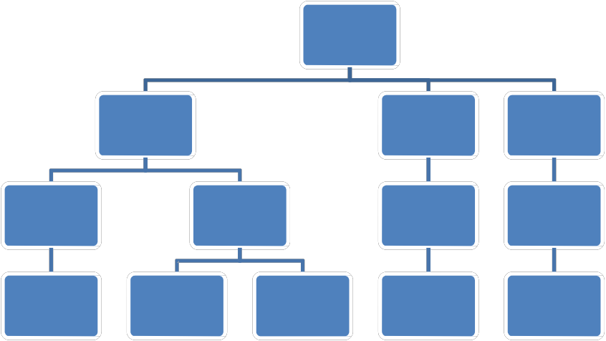

Strategic Objective

Key Strategic Activities

Performance measures
(KPIs highlighted)

Targets

Example
Aim: A Healthier Community
Objective: To increase participation in active transport
Key performance Indicator: % of population travelling to work by active means (walking or cycling) based on DPCD travel to work data
Target: Increase from 10%in 2011 to 15% by 2016 (in line with Victorian average)
Supporting Indicators:
km of off road cycle network
Implement cycle priority measures at intersections (as identified in cycle strategy)
Implement awareness campaign
Install cycle facilities at Council HQ
When setting Key Performance Indicators consider the following:
What data is easily available and will can be collected repeatedly?
Are you measuring something that the Council can directly influence?
How often is data available (quarterly, annually, every 5 years (census) When setting Targets consider the following:
Are there any legislative requirements?
What are other Council’s achieving in this area?
If you do nothing what will the results be?
Do you want to maintain your position or make a “step change”?

Annexure B - Glossary of Terms

Term | Definition | Ref. in Local Government
Vision | Describes the desired “future state” for the community or municipality. | None
Mission | The purpose of the Council – ie. What you do, why and how
Values | What values does the council hold and wish to model in the community e.g. Honesty, Respect, Fair Go
Themes | Sometimes called Pillars or Key Directions. Used to focus a Councils strategic planning into common subject matter and are usually a few Key words followed by a short statement of explanation. The number of themes are determine by Council but can range from 5‐9 areas e.g. Environmental Sustainability, Health and Welfare, Economic Growth, Art and Culture.
Strategic Objectives | Statement of outcomes that are to be achieved over the life of the Council Plan. There may be multiple Strategic Objectives for each Theme. These are sometimes referred to as Aims. | S3C  S75A, S125(2)(a) S127(2) (c)
Key Strategies | Key Frameworks or documents that have, or will be, developed to articulate what steps will be taken to achieve the objectives.  e.g. Bicycle and Walking Network Strategy | S125(2)(b)
Key Strategic Activity | Key Priority Activities which are in addition to “business as usual” which will most contribute to the achievement of the Strategic Objective. They may have a duration which extends for the life of the Council Plan or may be shorter in duration. | S127(2)(d) S132 (2) (a)
Action Plan | A Secondary document that clearly identifies actions or tasks to be undertaken by a named individual or team. This is a useful location to capture operational items and Councillor/community requests that emerge during the Council Plan development process. Targets should be set for delivery.
Input | A resource or action utilised to conduct and activity. e.g. finance, staff or asset that is supplied in order to deliver a service.
Output | The tangible product of service delivery e.g. A planning decision.
Outcome | The impact of the delivery of service e.g. Reduction of litter on verges. | S3C S208E(2)
Strategic indicators | Must appear in Council Plan. Also known as Key Performance Indicator –Highest level of Performance Indicators. | S125(2)(c)
Targets | Pre‐determined level for a Performance Indictor. The reason for setting a certain target level should be recorded. | S127(2)(d)
Strategic Resource Plan | Four year rolling financial and non financial resource plan. | S126
Measures/ Performance Indicators | What you will measure or monitor to ensure that the objective has been achieved. May be qualitative or quantitative. | S127(2)(d)

Resources

Victorian Local Government

There are many examples of good Council Plan documents available from Council web sites. Council officers could cross reference Council Plans with the recommended content contained within this document to gather examples of structure and content.

Victoria State Government

Department of Planning and Community Development – Local Government Victoria – Measuring Up: Linking Planning and Performance
Department of Planning and Community Development – Local Government Victoria – Planning Together: Lesson from Local Government Community Planning in Victoria
http://www.dpcd.vic.gov.au/localgovernment/publications‐and‐research/community‐strengthening
Victorian Auditor Generals Office – Performance Reporting by Local Government, April 2012 ‐
http://www.audit.vic.gov.au/reports_and_publications/latest_reports/reports_by_year‐
_2011‐12.aspx
Review of the Local Government Act 1989
http://www.yourcouncilyourcommunity.vic.gov.au/

Western Australia

Department of Local Government – Integrated Planning and Reporting ‐
http://www.dlg.wa.gov.au/Search.aspx?usterms=community%20plans

Queensland

Department of Infrastructure and Planning – Community Planning by Local Governments in Queensland http://www.google.com.au/url?sa=t&rct=j&q=queensland%20local%20government%20com munity%20plan&source=web&cd=1&ved=0CB8QFjAA&url=http%3A%2F%2Fwww.dlgp.qld.g ov.au%2Fresources%2Fguideline%2Flocal‐government%2Fcommunity‐planning‐ guide.pdf&ei=6h2sULi0Cq_PmAWc6YDYDg&usg=AFQjCNFxu25wqUtpIs0ShfP06o‐xjqFyrQ

