Councils under pressure to increase rates

1 July 2006

Data released today by the Municipal Association of Victoria (MAV) shows council rates will increase
an average 6.3% across Victoria, as budgets face a mounting combination of cost pressures.

MAV President, Cr Geoff Lake said local government revenue in Victoria is set to increase by 4.5%
to $4.7 billion in the year ahead, while rates are increasing at a faster pace.

“A range of external costs and inadequate funding arrangements have forced many councils to
make difficult decisions to meet the challenge of balancing responsible financial management with
community needs and expectations.

“In particular, the total proportion of financial contributions from other levels of government has
failed to keep pace with local government costs. This has severely undermined the budgetary
position of councils and forced rates up.

“As a result, a greater proportion of councils’ total revenue is now being generated from rates,
increasing from an average of 51% in 2004 to 55% this year.

“In addition, Victorian councils are facing an annual shortfall of $310 million to repair and maintain
ageing infrastructure such as roads, bridges, footpaths, town halls, recreation facilities, swimming
pools and drains,” he said.

Cr Lake believes sustainable funding streams from other levels of government must be addressed
as a matter of priority at the highest level.

“Of the total tax revenue collected by all levels of government, councils collect only three per cent.

“Communities cannot be expected to withstand the kind of rate increases that would be needed to
continue servicing the expanding range of functions now expected of local government.

“It is time for financial assistance grants from the Commonwealth to increase and other
government funding programs to keep pace with the real cost of delivering services.

“Until this happens, councils are faced with few options and will be forced to continue their reliance
on rate revenue to meet ongoing community needs,” Cr Lake concluded.

Note: 2006 is a biennial property revaluation year. New property valuations affect how much each
property owner contributes towards the rates, but not the total amount collected in rates by a council.

- Ends -
Further information contact MAV President Geoff Lake on 0411 645 281 or MAV Communications
on (03) 9667 5521/0414 396 097.

2006-07 council budget and rates data is on the hotlist of the MAV home page: www.mav.asn.au

Municipal Association of Victoria
Level 12, 60 Collins Street, Melbourne, 3000.
Tel: 9667 5555, Fax: 9667 5550, Email: comms@mav.asn.au

2006-07 council rates data collated by the MAV has been
provided in two formats – rates per assessment and rates
per capita.

Rates per assessment

The MAV has used average rates, municipal charges and garbage charges per assessment
to measure rate movements for the past two years.

Average rates per assessment are an estimate of the average rate bill received by
households.

Demographic characteristics and the economic dynamics of the community affect the
quantum average rates per assessment. For example, councils with high levels of
commercial and industrial businesses tend to have higher rates per assessment than other
councils do, irrespective of the residential rates.

Likewise, councils with little or no commercial and industrial activities and with large
households will also tend to have higher rates per assessment. In addition, a single farm
enterprise may include several assessments, which will skew the data.

Rates per capita

The MAV has adopted average rates, municipal charges and garbage charges per head of
population to measure rates for 2006-07.

Average rates per head are a good measure of the comparative tax burden placed on the
communities with other levels of government. Many of the taxes levied by Commonwealth
and state governments are compared on a per head basis so this measure enables a valid
comparison with these figures.

It is also a useful measure in gaining a clearer picture of the rate structures of councils that
have little or no industrial activities and large households.

Rates per head is an increasingly useful measure of local government rates as the services
provided by councils expand from property-based to human-based services.

2006-07 Victorian Council Budget and Rates Data

All data has been provided by individu al councils and collated by the MAV.

Budgeted total
revenue for 2006-
07

Gross Rates,
Municipal
Charges and
Garbage Charges
2006-07

Rate Revenue as
a proportion of
total revenue 05-
06

Rate Revenue as
a proportion of
total revenue 06-
07

Per assessment -
average rates,
municipal charge
and garbage
charge 06-07
Change in
average rates,
municipal charge
and garbage
charge per
assessment
Per head of
population -
average rates,
municipal charge
and garbage
charge 06-07
Change in
average rates,
municipal charge
and garbage
charge per head
of population

Alpine (S)
Ararat (RC)
Ballarat (C)
Banyule (C)
Bass Coast (S)
Baw Baw (S)
Bayside (C)
Benalla (RC)
Boroondara (C)
$19,837,000
$18,582,000
$93,351,000
$82,415,000
$40,400,000
$46,639,000
$69,465,000
$16,357,000
$123,900,000
$8,073,584
$8,134,000
$47,181,000
$46,910,109
$23,727,000
$22,561,734
$46,698,000
$9,509,803
$89,437,000
40.7%
46.4%
45.2%
52.4%
60.5%
47.4%
66.2%
42.9%
66.8%
40.7%
43.8%
50.5%
56.9%
58.7%
48.4%
67.2%
58.1%
72.2%
$1,037
$1,205
$1,148
$953
$910
$1,153
$1,178
$1,280
$1,313
$45
$75
$65
$67
$62
$138
$68
$93
$82
$597
$699
$536
$398
$780
$577
$511
$672
$562
$23
$43
$35
$28
$40
$64
$29
$51
$38

Brimbank (C)
Buloke (S)
Yet to consider draft budget
Yet to consider draft budget

Campaspe (S)
Cardinia (S)
Casey (C)
Central Goldfields (S)
Colac-Otway (S)
Corangamite (S)
Darebin (C)
East Gippsland (S)
Frankston (C)
$48,953,067
$51,200,000
$167,302,000
$19,173,534
$31,673,000
$29,560,000
$99,204,000
$53,114,000
$100,292,000
$20,783,674
$27,931,059
$84,795,000
$6,584,451
$14,736,888
$11,574,878
$62,869,786
$27,073,548
$51,897,000
38.4%
51.5%
47.5%
33.2%
46.4%
36.6%
62.4%
53.4%
52.8%
42.5%
54.6%
50.7%
34.3%
46.5%
39.2%
63.4%
51.0%
51.7%
$1,066
$1,100
$995
$827
$1,069
$1,228
$1,048
$984
$980
$38
$22
$62
$60
$92
$53
$62
$72
$61
$550
$436
$369
$501
$672
$659
$485
$655
$436
$23
$7
$24
$41
$53
$30
$22
$43
$30

Gannawarra (S)
Yet to consider draft budget

Glen Eira (C)
Glenelg (S)
Golden Plains (S)
Greater Bendigo (C)
Greater Dandenong (C)
Greater Geelong (C)
$86,422,942
$32,987,874
$21,074,380
$99,578,000
$107,325,000
$177,270,000
$54,917,710
$15,907,056
$7,824,540
$49,407,696
$68,217,749
$105,064,988
62.5%
44.7%
35.2%
50.6%
64.6%
57.7%
63.5%
48.2%
37.1%
49.6%
63.6%
59.3%
$952
$1,191
$897
$1,042
$1,235
$1,066
$34
$100
$82
$71
$99
$70
$446
$785
$452
$503
$505
$496
$19
$71
$32
$28
$41
$32

Greater Shepparton (C)
Yet to consider draft budget

Hepburn (S)
Hindmarsh (S)
$18,250,000
$12,815,625
$9,137,023
$4,242,274
41.7%
33.6%
50.1%
33.1%
$934
$849
$52
$50
$609
$668
$39
$44
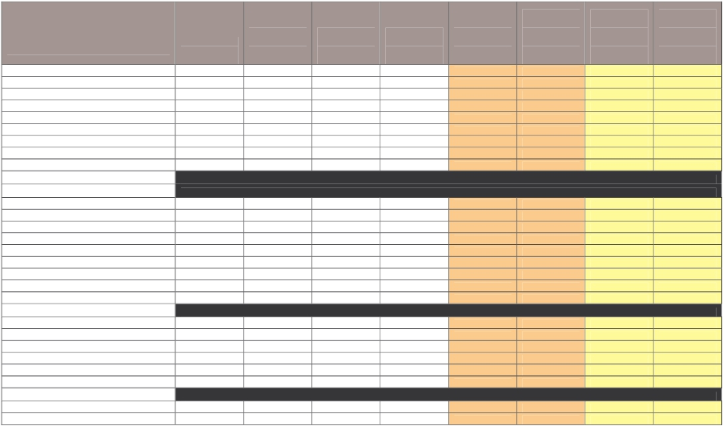

Budgeted total
revenue for 2006-
07

Gross Rates,
Municipal
Charges and
Garbage Charges
2006-07

Rate Revenue as
a proportion of
total revenue 05-
06

Rate Revenue as
a proportion of
total revenue 06-
07

Per assessment -
average rates,
municipal charge
and garbage
charge 06-07

Change in
average rates,
municipal charge
and garbage
charge per
assessment

Per head of
population -
average rates,
municipal charge
and garbage
charge 06-07

Change in
average rates,
municipal charge
and garbage
charge per head
of population

Hobsons Bay (C)

Horsham (RC)
Hume (C)
Indigo (S)
Kingston (C)
Knox (C)
Latrobe (C)
Loddon (S)
Macedon Ranges (S)
Manningham (C)
Mansfield (S)
Maribyrnong (C)
Maroondah (C)
Melbourne (C)
Melton (S)
Mildura (RC)
Mitchell (S)
Moira (S)
Monash (C)
Moonee Valley (C)
Moorabool (S)
i
Mornington Peninsula (S)
Mount Alexander (S)
$27,379,413
$136,764,000
$20,480,000
$114,188,000
$92,235,000
$76,999,000
$19,985,922
$39,049,000
$75,932,000
$12,721,000
$71,586,000
$73,499,000
$263,677,000
$97,568,221
$64,668,000
$32,656,000
$34,709,350
$111,094,223
$87,853,000
$29,199,465
$95,795,000
$129,718,000
$22,825,860
$11,628,514
$70,848,808
$7,622,676
$67,902,000
$55,996,860
$42,072,000
$5,903,712
$21,683,716
$53,840,473
$7,803,966
$44,769,000
$44,121,399
$135,553,756
$40,006,500
$35,491,000
$15,307,000
$18,051,853
$59,547,482
$56,612,850
$14,746,982
$66,763,824
$85,073,000
$9,578,380
42.3%
48.9%
31.5%
58.4%
59.4%
54.4%
26.9%
51.5%
70.8%
52.7%
56.8%
57.1%
52.2%
41.2%
50.3%
42.5%
49.8%
49.9%
64.2%
53.5%
67.0%
60.8%
42.1%
42.5%
51.8%
37.2%
59.5%
60.7%
54.6%
29.5%
55.5%
70.9%
61.3%
62.5%
60.0%
51.4%
41.0%
54.9%
46.9%
52.0%
53.6%
64.4%
50.5%
69.7%
65.6%
42.0%
$1,044
$1,208
$990
$1,048
$944
$1,217
$772
$1,169
$1,239
$1,161

$1,005
$2,318
$1,143
$1,360
$1,037
$1,135
$862
$1,134
$1,124
$1,037
$944
$940
$72
$87
$65
$70
$32
$40
$23
$63
$69
$73

$57
-$56
$39
$78
$128
$77
$71
$65
$84
$70
$44
$65
$602
$407
$485
$499
$371
$597
$679
$470
$465
$1,146
$704
$428
$1,820
$446
$666
$484
$645
$363
$505
$567
$484
$591
$545
$40
$24
$31
$34
$14
$33
$23
$47
$20
$111
$32
$20
$62
$8
$38
$58
$58
$29
$29
$55
$26
$33
$40

Moyne (S)
Murrindindi (S)
Yet to consider draft budget
Yet to consider draft budget

Nillumbik (S)
Northern Grampians (S)
Port Phillip (C)
Pyrenees (S)
Queenscliffe (B)
$50,435,241
$21,464,500
$118,977,000
$15,379,000
$6,860,546
$31,486,093
$8,598,298
$67,169,140
$4,694,752
$3,875,604
56.1%
37.3%
56.0%
33.7%
59.3%
62.4%
40.1%
56.5%
30.5%
56.5%
$1,456
$942
$1,156
$843
$1,349
$133
$32
$81
$51
$93
$516
$653
$774
$711
$1,188
$54
$22
$50
$46
$94
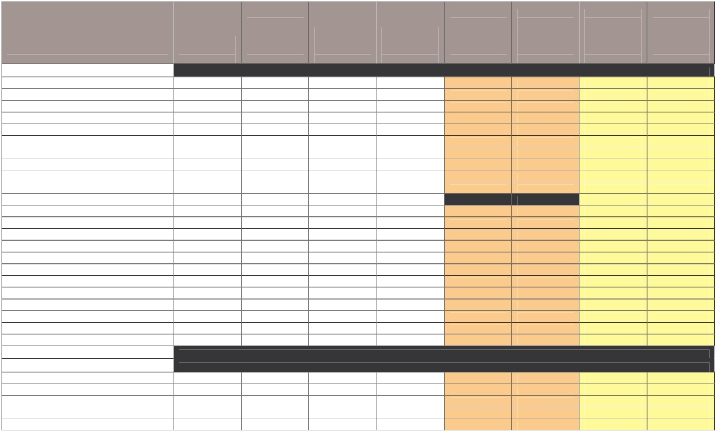

Moreland (C)

Budgeted total
revenue for 2006-
07

Gross Rates,
Municipal
Charges and
Garbage Charges
2006-07

Rate Revenue as
a proportion of
total revenue 05-
06

Rate Revenue as
a proportion of
total revenue 06-
07

Per assessment -
average rates,
municipal charge
and garbage
charge 06-07

Change in
average rates,
municipal charge
and garbage
charge per
assessment

Per head of
population -
average rates,
municipal charge
and garbage
charge 06-07

Change in
average rates,
municipal charge
and garbage
charge per head
of population

South Gippsland (S)
Southern Grampians (S)
Stonnington (C)
Strathbogie (S)
Surf Coast (S)
$34,861,000
$25,278,813
$101,965,000
$18,344,751
$37,886,788
$20,546,460
$10,082,773
$56,001,161
$8,178,936
$21,888,820
56.8%
41.8%
55.3%
45.8%
53.9%
58.9%
39.9%
54.9%
44.6%
57.8%
$1,155
$991
$1,086
$1,228
$1,280
$85
$54
$71
$100
$131
$744
$597
$619
$835
$907
$49
$33
$41
$71
$71

Swan Hill (RC)
Towong (S)
Yet to consider draft budget
Yet to consider draft budget

Wangaratta (RC)
Warrnambool (C)
Wellington (S)
West Wimmera (S)
Whitehorse (C)
Whittlesea (C)
Wodonga (RC)
Wyndham (C)
Yarra Ranges (S)
Yarra (C)
Yarriambiack (S)
Total
$40,477,000
$44,708,000
$58,671,151
$13,258,786
$115,858,000
$142,015,665
$50,762,000
$104,400,000
$105,711,067
$97,467,922
$13,768,000
$4,616,274,106
$15,746,561
$17,272,422
$28,216,413
$3,725,523
$54,997,224
$56,242,000
$21,937,356
$57,299,377
$68,202,601
$57,323,800
$6,355,575
$2,515,964,190
39.6%
35.2%
49.5%
24.4%
47.3%
37.8%
42.3%
52.1%
64.6%
55.7%
38.6%
52.7%
38.9%
38.6%
48.1%
28.1%
47.5%
39.6%
43.2%
54.9%
64.5%
58.8%
46.2%
54.5%
$1,154
$1,189
$961
$829
$859
$1,109
$1,417
$1,151
$1,160
$1,397
$951
$1,135
$79
$90
$60
$27
$88
$34
$58
$22
$80
$65
$75
$67
$583
$540
$620
$777
$368
$413
$616
$463
$474
$782
$782
$527
$42
$46
-$6
$25
$39
$12
$28
$15
$35
$42
$79
$32

Statewide Changes

Change in Budgeted Revenue 2005-06 to 2006-07
Change in Budgeted Rate, Municipal Charge and Garbage Charge Revenue per assessment 2006-07
Change in Budgeted Rate, Municipal Charge and Garbage Charge Revenue per head 2006-07
Change in Budgeted Rate, Municipal Charge and Garbage Charge Revenue
Change in Budgeted Total Revenue (inc government grants, rates, fees, fines and charges) 06-07
4.5%
6.3%
6.4%
$187,092,084
$199,470,677

i

Note that these figures do not include $2,400,000 in rate revenue which will be collected from vacant properties . It is anticipated that the revenue will be rebated directly back to these ratepayers.
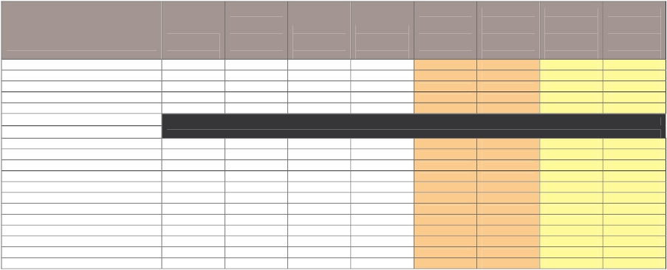

FACT SHEET

COUNCIL RESPONSIBILITIES

Role of Local Government

Local government provides for the peace, order and good government of its municipal area,
delivers services and facilities for the community and manages the resources of the district.

Local government must operate in accordance with the Local Government Act 1989 and has
responsibility for implementing many diverse programs, policies and regulations set by State
and Federal Government.

As councils have to respond to local community needs they also have powers to set their own
regulations and by-laws and provide a range of discretionary services.

Local laws developed by councils deal with important community safety, peace and order issues
such as public health, management of council property, environment and amenity. Local laws
often apply to noise, fire hazards, abandoned vehicles, parking permits, disabled parking,
furniture on footpaths, graffiti, burning off, animals in public space and nuisance pets.

Services and Infrastructure

Each Victorian municipality is different – its community may be young or old, established or still
developing, rural or urban, and its population may vary from fewer than 4,000 people to more
than 185,000.

Each council collects rates from residents and businesses in its municipality to help fund its
local community infrastructure and service obligations.

Victorian councils are responsible for $37 billion worth of infrastructure including roads,
bridges, town halls, recreation and leisure facilities, drains, libraries and parks. They
also provide over 100 services for local communities from the cradle to the grave. Every
time a person leaves their house they are using services provided by local councils.

From foot and bike paths, public street lighting, litter bins, school crossings, library books,
internet services, sporting facilities, community meeting spaces and places, swimming pools,
public playgrounds, bus shelters, parking spaces, community banking and public tips to dog
litter disposals, removal of dumped rubbish, youth and family counselling, baby capsule hire,
childcare programs, preschools & kindergartens, school holiday programs, head lice and
immunisations.

Many council services are also provided to residents in their homes including in-home child
care, parenting and baby health advice by maternal and child health nurses, multilingual
telephone services, recycling and hard waste collections, home maintenance, meals on wheels,
gardening services and respite care.

COUNCIL  SERVICE | PROGRAM | EXAMPLE
General public  services | Emergency prevention & protection | Community disaster/emergency plans
 | Animal management and control | Animal shelters, pet registration
 | Tourism | Visitor information centres, marketing plans
 | Commerce and industry | Local industry networks, incentive programs
 | Community information | Community directory, websites/online services,  counselling & support groups
Health, Welfare  and Community  Services | Aged care programs | Meals on wheels, home care
 | Maternal & child health services | Health checks, nutrition and parenting advice
 | Family & children’s services | School immunisations, childcare, playgroups
 | Youth services | School holiday programs, aerosol art program
 | Disability services | Wheelchair access in the community
 | Cultural development | Festivals, public art, theatre productions
 | Public libraries | Interactive media services, free internet access
 | Leisure and recreation services | Swimming pools, sports ovals,
 | Housing | Housing diversity through planning schemes
 | Public health services | Food safety inspection, public toilets
 | Employment | Community jobs program, traineeships
 | Migrant and indigenous services | Language aides, multilingual phone lines
Planning | Statutory planning | Land use regulation, planning application  assessment, zone and overlay controls
 | Strategic planning | Neighbourhood character, heritage overlays
 | Planning system reforms | Pre-lodgement certification
 | Built form sustainability | Energy efficient housing
Land Use  Management | Rural land use management | Agricultural production, chemical use
 | Forestry/Timber Towns | Forest regulation enforcement on private land,  supervising timber harvesting
 | Native title/Indigenous cultural  heritage | Recognition of traditional land owners
Environment | Waste management | Kerbside recycling, landfills, compost bins
 | Catchment management | Tree planting, protection of water catchments
 | Stormwater management | Litter traps, flood and litter management
 | Native vegetation management | Retention/conservation of native vegetation,  tree clearance permits
 | Salinity and water quality | Reticulated sewerage, Waterwatch, drainage
 | Water re-use programs | Septic tanks, greywater on public parks/gardens
 | Weed management | Weed/pest control for roadside reserves,  provision of Weed Officers
 | Sustainability | Solar heating for buildings & pools, provision of  walking tracks & paths to reduce car use
 | Green purchasing programs | Recycled asphalt, signage, mulch & compost
Infrastructure &  Assets | Asset maintenance and development | Town halls, historic buildings,
 | Road construction and maintenance | Roads, roundabouts, bridges, speed humps
 | Footpath constructions &  maintenance | Nature strips, bike paths, street cleaning
 | Traffic and parking management | Traffic and parking signs
 | Community safety measures | Public lighting, fire prevention plans
 | Public space maintenance | Parks & gardens, street cleaning, cemeteries
 | Leisure facilities | Recreation and community centres
 | Telecommunications & broadband  infrastructure | Wired Development collaborative venture

FACT SHEET

LOCAL GOVERNMENT COST PRESSURES

A range of cost pressures influence the decisions each council makes about its annual
budget and the rates it needs to collect.

1. COST SHIFTING

Cost shifting occurs when governments shift their responsibility for delivering programs and
service on to local government, with no or insufficient funding. This year all spheres of
government signed an intergovernmental agreement establishing a framework for the
allocation of responsibilities to local government, including appropriate funding levels. But the
agreement only covers future transfers. Cost shifting pressures still faced by councils include:

Maternal and Child Health Service
The Maternal and Child Health service is delivered by local government, with shared
responsibility between State and local government for its funding and policy development.
The indexation model applied by the State Government to an agreed hourly cost for the
service has led to a disparity between the proportional contributions of the two spheres of
government over the years, resulting in a funding shortfall of $2.4 million in 2005-06.

Kindergarten infrastructure
Kindergarten aims to develop children's social, emotional, intellectual, physical and language
abilities in the year before they start primary school. This State Government program often
operates out of facilities provided by local government including purpose built kindergartens,
long day care centres and community halls. Many of these buildings are between 35 and 50
years old and require constant maintenance. Minor capital grants provided by the State
Government are falling considerably short of the real costs of maintaining and upgrading
facilities to a standard acceptable for children to learn and flourish.

Childcare costs
As determined by the Australian Industrial Relations Commission, 44 Victorian councils are
paying wage increases of between 5 – 15% to deserving childcare workers but the
Commonwealth has not recognised increased costs and the Childcare Benefit remains
unchanged. Councils and parents must fund these additional costs.

Immunisation programs
Local government has been instrumental in Victoria achieving the highest rate of infant/
preschool immunisation in the nation, at the lowest cost. Established financial arrangements
exist between the Commonwealth and state governments to fund the delivery of immunisation
services. Despite this, a 2004 study demonstrated that Victorian councils contribute between 61
– 83 per cent of the total cost of delivering immunisation services, costing councils and
ratepayers $3.8 million per year while saving the Commonwealth and Victorian Government
$12.5 million per year. The Victorian Government increased funding by $1.3 million per year but
Federal Government funding levels remain unchanged two years on.

Home and Community Care services
Councils are the largest single providers of home and community care (HACC) services in
Victoria. Funding for HACC is the joint responsibility of the Commonwealth and state
governments. Councils have had to subsidise the costs of providing services as funding has
failed to keep pace with demand. The Auditor General estimated the cost of council
contributions to HACC services to be $130 million for the three years from 2000 to 2003. This
unsustainable trend continues to grow each year.

Public Libraries
The MAV estimates local government contributed $282 million in funding for public libraries
from 2000 to 2003, with council contributions growing each year. The State Government’s
contribution during this same period was $77.8 million. Over several decades, State
Government funding for public libraries has slipped from approximately 50 per cent of the cost
of the service to less than 20 per cent in 2004-05.

2. AGEING INFRASTRUCTURE

Funding for maintenance of ageing infrastructure and assets is a major cost pressure for
councils. The Auditor General identified a backlog of $1.5-$2.7 billion for maintenance of
ageing infrastructure in 2002 and the MAV recently calculated an annual infrastructure
spending shortfall of $310 million for Victorian councils over the next five years. In order to
address the infrastructure renewal gap and prevent it from further increasing, councils need
to significantly increase their capital expenditure. With a limited capacity to raise the revenue
needed to upgrade, replace and maintain ageing infrastructure, local government will need to
look at a range of options including rate rises, service rationalisation, and cost cutting in other
areas to fund vital renewal programs.

3. UNPAID RATES AND FINES

PERIN
Local government’s share of infringements awaiting collection by the PERIN Court is in the
order of $140 million for the last five-year period. This amount includes an up-front fee of
$39 paid by councils to lodge each fine and an $18 fee for each courtesy letter. These fees
are paid regardless of whether the infringement is ever resolved. It is hoped that new
enforcement measures that come into effect 1 July 2006 will improve recovery rates.

Unpaid Rates
Each year a percentage of council rates remains unpaid, or is waived or deferred for
extenuating circumstances. While all outstanding rates are collected over time, services and
programs continue to be delivered and the interim funding gap places additional pressure on
councils’ financial capacity.

4. TAX COLLECTION OF BEHALF OF OTHER ORGANISATIONS

Fire Services Levy increases
Twenty-five metropolitan councils each contribute 12.5% of all funding for metropolitan fire
services in Victoria. Council contributions have increased 80% since 1999-2000. In 2006-07
this amount is predicted to increase again by 4.5% or an additional $1.32 million. Such
significant increases in levies are a burden for ratepayers, who already contribute to the fire
services through their own insurance premiums.

5. FUNDING CUTS

Local Government Improvement Incentive Program
Local government stands to lose approximately $18 million in 2006-07 following the
conclusion of the Local Government Improvement Incentive Program, which provided
councils with a stream of revenue for compliance with National Competition Policy, asset
management and Best Value. Some councils with small populations are expected to face
rate rises of approximately 4.5 per cent to recover this loss in revenue.

FACT SHEET

SETTING A COUNCIL BUDGET

Council Plan

Victoria’s 79 councils operate as separate entities with different local issues, costs and
service provision needs.

All councils identify the needs and issues to be dealt with in their municipality through their
Council Plan. This Plan is a statutory requirement which describes the strategic objectives
and strategies that will be implemented by a council for the following four years. It includes a
Strategic Resources Plan, which sets out the financial, and human resources required to
achieve the objectives contained in its Council Plan over four financial years.

A Council Plan must be prepared by 30 June each year. Each council issues a public notice
seeking community input into its draft plan for 14 days, before the plan is finalised and
adopted by council for submission to the Minister.

Council Budget

Each council budget is different to reflect local community needs and priorities. However,
there is a common legislated framework for setting a budget that each council must follow.

The budget process involves a council setting its priorities, identifying measures and
allocating funds that will show how the key strategic objectives outlined in its Council Plan
are to be achieved in the coming year.

Through the budget process a council also specifies the annual maintenance needs of its
assets and infrastructure, as well as the community services and facilities it will provide in the
next financial year, and how much these will cost.

A council budget also estimates the revenue that will be collected from other sources such as
State and Federal Government funding and from loans. By using these estimates a council
can then determine the amount that needs to be collected in rates to meet its financial
responsibilities for the coming year.

This information is adopted as a draft budget, which is advertised and open to public comment
for a minimum of 14 days.

All councils are required to submit their budget to the Minister before 31 August each year.

Local government is the only level of government that provides an open and transparent
budget-setting process that seeks community discussion and input into the development
of council spending initiatives and priorities for the coming year.

FACT SHEET

COUNCIL RATING BASES

Each Victorian council chooses one of three valuation bases for their municipality - Capital
Improved Value (CIV), Site Value (SV), or Net Annual Value (NAV).

The common process for calculating each of the three valuation bases is as follows:

•

•
•
•

•

•

Every two years council valuers have a statutory requirement to conduct a review of
property values based on market movements and recent sales trends
The last revaluation is based on levels as at 1 January 2006
Council valuers undertake a physical inspection of a sample of properties
The total value of property in a municipality is used as the base against which that
council strikes its rate in the dollar
The rate in the dollar is multiplied by the CIV, SV or NAV value of the property to
determine the general rates due on each property
The Valuer General is responsible for reviewing the total valuation of each

municipality for accuracy before he certifies that the valuations are true and correct.

Capital Improved Value

•

CIV refers to the total market value of the land plus the improved value of the

property including the house, other buildings and landscaping

Site Value

•

SV refers to the unimproved market value of the land

Net Annual Value

•

•

NAV is the annual rental a property would render, less the landlord’s outgoings (such
as insurance, land tax and maintenance costs) or 5% of the CIV for residential
properties and farms
The value is higher for commercial/industrial and investment properties.

FACT SHEET

COUNCIL RATES

Property Tax

Council rates are a form of property tax. Councils use property values as the basis for
calculating how much each property owner pays in rates.

Seventy-five per cent of the infrastructure and services provided by councils are funded
through the collection of rates, user fees, fines and charges.

In Victoria, council rates can comprise up to three components:

•
•
•
municipal charges
waste management (garbage) charges
rate in the dollar.

Rate Process

A council begins its rate process each year by determining any municipal and garbage
(service) charges that may be needed to recover part of its administrative cost and the cost
of providing waste collection and disposal services respectively.

Once these discretionary charges have been accounted for, a council determines the rate in
the dollar by dividing the balance of the required budget revenue by the total value of all
rateable properties in the municipality.

The rate in the dollar is then multiplied by the value of a property (using one of three
valuation bases) to establish the amount to be paid by each property owner. This amount is
known as the general rates.

General rates are added to any municipal and garbage charges set by a council to determine
the total rates payable on a property.

Example: Calculating General Rates

If the total value of rateable properties within a municipality is $10,000,000,000 and council
needs to collect $40,000,000 in rates, the rate in the dollar would be 0.004 (40,000,000 ⎟
10,000,000,000).

The rates payable on Property A, valued at $200,000, would be $800 ($200,000 x 0.004).

Contrary to popular belief, rising property values have no impact on council revenue
collection. Council budgets are pre-determined to meet expenditure requirements.

Rising property values usually result in the adjustment, by council, of a lower rate in
the dollar to offset the overall increase in property values.

FACT SHEET

PROPERTY VALUATIONS 2006

Biennial Property Valuations

Victoria has more than 2.5 million properties. Local government uses property values to
apportion the rates payable for each individual property.

As property values change, a council must periodically reassess the valuation of all
properties within its municipality. A valuation determines the market value of a property, at a
specific date and in accordance with relevant legislation and legal precedent.

All Victorian properties have recently undergone valuations at the prescribed date of 1
January 2006. To work out how much each property is worth council valuers’ analyse latest
property sales and rental data, as well as consider other factors such as use of the land,
shape, size, location, house value and other site improvements.

Each council will use this valuation data to apportion the amount of rates to be paid by each
property owner in the 2006-07 and 2007-08 financial years.

Up-to-date valuations are critical for ensuring property owners pay a fair and equitable share
of rates. Two-yearly revaluations assist in delivering rating equity by redistributing the rate
burden within a municipality according to property price movements.

No Financial Windfall for councils

•
•

Councils use property valuations to determine how much each ratepayer will pay in rates
Councils do NOT generate extra revenue as a result of property revaluations.

Increased property values do not increase the total amount of money a council
collects in rates - it redistributes the amount of rates paid between individual
properties. Some ratepayers will pay more and some will pay less, depending on the
new value of their property relative to other properties in their municipality. A council
budget determines how much a council collects in rates – not property valuations.

Role of Valuer-General Victoria

While the property valuation and rating process is the responsibility of local government, the
Valuer-General Victoria (VGV) independently oversees this process to ensure statutory
requirements and best practice standards have been met.

Only qualified valuers - professionals holding recognised tertiary qualifications and with the
required practical experience - can perform municipal valuations.

Once the VGV certifies that a council’s general valuation meets required standards, the
Minister may declare that the valuation is suitable to be adopted and used by council.

Ratepayer Rights

Ratepayers have rights under the Valuation of Land Act 1960 to object to the valuation of
their property if they are dissatisfied with the determination provided by the council valuer.

FACT SHEET

FUNDING OF LOCAL GOVERNMENT

Local Government Funding Sources

There are several sources of funding for local government in Australia:

•

•

•

•

•

Rates on property

Fees, fines and charges (eg. swimming pool entry fees, waste depot
fees, planning permit fees, parking fees and fines)

Borrowings (eg. to pay for large infrastructure projects), asset sales,
donations, contributions, reimbursements and interest earned

Specific purpose grants from State and Commonwealth Government, for
funding specific projects or programs

General purpose grants from State and Commonwealth Government that

are not tied to a specific purpose.

* State and Commonwealth Government grants are typically derived from a sharing of
taxation revenue.

The total funding for local government in Victoria in 2004-05 from all sources was $4.35
billion. This can be broken down as follows:

•
•
•
•

$3.17 billion or 72.9% in rates, fees, fines and charges
$579 million or 13.3% in specific purpose grants
$365 million or 8.4% in untied revenue from general purpose grants
$235 million or 5.4% in other sources, for example interest earned

In 2004-05 local government in Australia collected only three cents of every dollar
raised through taxes. It is the only level of government that issues a bill seeking
payment for the revenue it collects.

 | Public Sector Revenue
Commonwealth Government | 70%
State Government | 27%
Local Government | 3%

