|  |  |  |
| --- | --- | --- |
| **Opportunities Pyrenees, Ararat and Northern Grampians (OPAN)Council name here**  https://dummyimage.com/599x300/dba51c/141413.jpg&text=599+pixels+wide+landscape+image | | |
| Opportunities Pyrenees Ararat and Northern Grampians (OPAN) aims to directly address the existing and future shortage of skilled and unskilled workers across the Pyrenees, Ararat and Northern Grampians local government areas (LGAs) by focusing on workforce planning, migration, housing, and transport, and is supported by the Victorian Government.  Pyrenees Shire, Ararat Rural City and Northern Grampians Shire Councils found local employers were struggling to recruit and retain workers. In addition, the next five years is expected to see 20% of the existing workforce reach retirement age and a construction boom, resulting in around 1,000 new ongoing jobs.  Pyrenees Shire, Ararat Rural City and Northern Grampians Shire Councils identified that without action to attract and retain a new workforce to the region, they risked missing out on an opportunity to grow local economies and communities. |  |  |

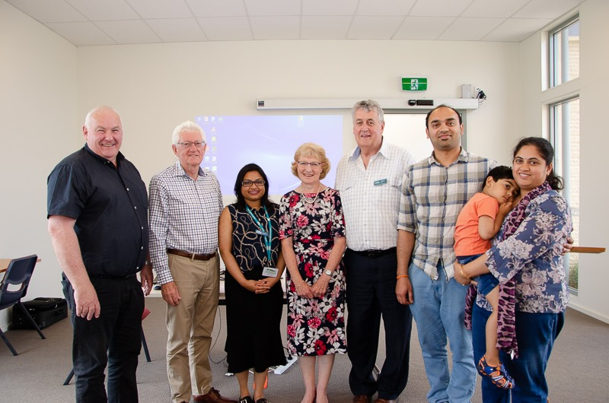

World Migrant Day guest speakers included OAM recipients John and Margaret Millington (who were instrumental in the success of the Karen peoples' resettlement to Nhill), Manzoor Mian, Victorian Multicultural Commission Regional Representative, and Sumaya Tonny, Strategic Planner at the Northern Grampians Shire Council, who shared her story from Bangladesh to Stawell.

The Mayor of Pyrenees Shire, Cr Tanya Kehoe, also signed the Refugee Welcome Zone declaration at the Beaufort event. The events were strongly supported by the local community, with over eight existing migrant communities represented.

* To learn more visit the [OPAN website](https://www.ngshire.vic.gov.au/EngagiNG/OPAN-Opportunities-Pyrenees-Ararat-and-Northern-Grampians) or download the [OPAN-Overview-and-Action-Plan.pdf](https://www.ararat.vic.gov.au/sites/default/files/document/OPAN-Overview-and-Action-Plan.pdf).

The OPAN project also has a regional migrant and refugee resettlement focus delivered in partnership with AMES Australia through a Try, Test and Learn program grant from the Australian Government Department of Social Services.

In its latest step toward increasing migration of new residents, OPAN held World Migrant Day events on 18 December 2019 to celebrate the council’s collective multicultural communities.

**Find out more about Vic Councils  
viccouncils.asn.au**

**For more information on this project:**  
**Phuong Au, Project Manager OPAN**Northern Grampians Shire Council   
E:[phuong.au@ngshire.vic.gov.au](mailto:phuong.au@ngshire.vic.gov.au)  
T: 03 5358 0526

A grant funded Regional Migration Project Officer works across all three local government areas to supports migrant families identified in Melbourne who are interested in relocating, matching them with local employment opportunities and introducing them into the local communities.