

Pathways to better employment

outcomes for Aboriginal people

in Victorian local government





Contents

Total Indigenous population by local government area, Victoria and Melbourne, 2006 iii

The gap between Aboriginal and non-Aboriginal employment and underemployment among Aboriginal people remain high despite Aboriginal unemployment decreasing over the last decade.1 2

National policies, programs and initiatives 2

Closing the Gap 2

The Indigenous Economic Development Strategy 2011-2018 2

The National Partnership on Indigenous Economic Participation 2

Reconciliation Australia 2

Victorian policy and programs 3

The Victorian Indigenous Affairs Framework 3

Moonda Wurrin Gree: Pathways to a better economic future. 3

Kareeta Yirramboi: Victorian public sector employment and career development plan and toolkit. 3

The Reconciliation Victoria Reconciliation in Local Government Project 3

Setting targets and action plans 4

Alice Springs Town Council, Northern Territory 4

A long-term approach starting with a reconciliation action plan 4

Blacktown City Council, New South Wales 4

Employing an Indigenous employment coordinator 5

Latrobe City Council, Victoria 5

Traineeships 5

Frankston City Council, Victoria 5

Linking with Aboriginal training organisations and local TAFE College 6

Hume City Council, Victoria 6

Employing Aboriginal people in council community programs 6

Mornington Peninsula Shire Council, Victoria 6

Casual work pools can provide pre-employment training 7

Darebin City Council, Victoria 7

Sharing Aboriginal employment programs between councils 7

Bass Coast Shire Council, Cardinia Shire Council, Casey City Council, Greater Dandenong City Council, Kingston City Council, Frankston City Council, Knox City Council, Mornington Peninsula Shire Council 7

MANAGING ABORIGINAL EMPLOYMENT PROGRAMS TO ACHIEVE LONG-TERM RETENTION OF ABORIGINAL EMPLOYEES 8

COMMON THEMES AND LESSONS LEARNT 9

# Total Indigenous population by local government area, Victoria and Melbourne, 2006

Indigenous population

TOP 10 REGIONAL LGAs

Indigenous population

TOP 10 METRO LGAs

1 Casey 1,165

2 Darebin 1,108

3 Hume 896

4 Yarra Ranges 846

5 Whittlesea 843

6 Frankston 750

7 Wyndham 707

8 Mornington Peninsula 635

9 Moreland 627

10 Brimbank 570

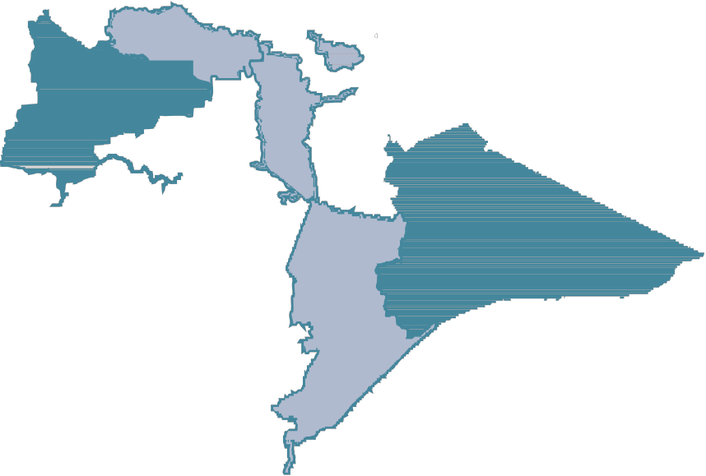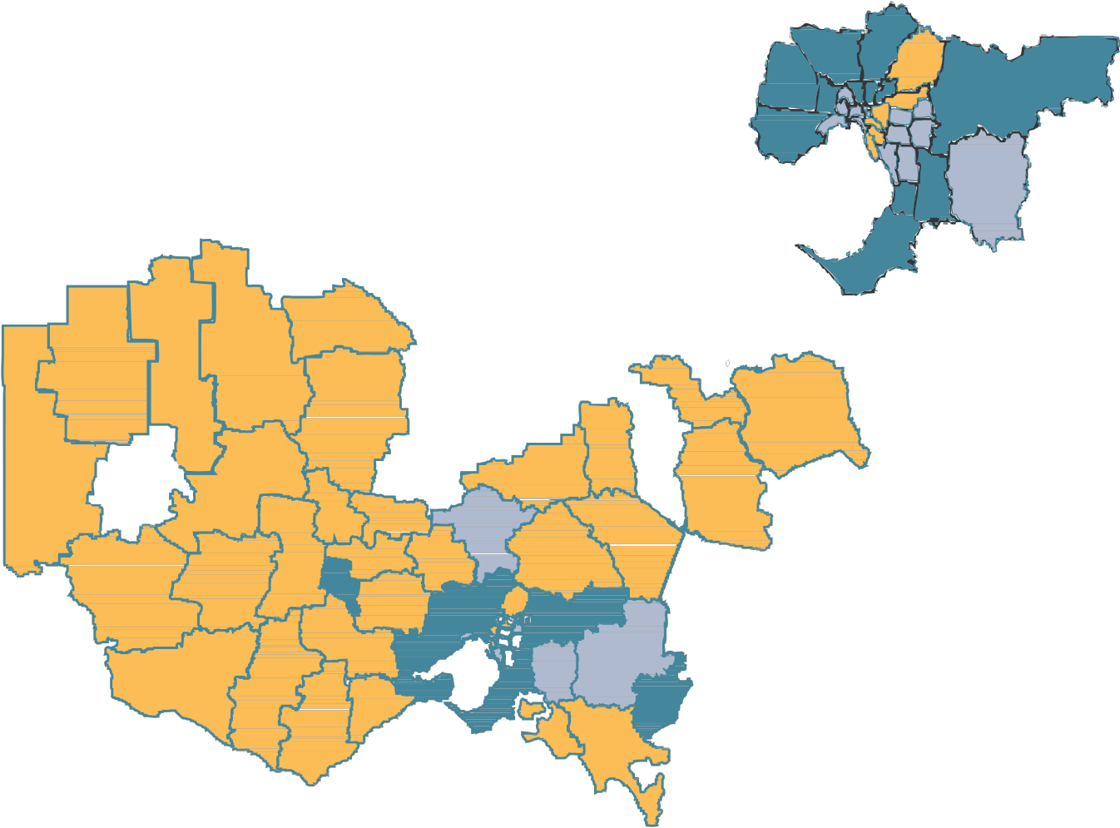

**3 5**

**9 2**

|  |  |
| --- | --- |
| 1 | Greater Shepparton 1,820 |
| 2 | Greater Geelong 1,435 |
| 3 | Mildura 1,432 |
| 4 | East Gippsland 1.141 |
| 5 | Greater Bendigo 1,023 |
| 6 | Latrobe 868 |
| 7 | Ballarat 853 |
| **8** 8 | Swan Hill 801 |
| 9  Swan Hill 10 | Campaspe 661  Wodonga 456 |

**10**

**4**

Mildura

**7**

**3**

**6 1**

**8**

**9**

Bendigo

**5**

**10**Wodonga

Shepparton Wangaratta

**1**

**7** Ballarat

MELBOURNE

**4**

Bairnsdale

Portland

Warnambool

**2**

Geelong

Traralgon

**6**

Total Indigenous persons by LGA

500 – 1,820

200 – 500

0 – 200

Source: Australian Bureau of Statistics Census of Population and Housing 2006, Persons, Place of Usual Residence, Local Government Area (LGA), by Indigenous status.

ACKNOWLEDGEMENTS

This paper has been prepared by the Municipal Association of Victoria (MAV) as part of the Aboriginal Employment Broker

Program it is undertaking in partnership with the Victorian Government’s Indigenous Economic Unit, Department

of Business and

Innovation (DBI).

Thanks are due to John Smith from Cedar Creek Consultancy Service for his assistance in compiling the local government examples contained in this report.

# The gap between Aboriginal and non-Aboriginal employment and underemployment among Aboriginal people remain high despite Aboriginal unemployment decreasing over the last decade.1

There are over 33,500 Indigenous people living in Victoria. It is a relatively young population, with 58% under 25 years of age, compared to 31% of the non-Indigenous population. It is largely urbanised, with half living in metropolitan Melbourne.

Aboriginal people in Victoria have experienced significant dispossession and forced relocation since the commencement of European settlement. They have suffered disproportionately from policies that removed children from their homes and families, compared with Indigenous people elsewhere in Australia. Nearly half of Aboriginal Victorians report having had relatives removed from their families.2

Despite this, the Victorian Aboriginal community is active, resilient, and has a strong sense of identity and cultural connection.

This report provides examples of efforts undertaken by local government to improve Aboriginal employment outcomes and distil common elements of good practice. Relevant national and state government policy is briefly described to provide context. Some examples of initiatives that have worked in local government are also provided.

Common attributes of practices that can lead to increased employment and retention of Aboriginal people are drawn from these national and local examples. These are provided as a way of starting a discussion about practical actions that Victorian councils can take to increase the number of Aboriginal employees in their organisations.

In this report, ‘Aboriginal’ refers to Aboriginal and Torres Strait Islander people.

PATHWAYS TO BETTER EMPLOYMENT OUTCOMES FOR **1**

ABORIGINAL PEOPLE IN VICTORIAN LOCAL GOVERNMENT



1 Hunter, B and Gray, What explains the increases in Indigenous employment since the mid 1990’s? Presentation to the CAEPR seminar series, 7th September 2011. Accessed from [http://caepr.anu.edu.au/sites/default/files/Seminars/presentations/Gray%20+%20Hunter%207%20September.pdf](http://caepr.anu.edu.au/sites/default/files/Seminars/presentations/Gray%20%2B%20Hunter%207%20September.pdf) February 2012

2 Analysis undertaken by Aboriginal Affairs Victoria shows that 11.5% of Indigenous Victorians report having been moved from their natural family, compared with 7.0% across the national Indigenous population. 47.1% of Victorian Indigenous respondents reported they had relatives removed from their family compared to 37.6% nationally.



# National policies, programs and initiatives

## Closing the Gap

In 2008, 53.8% of Indigenous people were employed compared to 75% of non-Indigenous people. The Council of Australian Governments (COAG) set a target to halve the gap in Indigenous employment outcomes in Australia within a decade. The Australian Government Department of Families, Housing, Community Services and Indigenous Affairs is the lead agency on Closing the Gap.

[www.aihw.gov.au/closingthegap/](http://www.aihw.gov.au/closingthegap/)

[www.fahcsia.gov.au/sa/indigenous](http://www.fahcsia.gov.au/sa/indigenous)

## The Indigenous Economic Development Strategy 2011-2018

This national strategy provides a comprehensive framework and plan for government to support improved Indigenous economic development. Actions related to skills development and jobs

aim to improve job readiness, increase training and mentoring and support cultural awareness training. The strategy includes a focus on increasing public sector employment.

[www.indigenous.gov.au/ieds/](http://www.indigenous.gov.au/ieds/)

## The National Partnership on Indigenous Economic Participation

Particularly relevant for local government, the partnership agreement commits the Australian Government and all states and territories to achieving a target of 2.6% Indigenous employment across the whole of the public sector by 2015.

[www.coag.gov.au/intergov_agreements/](http://www.coag.gov.au/intergov_agreements/)

The Local Government Indigenous Employment Program

In 2010, the Australian Centre of Excellence for Local Government (ACELG) released a Green Paper entitled ‘Closing the gap through place based employment’. The paper argues the economic and business case for increasing Aboriginal employment in local government and suggests in the areas of leadership and management, entry level jobs, language and literacy, high demand jobs, regional cross sector approaches and Aboriginal controlled organisations. A White Paper is due for release in mid 2012. The ACELG intends to use the White Paper as a catalyst for implementation of the program.

[www.acelg.org.au/](http://www.acelg.org.au/)

## Reconciliation Australia

Reconciliation Australia is the peak organisation promoting reconciliation between Aboriginal and Torres Strait Islander peoples and the broader Australian community. It works closely with the state and territory reconciliation councils, all of which are separate, independent bodies.

[www.reconciliation.org.au](http://www.reconciliation.org.au/)

# Victorian policy and programs

## The Victorian Indigenous Affairs Framework

The Victorian Indigenous Affairs Framework (VIAF) prepared by the Victorian Government reflects the COAG commitments and supports a collaborative whole of department approach to improving outcomes for Aboriginal people. The VIAF provides an overarching policy direction and includes a commitment to improving economic development.

[www.dpcd.vic.gov.au/indigenous/publications-and-research/victorian-indigenous-affairs-](http://www.dpcd.vic.gov.au/indigenous/publications-and-research/victorian-indigenous-affairs-) framework-viaf

## Moonda Wurrin Gree: Pathways to a better economic future.

This is the report of the Victorian Aboriginal Economic Development Group which was established in 2008 to improve the economic circumstances of Victorian Aboriginal people. Moonda Wurrin Gree includes consideration of initiatives to improve workforce participation and economic development opportunities for Indigenous Victorians, including employment in both the public and private sector. The report has driven a number of strategies to improve employment outcomes for Aboriginal Victorians, including the funding of employment brokers in areas with high Aboriginal population and for industry sectors, including local government.

[www.dpcd.vic.gov.au/aboriginaltaskforce](http://www.dpcd.vic.gov.au/aboriginaltaskforce)

## Kareeta Yirramboi: Victorian public sector employment and career development plan and toolkit.

This action plan includes a target of 1% Aboriginal employment in the Victorian public sector by 2015. The plan outlines a number of strategies to increase Aboriginal employment and is supported by an Aboriginal employment toolkit. While local government forms a significant part of the public sector, Kareeta Yiramboi includes no reference to local government and is geared toward Victorian state government departments and agencies. Nevertheless, most of the strategies and ideas in the plan are relevant to local government.

[www.dpcd.vic.gov.au/](http://www.dpcd.vic.gov.au/) data/assets/pdf_file/0004/49981/KarreetaYirramboi.pdf

## The Reconciliation Victoria Reconciliation in Local Government Project

This project mapped the work of three councils as they developed their Reconciliation Action

Plans (RAPs). RAPs are tools to promote reconciliation and connection between agencies

and Aboriginal communities, and to close the gap in life expectancy, education, health and employment between Indigenous and non Indigenous Australians. The report of the project recommends that councils commit to increasing Aboriginal employment and retention as a way of improving Aboriginal community experiences of local government and building stronger relations with local Aboriginal communities.

[www.reconciliationvic.org.au/](http://www.reconciliationvic.org.au/)

Setting targets and requiring management progress reports assists organisations to focus on achieving change.

“Business, council and the local Aboriginal community formed a steering committee that enabled them to collectively build pathways for Aboriginal employment.”

“Council encouraged members of the local Aboriginal community to volunteer for lifeguard duty while they were completing the necessary qualifications for permanent positions.”

# Setting targets and action plans

## Alice Springs Town Council, Northern Territory

Approximately 30% of Alice Springs residents are of Aboriginal descent and the Alice Springs Town Council made a commitment in 2009 to ensure that 20% of their employees were Aboriginal people. The council developed an Indigenous Employment Action Plan, which includes commitments to:

> Improve retention of Indigenous employees at council

> Develop the vocational and personal skills of Indigenous employees

> Assist Indigenous employees with their career development

> Become perceived by both the Indigenous and wider community as an employer of choice

The number and percentage of Aboriginal employees are included in monthly council reports, which are widely available and published on the council website. The Indigenous Employment Action Plan also includes measures related to:

> The length of employment in council for Indigenous employees

> The number of Indigenous employees who secured more senior positions at council in the past 12 months

> The numbers of Indigenous employees in positions of authority (team leaders, supervisors, managers)

> The number of Indigenous employees who obtain training certificates

The council has not yet reached its 20% target – 18% being the greatest proportion of Aboriginal employees engaged in any month. Many of these positions are also trainee positions funded by the Australian Government. However, around one in every five trainees

has moved on to permanent employment. Council is now considering ways to self-fund trainee positions and how it can invest in pre-employment training, skills and capacity building.

# A long-term approach starting with a reconciliation action plan

## Blacktown City Council, New South Wales

Blacktown is a large municipality in Sydney’s west characterised by high unemployment, widespread disadvantage, cultural diversity and a relatively high proportion of Aboriginal residents. Census data, which often under-represents the number of Aboriginal people in an area, suggests that there may be 10,000 Aboriginal people living in the municipality.

Council has taken a long term approach to the development of its Aboriginal Employment Strategy. The council began in 2009 with the development of a Reconciliation Action Plan (RAP) and has since developed a number of initiatives in close consultation with its local Aboriginal community. Council has been formative in the creation of the Western Sydney Aboriginal and Torres Strait Islander Employment Committee Steering Committee, a forum where business, government and the Aboriginal community come together to build pathways for Aboriginal employment.

Council also instigated a pre-employment program through its swimming pool facilities, encouraging members of the local Aboriginal community to volunteer for lifeguard duty while completing the required qualifications. Some of those who completed this process have been employed as lifeguards on a casual basis and are better placed to apply for permanent positions when they become available.

Council has developed an Indigenous Employment Strategy, which was the subject of consultation with the local Aboriginal community. The challenge for Blacktown is to continue to bring councillors, the organisation, the broader community and the Aboriginal community along with it as it develops and implements its employment action plan.

“Having numbers of Aboriginal people join an organisation is more attractive to Aboriginal

candidates than being the only Aboriginal person in an organisation.”

Traineeships are most useful if there is an allocated position available once

the traineeship has been completed - they are not an end in themselves to satisfy organisational targets.

# Employing an Indigenous employment coordinator

## Latrobe City Council, Victoria

Latrobe City Council clearly demonstrates the positive achievements that can be made when councils are prepared to commit to a long term and single minded approach to improving Aboriginal employment. Under the Australian Government Indigenous Employment Program (IEP), Latrobe City Council has become the major employment broker for Aboriginal employment in the region. With IEP funding, council employs an Indigenous Employment Coordinator who manages the employment program, arranges mentoring and assists with cross cultural training and cultural awareness training. The coordinator is also responsible for marketing the program internally and to private sector agencies.

Since 2003, more than 300 Aboriginal people have been employed, with around 85% retention rate. Since October 2009, nearly 50 people have been employed and the retention rate currently sits at 90%. This includes 26 participants with government agency traineeships. As well, the program has provided placements for 18 Indigenous participants in private sector apprenticeships including as an apprentice painter, plumber, chef, retail, roof tiler and in civil construction. Latrobe City Council currently employs 11 Indigenous staff.

Latrobe City Council’s initiative is the fruit of fourteen years of working with the local Aboriginal community, commencing with the establishment of the Braiakaulung Advisory Committee in 1998.

# Traineeships

## Frankston City Council, Victoria

Frankston City Council has a history of commitment to Aboriginal employment, and has employed a number of trainees over the last decade. In early 2012, council employed two Aboriginal trainees. One is a community development student from a local university who is involved in researching and testing improved consultation with its local Aboriginal community. The human resources management function is responsible for securing and administering Aboriginal traineeships.

Frankston is about to commence consultation on an Aboriginal Action Plan. The Plan will include a strong focus on Aboriginal employment, including strategies to move beyond traineeships only to introduce a more sustainable and embedded approach to Aboriginal employment.

Council demonstrates broader commitment by hosting a local Close the Gap worker and also by being actively involved in the Inter Council Aboriginal Consultative Committee (ICACC).

Working with local educational institutions can assist prospective

Aboriginal employees gain the necessary qualifications while gaining familiarity with councils as an organisation.

The value of a well-supported and integrated approach has enabled an increase in focus on Aboriginal issues across

a number of portfolio areas within the shire.

# Linking with Aboriginal training organisations and local TAFE College

## Hume City Council, Victoria

Hume City Council’s approach to Aboriginal employment demonstrates the value for local government of long term and sustained commitment to working more broadly with local Aboriginal communities. In collaboration with its local Aboriginal community, Council has developed innovative programs in the area of childcare, aged care and youth development.

Hume City Council has a long term commitment to Aboriginal employment which was recognised when council won the Wurreker Award for Aboriginal Employment in 2011. It trialed a number of different approaches to improving Aboriginal employment, most recently linking with a local Aboriginal Group Training Organisation (GTO) and working in connection with Kangan Batman TAFE, which also has a strong commitment and reputation for support for Aboriginal employment.

School based traineeships have enabled long term relationships to be developed between the council and a prospective employee. They also give greater experience to young people to make decisions about training and further education they might undertake. Hume also reserves trainee positions for Aboriginal people in high potential areas of council (e.g. parks and gardens and the Home and Community Care program). This enables suitable trainees to be quickly placed as opportunities arise.

# Employing Aboriginal people in council community programs

## Mornington Peninsula Shire Council, Victoria

Mornington Peninsula Shire Council funds a large Aboriginal support team that includes seven different roles:

> Team Leader

> Access and Support Officer

> Cultural Heritage Officer

> Support Officer

> Policy and Development Officer

> Special Programs and Submissions Project Officer (part-time)

> Arts and Crafts – (part-time and filled by various people)

Aboriginal people fill a number of these roles. The shire has a detailed Reconciliation Action Plan (RAP) and operates a number of specialist programs for Aboriginal people including support programs and youth programs, such as a youth shed.

The shire has linked with a local jobs program to host two Aboriginal trainees. It is currently considering the development of an Australian Government supported program to employ Aboriginal workers in the Home and Community Care (HACC) program.

Including Aboriginal people in casual work pools can increase their knowledge and understanding of what

it is like to work in their local council, at the same time

as increasing their potential to be selected on merit for permanent positions.

Sharing resources and employment costs can assist councils to work collaboratively with the Aboriginal community which crosses multiple municipalities.

# Casual work pools can provide pre-employment training

## Darebin City Council, Victoria

In 2008, in partnership with East Reservoir Neighbourhood Renewal (ERNR), Darebin City Council developed a pathways program to enable members of the community having trouble finding employment undertake initiation training with a view to participating in a casual labour pool for council to call on when required. It enabled council to reduce the cost of engaging staff through agencies and simultaneously provided an opportunity for residents to increase

their employability skills, confidence and self-esteem.

Of the 60 participants in the program, five have been successful in obtaining permanent positions at council (through a merit selection process); several have been in temporary, long and short term positions; and some have found employment in other organisations. Although this program was not developed specifically for Aboriginal candidates, one Aboriginal participant was involved and successfully undertook casual work at council.

For the business administration pool, participants undertook a 16 week Certificate II in Business Administration. Darebin City Council supplemented the training by providing the training facility and some in house Darebin systems training, as well as a full day induction, job application assistance and mock interviews. The participants also did a one week, unpaid placement at council and their achievements were celebrated at a graduation ceremony.

For the Collection Services Pool, participants attained a Certificate III in Transport. The training was provided by a training provider and included overhead power line certificate, fork-lift licence and Certificate II in First Aid.

For the Home Care Pool, participants attained a Certificate II in Aged Care. They were buddied up with current employees and were provided with hands-on experience.

# Sharing Aboriginal employment programs between councils

## Bass Coast Shire Council, Cardinia Shire Council, Casey City Council, Greater Dandenong City Council, Kingston City Council, Frankston City Council, Knox City Council, Mornington Peninsula Shire Council

The Inter-Council Aboriginal Consultative Committee is a forum developed and managed by eight councils in the south east of Melbourne and surrounds. The ICACC brings the councils together with service providers, Aboriginal organisations and community members to identify service gaps and develop programs that link Aboriginal people to community. The ICACC contributes to reconciliation by arranging and conducting cultural awareness programs within councils and for the community and by partnering with local Aboriginal organisations to attract external funding.

The ICACC has been in operation since 1997 and includes a growing focus on Aboriginal employment. The eight councils contribute to the operation of the forum and share the costs of employing an Aboriginal liaison role that is hosted on rotation by the different councils.

One of the key strengths of ICACC is that it recognises that Aboriginal communities often have natural boundaries that may span several different local government areas.



# MANAGING ABORIGINAL EMPLOYMENT PROGRAMS TO ACHIEVE LONG-TERM RETENTION OF ABORIGINAL EMPLOYEES

Changes to work processes and procedures may be required to effectively support improved

Aboriginal employment outcomes. Ideas to consider include:

1. Development of plain language position descriptions that specifically include statements that encourage Aboriginal people to apply

2. Distributing all job vacancies (not just those deemed

‘appropriate’) through Aboriginal networks and community controlled

organisations

3. Recruitment through workshops – a common approach in the minerals industry – where all potential recruits are encouraged to display their skills while learning about the role and the organisation

4. Open interviewing, where elders are invited to join a panel and interviews are conducted as conversations, rather than ‘tests’

5. Use of reserved positions – where vacant traineeships are held in high demand areas at no cost to be filled in the event of a suitable candidate becoming available

6. Use of identified positions. Exemptions for many roles are relatively easy to obtain and advertising identified positions sends

a positive message to council and to local Aboriginal and broader community.

7. Development of a mentoring system in collaboration with local elders. A system that provides an internal mentor (not the line manager) and an external Aboriginal community mentor can be effective

8. Cultural respect training for all staff is an element of every effective program. Training is provided to all staff at induction and should also ideally by tailored to different work areas, particularly those with Aboriginal staff. Separate and focused training should also ideally be provided to managers and supervisors of Aboriginal staff.

# COMMON THEMES AND LESSONS LEARNT

PATHWAYS TO BETTER EMPLOYMENT OUTCOMES FOR **9**

ABORIGINAL PEOPLE IN VICTORIAN LOCAL GOVERNMENT

F URTHER INFORMATION:

MAV Website:

[www.mav.asn.au](http://www.mav.asn.au/)

Rosemary Hancock

email: [rhancock@mav.asn.au](mailto:rhancock@mav.asn.au)

There are some important elements that can make a difference in attracting Aboriginal recruits and retaining them as employees.

1. Build from recognition

Recognition and respect are the cornerstones of relationships with the local Aboriginal community and the support of the local Aboriginal community is essential. Successful programs come from a place that recognises the importance of Aboriginal people in the broader community, the local economy and the council workforce.

2. Commit to the long journey

Improving Aboriginal employment outcomes requires a formal commitment from council to prioritise the issue in the long term. Successful programs are supported by active councillors and senior managers who recognise that it may require many attempts to achieve positive outcomes. Councils that do well take the time to reflect on their mistakes and try new approaches.

3. Move on all fronts

Successful councils manage a range of other activities that complement employment programs. Councils who are active around Aboriginal employment often have in place a Reconciliation Action Plan, special childcare, aged care and youth programs and an Aboriginal consultative committee or similar structure. These form part of a broader and very meaningful engagement with local Aboriginal people and reduce barriers to employment.

4. Find like-minded organisations

Regional and subregional committees and forums feature in the stories of successful councils. The Western Sydney Aboriginal and Torres Strait Islander Employment Steering Committee (Blacktown), the Inter Council Aboriginal Consultative Committee (currently hosted by Frankston City Council) and the Indigenous Economic and Employment Taskforce (Alice Springs) all

bring together councils, local Aboriginal organisations and business to improve Aboriginal employment on a regional basis.

5. Build local capacity

Pre-employment training and development programs that build specific skills for prospective Aboriginal employees while building a relationship between council and the person are highly effective. Programs can range from formal pre-employment training programs through to informal and semi-formal arrangements such as those developed by Blacktown Council. A long term commitment to building the capacity of the local community and investing in training and the development of high demand skills will support a sustainable Aboriginal employment strategy.

6. Connect within your own organisation

Councils interviewed for this report commented on the importance of internal integration. Social policy or community development areas of council are often the drivers for improved Aboriginal employment, but can find it difficult both to manage up to more senior decision makers and to connect with the human resources management portfolio. An internal reference group made

up of the community development and human resources functional areas as well as senior managers most often supports successful programs. The group can also include managers of high demand work areas, such as community care, parks and gardens and customer service.

