PROTOCOL FOR INTER-COUNCIL EMERGENCY
MANAGEMENT RESOURCE SHARING

Version: 3.1

Table of Contents
Purpose 3
Constraints/Recitals 6
Safety 8
Procedures 9
Reference 11
Review 11
Document Authority 11
Municipal Endorsement 12
Attachment 1: Pro-forma letter from Council CEO accepting the Protocol 12
Attachment 2: Council Emergency Management Authorised Officer - Contact Information Form 13
Attachment 3: Inter-Council Resource Request Form 15
Attachment 4: Inter-Council Resource Deployment Form 15
Attachment 5: Protocol Endorsement and Withdrawal Process Map 17
Attachment 6: Response Resource Sharing Process Map 18
Attachment 7: Relief and Recovery Resource Sharing Process Map 18

Title | Inter-Council Emergency Management Resource Sharing Protocol
Purpose | The purpose of this protocol is to provide the best possible outcomes for emergency management by enhancing the capability of councils and supporting the escalation arrangements consistent with the State Emergency Management Plan (SEMP) (p33). This includes:  - Establishing an agreed position between councils for the provision of inter-council assistance for response, relief and recovery activities during an emergency  - Facilitating a process for the timely mustering of resources ready to discharge municipal functions  - Clear protocols and processes for:  - Initiating and completing requests to acquire, manage and cover costs for people and resources from another council  - The identification and management of associated operational and administrative requirements.
Scope | This protocol applies to requests from a council to other councils for human resources, equipment and/or facilities in relation to response, relief or recovery activities associated with an emergency.
Applicable Agencies | - Signatory Victorian Municipal Councils  - Municipal Association of Victoria (MAV)  - Municipal Emergency Management Enhancement Group (MEMEG)  - Emergency Management Victoria (EMV)  - Emergency Recovery Victoria (ERV)  - Department of Families, Fairness and Housing (DFFH)  - Department of Health (DH)  - Control Agency as defined under the SEMP
Activation | By signing up to this protocol, councils via their CEO have agreed to share resources to support a requesting council where practicable and will ensure there is a process within their council to coordinate and manage deployed resources.  The council CEO is to ensure appropriate delegation to council officer/s to enact this protocol.  The protocol is activated once two or more councils become signatories. No further activation is required.
Responsibilities | Representative of a Requesting Victorian Municipal Council | - Follow this Protocol when requesting resources from other councils.  - Manage council functions for the emergency including municipal response, relief and recovery activities, as well as the management of resources made available from assisting councils.  - Release resources as soon as practicable after a request from an assisting council.
 | Representative of an Assisting Victorian Municipal Council | - Provide requested resources where practicable with consideration of the impact on maintaining business continuity.
 | Control Agency | - Will manage and fund municipal resources requested to support response activities.
 | Municipal Association of Victoria (MAV) | - Review and update this Protocol in consultation with council representatives  - Maintain a list of participating councils available on the MAV website.  - Renew signatory membership on a four-yearly basis.
 | Municipal Emergency Management Enhancement Group (MEMEG) | - Review this Protocol in consultation with council representatives.
 | Emergency Management Victoria (EMV) | - Administer Victoria’s Natural Disaster Financial Assistance scheme (NDFA), a component of the Disaster Recovery Funding Arrangements (DRFA).  - Advise on reimbursement and eligible expenses.
 | Emergency Recovery Victoria (ERV) | - Coordinate recovery operations on a state-wide and regional basis.
 | Department of Families, Fairness and Housing (DFFH) | - Build resilience and coordinate relief payments and recovery programs for natural disasters.
 | Department of Health (DH) | - Control agency for public health emergencies.  - Supports deployment processes for Environmental Health Officers
Acronyms | AFAC  Australasian Fire and Emergency Service Authorities Council  Assisting Council  Council providing resources under this Protocol  CEO  Chief Executive Officer  DFFH  Department of Families, Fairness and Housing  DH  Department of Health  EHO  Environmental Health Officer  EMV  Emergency Management Victoria  ERV  Emergency Recovery Victoria  LGV  Local Government Victoria  MAV  Municipal Association of Victoria  MEMEG  Municipal Emergency Management Enhancement Group  MEMPC  Municipal Emergency Management Planning Committee  MEMP  Municipal Emergency Management Plan  MERC  Municipal Emergency Response Coordinator (Victoria Police)  MEMO  Municipal Emergency Management Officer (Council)  MRM  Municipal Recovery Manager (Council)  REMP  Regional Emergency Management Plan  REMPC  Regional Emergency Management Planning Committee  RERC  Regional Emergency Response Coordinator (Victoria Police)  SEMP  State Emergency Management Plan
Definitions | Assisting Council  Council providing resources/personnel to a requesting council.  Authorised Officer  Council officer authorised by a CEO under section 47 of the Local Government Act 2020  Coordinator of Resource Sharing  Council officer from Requesting Council set up to monitor resource sharing through this Protocol. For large scale events, it is recommended that a resource coordinator be situated in the ICC or RCC as a liaison officer  Control Agency  The agency with the primary responsibility for responding to a specific form of emergency  Manager Community Strengthening and Infrastructure  MAV staff member with responsibility for maintenance and updating of this Protocol.  Participating Council  Council that is a signatory to this Protocol  Requesting Council  Council that requires assistance and/ or resources from a signatory to the Protocol.  Resource Sharing  The provision of council resources to assist other councils with response, relief and recovery tasks during emergencies

Constraints/Recitals
Authority to Perform Duties | - Where personnel from an Assisting Council are requested to perform duties in specific roles (including statutory roles such as an Environmental Health Officer or Municipal Building Surveyor), those personnel must be appropriately trained and/or supervised. In most cases, appropriateness is to be determined though discussions between Requesting and Assisting councils. In some cases, third party advice may be required (for example, DH may advise on EHO skillsets).  - The Requesting Council receiving assistance will endeavour to afford the same powers, duties, rights and privileges to personnel from the Assisting Council as its own personnel performing equivalent roles or functions.  - If the role of the personnel from an Assisting Council will include compliance and/or enforcement functions under legislation, they must be authorised officers of the Requesting Council. In this case, they will be appropriately authorised under section 47 of the Local Government Act 2020 to undertake roles prior to commencement. Each council should have an authorisation proforma that can be used for this purpose. A standard proforma will be also available on the EMV resource library and MAV e-library.  - Some specialist roles (e.g. building surveyors) also require delegation to perform the role.  - Personnel from an Assisting Council are not to be assigned to a role if uncertainty exists regarding the competency of the person to perform those duties. If uncertainty exists, personnel from an Assisting Council may be reassigned to alternative duties or stood down at any time.
Reimbursement of Assisting Council Expenses | - The Requesting Council is responsible for the reimbursement, or payment, of all expenses incurred by the Assisting Council, including salaries, overtime, penalties, travel and accommodation expenses and consumables utilised in conjunction with the resources provided.  - The Assisting Council will calculate expenses and provide a detailed account for all reasonable costs incurred by seconded personnel. Salaries, overtime and penalty rates will be calculated at rates applicable to the Assisting Council.  - The Assisting Council may at its absolute discretion waive any part of these costs.
Claims for Reimbursement of Requesting and Assisting Council Expenses from the State | - Claims for reimbursement of eligible municipal expenditure on defined eligible disasters under the Commonwealth’s Disaster Recovery Funding Arrangements (DRFA) from the State Government may include expenses paid to the Assisting Council.  - It is the responsibility of the Requesting Council to make a claim for all expenses from the State Government before 30 July, in relation to expenditure incurred in the preceding financial year. To assist the Requesting Council make the claim, the Assisting Council will calculate expenses and provide a detailed account for all reasonable costs incurred.  - All parties should read and familiarise themselves with the current DRFA Fact Sheets and (NDFA) guidelines on Emergency Management Victoria’s website https://www.emv.vic.gov.au/natural-disaster-financial-assistance/events-post-1-november-2018. This includes what supporting documentation is required to be provided by the Assisting Council to the Requesting Council to ensure that claims can be reimbursed to the Requesting Council.  NOTE: The Victorian DRFA documentation requirements and forms are regularly updated.
Liability for Loss or Injury | - Both the Assisting and Requesting Councils are responsible for their own potential liabilities in respect to any losses arising out of activities associated with “Resource Sharing” under this Protocol on the assumption that common law will prevail.  - Each Requesting Council’s Public Liability and Professional Indemnity Insurance Policy must be extended to indemnify those Assisting Councils providing the resource service/equipment. This extension must cover any claim able to be indemnified under the policy brought in respect of personal injury or damage to property caused by an occurrence, or for breach of professional duty arising directly and solely out of the negligent acts, errors or omissions of the Requesting Council under the resource sharing arrangement. This extension would not extend to any negligent acts, errors or omissions of the Assisting Council, its staff or agents themselves.  - Requesting Councils that are insured with MAV Insurance under the Liability Mutual Insurance Scheme (LMI) will automatically have their insurance policy extended to indemnify assisting councils as outlined above. Therefore, they will not need to take any further action. If your council is not insured with MAV Insurance, the Requesting Council will need to contact their insurer to arrange this extension.
Withdrawal from this Protocol | - A participating Council may withdraw from the arrangements based on this Protocol at any time by providing 30 days’ written notice to the MAV.

Safety
Shared Occupational Health and Safety Responsibility | Protection and preservation of life is paramount. This includes the safety of:  - Council and agency personnel.  - Community members, including community members at increased risk and visitors/tourists.  In the application of this Protocol, the following safety considerations apply and documented in the deployment form (Attachment 4):  - Both the Control Agency and the Requesting Council have a shared OHS responsibility for any personnel deployed in emergency response roles. These responsibilities cannot be transferred or delegated, and cannot be dismissed.  - A set of responsibilities agreed to by all parties should be documented with each role articulated and individual responsibilities clearly stated.  - The wellbeing of personnel must be included in the responsibilities covering issues such as rostering, fatigue and psychological well-being.  - A copy of the deployment form (Attachment 4) must be made available to all parties assisting with the emergency.  - Requesting Council must ensure that COVIDSafe plans are in place in compliance with relevant Chief Health Officer directions.
Induction Briefing | - An induction briefing session shall be conducted prior to any personnel being assigned to a role or undertaking duties.  - It is preferable that a representative from the Control Agency should participate in the induction briefing sessions (if deployment is during the response phase) and it should be recorded that this induction took place.  - Prior to personnel being deployed, arrangements must be made by the Requesting Council for the personnel to be registered and appropriately briefed.  - The briefing must include:  - An overview of the emergency  - The tasks / activities to be performed together with the details of hazards personnel may be exposed to  - The safety requirements and measures personnel must apply in response to the identified hazards  - The reporting lines and the process for reporting OHS concerns or incidents.  - A representative of the Control Agency should participate in this briefing.
Transition Back to the Assisting Council | - At the conclusion of the emergency the Requesting Council must arrange for transitioning of all personnel involved in the emergency from secondment back to the Assisting Council before personnel return.  - The Assisting Council should ensure that appropriate debriefing and support services are available for their staff. Assisting Councils must be informed of any OHS matters or concerns raised throughout the emergency that may have involved or impacted on the personnel of the Assisting Councils.  - In addition, any notifiable workplace incidents under the Occupational Health and Safety Act (2004) that occurred during the emergency event must be reported to Worksafe and recorded in an incident register for investigation follow up as per OHS regulations.  - Any injuries that occurred during the emergency are subject to a workers’ compensation claim being made, and while maintaining confidentiality at all times, the nature and cause of the injury must be communicated between both the Assisting and Requesting Councils.

Procedures
Content | Step 1. Signing up to this Protocol (Attachment 1)  Step 2. Requesting Assistance (Attachment 3)  Step 3. Amending a Request for Assistance (Attachment 3)  Step 3. Risk Assessment (Attachment 3)  Step 4. Deployment (Attachment 4)  Step 5. Staff Registration and Induction  Step 6. Withdrawing from this Protocol  Attachment 1: Pro-forma letter from Council CEOs accepting the Protocol  Attachment 2: Council Emergency Management Authorised Officer - Contact Information Form  Attachment 3: Inter-Council Resource Request Form  Attachment 4: Inter-Council Resource Deployment Form  Attachment 5: Protocol Endorsement and Withdrawal Process Map  Attachment 6: Response Resource Sharing Process Map  Attachment 7: Relief and Recovery Resources Sharing Process Map
Step 1: Signing Up to the Protocol | - The Council CEO sends the MAV a letter electing to participate in the Resource Sharing Protocol (Attachment 1). The letter must include the contact details of the Council Emergency Management role that is authorised to commit the Council to supplying or requesting resources (Attachment 2).  - The MAV publishes the generic Council contact details for participating Council on the MAV website.
Step 2: Requesting Assistance | The Requesting Council identifies a need for assistance.  The Requesting Council discusses the resource need as appropriate with:  - The MERC  - Incident Controller  - Regional Recovery Coordinator  These discussions may be to brief or advise of resource requirements, or to gain access for through road closures, particularly when the controller has OHS responsibilities. These discussions also support situational awareness in regional coordination and flag resource constraints as a potential issue.  NB It is strongly recommended that the Requesting Council assigns at least one officer to the role of Coordinator of Resource Sharing. For large scale events, it is recommended that a resource coordinator be situated in the ICC or RCC as a liaison officer.  - The Requesting Council completes the Inter-Council Resource Request Form – (Attachment 3) (Note: The DH Regional Recovery Coordinator must be informed of all relief and recovery assistance requests to the region or rest of the state)  - The potential risks are assessed and recorded on the Inter-Council Resource Request Form  - Ensure the completed Inter-Council Resource Request Form is authorised by the appropriate officer  - After discussions with other signatory council/s with available staff, send the completed form  - Once a suitable deployment is identified, it must be recorded in the Inter-council Resource Deployment Form (Attachment 4) as a record of deployment. This form must be signed by delegated officers at both Requesting and Assisting councils.  - Appoint a Coordinator of Resource Sharing and supporting team, to coordinate staff from other councils  - Ensure all appropriate equipment is available  - Induct and brief assisting staff from other councils
Step 3: Amending a Request for Assistance | - The Requesting Council may amend or change a resourcing request at any point so long as the change is aligned with the incident by re-issuing an amended Inter-Council Resource Deployment Form (Attachment 4).  - The Requesting Council may:  - Release resources early  - Demobilise resources  - Redirect resources to another location within the incident area  - Change the role personnel are to perform, within the skill and abilities of the person  - Request an extension of a resource deployment  - Re-task the resource to another incident
Step 4: Assisting Staff Registration and Induction | - Requesting Council staff provide a briefing to Assisting Council staff on:  - The incident  - The objectives  - Their role and duties  - Where staff will be stationed  - OH&S considerations  - House-keeping information  - The anticipated length of the incident  - The Assisting Council staff are to sign in and out of ICC/ RCC/ relief or recovery centre (or other relevant checkpoint) before and after each shift.
Step 5: Transition Back to the Assisting Council | Refer to information in the Safety section on transitioning personnel back to assisting council (page 9).
Withdrawing from this Protocol | - The CEO of the participating Council sends a letter to the MAV requesting withdrawal of their Council from this Protocol, providing 30 days’ notice.  - The MAV removes the Council from the Protocol area of the MAV website

Reference
Related Documents | Emergency Management Act 2013
 | Local Government Act 2020
 | State Emergency Management Plan
 | Regional Relief and Recovery Plan
 | Municipal Emergency Management Plan
 | Municipal Emergency Relief and Recovery Plans

Review
Version | Version 3.1 (this version includes a number of small changes: updates to State Government department names, updates to ensure consistent attachment names, new MAV mailing address and minor formatting changes)
Date Issue | October 2023
Date Effective | December 2020 – The date where two or more Councils first endorsed this Protocol.
Next Review Date | 2024
Date to Cease | When only one Council remains as signatory.

Document Authority
This Protocol is consistent with the concepts and policy guidelines articulated in the Emergency Management Acts 1986 and 2013, and the SEMP.
Organisation | Role | Name | Date
MAV | Manager Community Strengthening and Infrastructure | Emma Lake | 08/12/20
MEMEG | Chair | Scott Hilditch | 6/11/20
EMV | Director, Capability and Risk | Lachlan Kelsell | 08/12/20

Municipal Endorsement
Municipality | Role | Date

Attachment 1: Pro-forma letter from Council CEO accepting the Protocol
Councils are requested to formally commit to this Protocol by signing and returning the attached letter template for this purpose. Please send electronically to emergencymgt@mav.asn.au

(Insert Council Letterhead)

[Name]
Manager Community Strengthening and Infrastructure
Municipal Association of Victoria
PO Box 24131
15 Southern Cross Lane
Melbourne VIC 3000
emergencymgt@mav.asn.au

Dear [salutation],

Re: Protocol for Inter-Council Emergency Management Resource Sharing

The ______________ Council confirms its commitment to the protocol and attaches the details of the Emergency Management role responsible for committing the Council to providing resources to or requesting resources from other Victorian Councils.

The purpose of this protocol is to provide an agreed position between Councils for the provision of inter-council assistance for response, relief and recovery activities during an emergency. This protocol details the process for initiating requests for resources from another Council and identifies associated operational and administrative requirements.

The application of this protocol is expected to enhance the capability of Councils to provide the best possible outcomes for emergency management and to support the step up arrangements as detailed in the State Emergency Management Plan.

The co-ordination of responding agencies involves the systematic acquisition and application of resources (personnel, equipment and facilities) in accordance with the requirements of the emergency. This protocol will facilitate appropriate timely mustering of resources ready to discharge municipal functions.

Signed CEO or Delegated Officer.

Attachment 2: Council Emergency Management Authorised Officer - Contact Information Form

The role specified in this form is authorised on behalf of this Council to request assistance from other Victorian Municipal Councils or commit their Council to supply resources for any Requesting Council subject to the provisions of the Protocol for Inter-Council Emergency Management Resource Sharing.

Note: All fields are mandatory.

It is the responsibility of the Requesting Council to set up its own internal processes and to liaise with the MERC to determine what resources are required or what resources could be spared to assist another Council prior to committing or requesting resources.

Information Required | Response
Council Name:

Authorised Emergency Management Role:
E.g MERO, MEMO, MRM, MEM
Role email address:
(generic email required e.g. MEMO@Council.vic.gov.au)
Role contact phone number:
(generic number for the acting MERO, MEMO, MRM or MEM)
Role mobile phone number:
(generic number for the acting MERO, MEMO, MRM or MEM)
CEO Name:

CEO Signature:

Signature Date:

Attachment 3: Inter-Council Resource Request Form
(To be completed by Requesting Council)
Information Required |  | Request Details
Requesting Council details
(Council name, contact person and contact details)
Authorising person
(CEO or their delegate - eg MEM, MERO, MRM)
Incident Name / Type
What is affected / relevant impacts?
(Council asset, community asset)
What resource(s) are required? (Personnel, equipment etc.)
Where resource(s) are required? (MECC, Emergency Relief Centre, Marshalling Point, emergency-affected area)
How resources will be used? (Staffing, outreach, impact assessment, Council operations)
Special qualifications / specifications /accreditations / limitations /experience relevant to the resource / equipment (particular role, EHO, etc)
Health and safety risks
Request urgency
(e.g. immediately, next working day, next week)
Length of time resource(s) is/are required (consider travel times)
Address and time resource(s) are to be dispatched
Onsite contact for resources (Council contact name, role and contact details)
Where appropriate, confirm how costs will be reimbursed to provider |  | The assisting Council is entitled to claim expenses from the Requesting Council in line with the MAV resource sharing Protocol.
Request Sent by
Officer Name | Title | Email | Contact Number | Request Date

Attachment 4: Inter-Council Resource Deployment Form
(To be completed and approved by Requesting and Assisting Council as a record of deployment)
Deployed Officer’s Details
Name
Council
Title/Role
Special qualifications / specifications /accreditations / limitations /experience relevant to the resource / equipment
Direct contact information
(Phone/email)
Assisting council key contact
(Phone/email)
Personal emergency contact
(Phone & relationship to officer)
To be completed by requesting council
Incident Name/Type
Deployed role/tasks
(if different to existing role)
Deployment Dates
(Including travel)
Report to:
Onsite contact for resources (Council contact name, role and contact details)
Requirements to perform task/role:
Equipment needed i.e. PPE, comms, tools
Health & Safety Risks
(Include strategies for mitigation if relevant)
Accommodation details
(Name & location)
Travel arrangements

Authorisation for deployment | Name | Contact | Signature
Delegated officer at REQUESTING council
Delegated officer at ASSISTING council

Attachment 5: Protocol Endorsement and Withdrawal Process Map
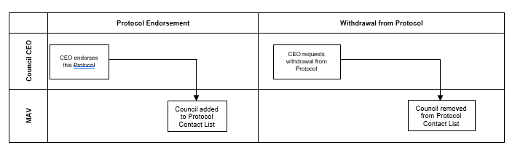

Attachment 6: Response Resource Sharing Process Map

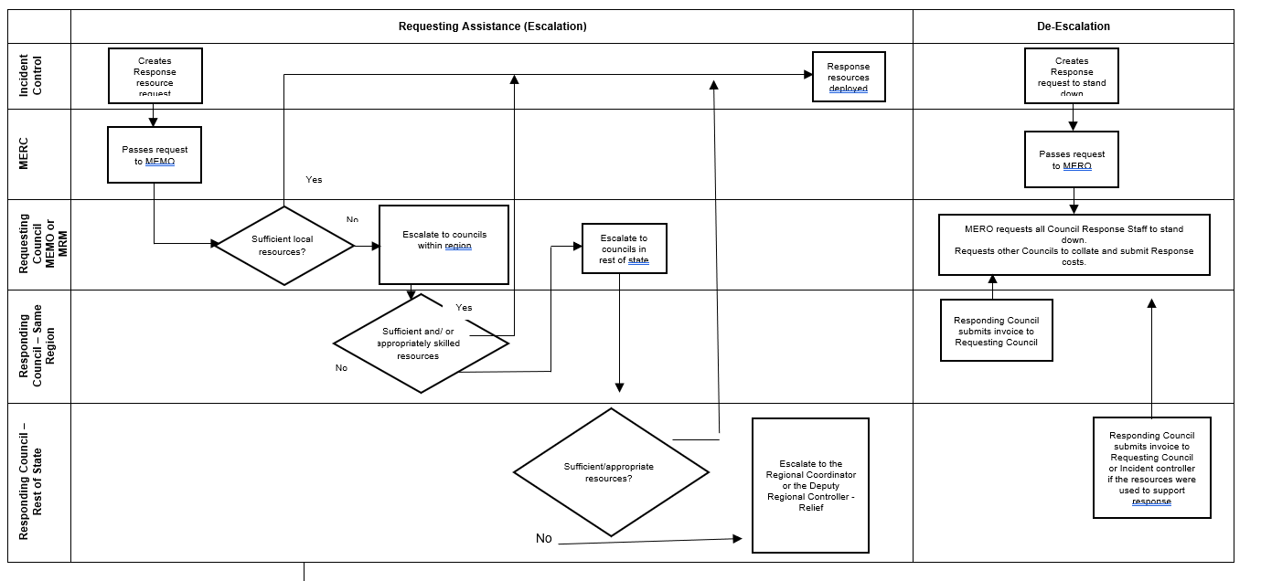

Attachment 7: Relief and Recovery Resource Sharing Process Map
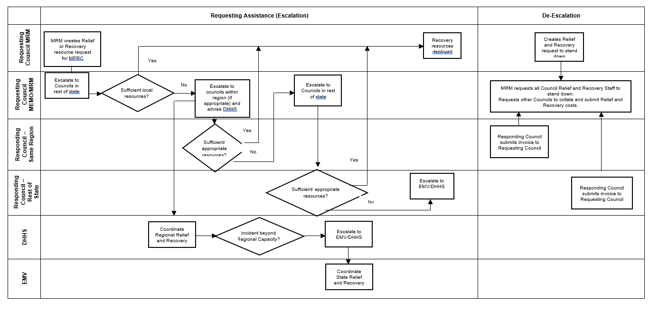

See Sourcing Supplementary Emergency Response Resources through Municipal Councils – Practice Note

