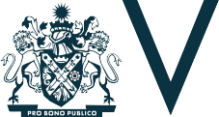

M U N I C I P A L A S S O C I A T I O N O F V I C T O R I A

Strategic Plan
2019-21

The Municipal Association of Victoria (MAV) is the legislated peak body for Victoria’s 79 councils. We advocate for local government interests; build the capacity of councils; protect and support the viability of councils and promote the role of local government.

Who we are and what we do
New funding
Advocacy by the MAV helps to increase funding for councils to provide community services
New partnerships and agreements
MAV representation provides councils with a stronger voice to negotiate
on behalf of local communities
New efficiencies
MAV-led collaboration and innovation helps councils provide more efficient community services
Better understanding
Support from the MAV helps councils to improve community appreciation of local government

OUR ROLE

The Parliament of Victoria passed the Municipal Association Act in 1907, officially recognising the MAV as the voice of local government in the state.
In Victoria, local government is made up of 79 councils representing over five-and-a- half million people.
Councils operate with a legislative and electoral mandate to manage local issues and plan for the community’s needs.
Local government is closely interwoven in the fabric of community life. It is the most trusted level of government and has a vital leadership role to play in facilitating economic development and improving quality of life for the people
it serves.

The MAV protects the interests of local government through advocacy, provision of services to improve efficiency and productivity of councils; and promotion of the value of local government to a diversity of stakeholders.
The MAV is an influential force, supporting a strong and strategically positioned local government sector. Our role is to represent and advocate the interests of local government, lobby for a ‘fairer deal’ for councils, raise the sector’s profile, ensure its long-term security and provide policy advice, strategic advice, capacity building programs and insurance services to local government.
The MAV is a membership association, accountable to its constituent members through State Council and an elected Board. Membership of the MAV is discretionary (78 Victorian councils are current financial members), and participation in our insurance schemes, procurement program, events and other activities is voluntary.

CAPABILITY & RESOURCES
The MAV team understand the challenges of local government and implement the strategic direction set by our members through activities including advocacy and policy development, and performance and productivity services.
Our members play a significant role in how we operate. In consultation with them, we work to set both a specific and broad agenda in terms of local government’s needs and priorities. MAV work areas are also guided by input from six MAV Board Advisory Committees, fourteen other MAV Committees and a long list of external committees. MAV staff coordinate and disseminate the work of these committees.
In addition to all the planned activities, MAV staff must be able to move swiftly

on urgent arising issues. With such a small team of core staff members, the balancing of planned and arising activities is a constant challenge.

AREAS OF OPERATION
MAV advocacy and capacity building services for councils include:
- Community services and development including maternal and child health, early years, vulnerable children, preventing family violence, disability, active lifestyle, positive ageing, aged services, multicultural, Aboriginal, gambling, and arts and creative industries)
- Emergency management
- Environment including climate change adaptation and mitigation, waste and resource recovery, biodiversity, water, environment protection
- Governance and mediation
- Planning and building
- Public health and safety
- Technology and innovation
- Transport and infrastructure; Member services including:
- Procurement
- Debt funding
- Events and training; and Insurance services including:
- Liability mutual
- Commercial Crime and
- LGE Health schemes, and
- MAV Workcover, worker’s compensation self-insurance scheme for members.
The MAV has a strong reputation in both the state and federal arenas as a credible lobbyist with a significant track record in representing the interests of local government. Building and maintaining this reputation requires diplomacy and respect, even while campaigning passionately for our members’ priority issues.
It’s important to note that a significant amount of MAV staff time is spent

CIVIC LEADERSHIP
The MAV supports councils to address current and emerging civic leadership issues such as social cohesion in diversifying communities, reconciliation with Aboriginal and Torres Strait Islanders, advancing gender equity, and planning for the anticipated impacts of digital transformation and climate change.
Activities to directly address these critical issues are dependent upon available resources. The MAV is continually exploring opportunities for new partnerships and funding to enable the delivery of programs to assist councils in their civic leadership role.

STATE COUNCIL
MAV member councils appoint a representative to attend State Council meetings, exercise their council’s vote and provide regular reports to their council on our activities.
The State Council’s powers include:
- considering the Rules of the Association
- determining our strategic direction
- appointing the auditor. State Council is our members’
opportunity to raise new issues as motions of business. Endorsed resolutions are addressed as directed by our Board and in accordance with their alignment to the strategic objectives, level of member support, immediacy of the issue and available resources.
State Council generally meets twice a year. Members can submit business to be considered by the State Council in accordance with the MAV Rules.
Over the term of this plan, the MAV Rules will be comprehensively reviewed. The review will include examination of the role, purpose and alignment of our strategic planning process, State Council, Board Committees and other MAV

advisory committees. The aim of the review is to maximise the effectiveness and influence of the MAV in supporting member councils. Outcomes may affect the implementation of this plan.

OUTCOMES
As presented in our most recent Annual Report (2018), Victoria’s 79 councils contributed a total of $3 million in membership subscriptions to the MAV.
Over this period, the MAV helped to unlock in excess of $400 million in member service benefits including new funding for maternal and child health services, kindergarten infrastructure and operations, strategic land use planning, preventing violence against women, emergency resources, age-friendly projects and coastal climate change impacts.
We also negotiated new partnerships and agreements for planning fees, home and community care, social procurement and energy efficient street lighting. We facilitated improved efficiency and productivity through collaborative procurement, the roll out of the Child Development Information System (CDIS), improving asset management and procurement capability, open data publishing, professional development initiatives and the second issuance of the Local Government Funding Vehicle.
The aim of our strategic planning process is to improve on the value of these outcomes for members every year.

responding to unplanned council, councillor and council officer requests for advice and support. This key function of the MAV is yet to be adequately represented in our formal reporting framework.

The MAV consistently delivers a
return on investment well in excess of subscription fees for its members

We surveyed our members to gain deeper insights into the current priority issues for councils, and how well MAV services are helping councils to address those issues.

A new approach to strategic planning

MEMBER PRIORITIES
OUR PERFORMANCE
Councillors
Executive
Operational
Statewide consultation sessions

MEMBER SURVEY

CONSULTING WITH OUR MEMBERS
This Strategic Plan guides the MAV’s work program for the next two years. The issues and actions within it have been determined in consultation with our member councils.
Formal consultation opportunities included CEO and regional forums, member surveys and
dedicated strategic planning consultation sessions held in Castlemaine, Sale, Melbourne, Warracknabeal, Wangaratta, Geelong and Portland.
MAV staff members also have significant input into development of the plan. The
staff are informed by constant interaction with member councils in their areas of expertise, as well as by input and advice from more than 20 expert committees established and supported by the MAV to inform major policy and project areas.
The survey was distributed to councillors, executives and operational staff across the state. Despite a fast turnaround time, we received responses from all 12 MAV Board regions and every category of respondent.
On priority issues, the survey asked:
  - On a scale of 1-5, how important is this issue?
  - In a few words, why?
  - Should MAV play a role in addressing this issue?
  - What should that role be?
On MAV service performance, the survey asked:
  - On a scale of 1-5, how important is this area?
  - On a scale of 1-5, how would you rate this service?
  - If MAV could do one thing to improve your rating, what would it be?
The survey results helped us to validate and prioritise the priority issues (which had been identified through consultation with member councils at CEO and
regional forums and workshops) and determine which MAV services are highly valued, and which services need further development.
The insights from the survey also demonstrated some marked differences of opinion between operational staff, executive staff and elected members; as well as between different types of council (metro, interface, small rural, large rural, regional city).
These insights were presented as conversation starters for each of the eight consultation sessions.

CONSULTATION SESSIONS
Eight strategic planning consultation sessions were conducted with representatives from MAV member councils at seven locations during February and March 2019.
Participants were asked to consider, validate and prioritise the proposed priority areas and then work together to craft a single objective for each of the priority issues.
Once the objectives were agreed,

MAV Members
MAV Staff
MAV Members
Strategic Plan
Key Priorities
Strategies
Actions
Measures

MAV Staff

participants were asked to determine measures to help us assess if we had been successful in achieving them over the next 24 months.
Participants were also asked to consider the outcomes from previous sessions in determining their agreed objectives
and measures.
Some common themes emerged across many of the priority areas. These included the need for increased use of data and analysis to support business cases and advocacy campaigns; better collaboration between councils and other levels of government; and stronger leadership supported by the development of policy roadmaps and governance structures to support local government priorities.
Strengthening MAV capability in these areas will enable the delivery of the nine objectives identified by our members.
Members were also consistent in calling for the MAV to focus on achieving meaningful outcomes in areas of highest priority to local government, rather than attempting to “do everything”.
During the consultation sessions, the MAV advised members that it had identified the need to review and improve systems and processes within the organisation to improve our efficiency and effectiveness.
The outcomes from the member survey and consultation sessions informed subsequent strategic planning sessions with MAV staff at which our strategy and actions for delivering the member objectives were determined.
MAV consultation networks are vast and varied. The MAV team consult with council staff on matters of policy and process on a daily basis. The MAV also coordinates more than a hundred policy and project committees, task forces, advisory committees and groups to ensure our processes and policies are consultative and representative of our members’ needs.
At Board and CEO level, our networks include elected and appointed members, as well as representatives from all levels of government, unions, industry, service providers and fellow local government and member associations.
The strength of MAV relationships is critical to providing the best outcomes

for our members. In order to be a strong voice for local government, we must ensure that short-term gains for the sector do not come at the expense of longer-term stakeholder relations. The value of this advocacy foundation is difficult to quantify, but fundamental to our success.

PLAN FEEDBACK
The proposed Strategic Plan 2019-21 has been be distributed in draft form to all councils via their nominated MAV representative for further feedback.
Input from councils is collated and considered for inclusion in the plan according to alignment with the strategic objectives, the number of councils supporting the change, and the resources available to deliver it.

STATE COUNCIL
The final draft of the Strategic Plan is distributed to MAV council representatives for the consideration of councils, two weeks prior to State Council. The draft plan is formally presented for the endorsement by members at State Council. If accepted, the draft is adopted to guide MAV work for 2019-21.
During the term of the plan, State Council presents a further opportunity for councils to suggest changes to the plan. These requested changes may be in response to an arising issue or a change in operating environment.
State Council resolutions are considered for inclusion in the current work plan by the MAV Board. Resolutions are assessed against the same criteria used for developing the plan.

REPORTING
The new strategic framework will result in simpler, more meaningful reporting for our members. The aim is to ensure that all MAV activities contribute to the delivery of our strategic objectives. Using the measures identified for each activity, we will assess and report on the outcomes in our Annual Report to members. We will also report on the factors influencing the outcome, including our progress in building our capability and improving our processes.

The strengths or weaknesses of the outcomes will inform the activities of the second year of this plan, demonstrating continual assessment and review of how the MAV provides maximum value for
its members.

WHAT WE HEARD
“The MAV should not try to be all things to all people.”
“Focus on high-value activities.”

“Collaborate more with other local government associations.”
“Build relationships to influence other levels of government.”
“Develop an evidence base to strengthen business cases and advocacy efforts.”
“Apply a rural lens to priority areas”
“Fix the alignment of the strategic planning and State Council processes”
“Strengthen the partnership and increase benefits from our ALGA membership”
“Provide stewardship towards an equitable and sustainable funding model for local government”
“Explore new partnerships, innovations and efficiencies”
“More representation and intergovernmental advocacy”
“Lead the agenda”

Plan on a page

fl

Financial sustainability Waste & resource recovery Government relations Transport & infrastructure
•
P
C
R
r
I
e
d
O
i
b
R
l
I
e
T
•
I
E
C
a
S
p
a
b
l
e
I
n
f
o
r
M
m
A
e
d
V
•
M
I
n
E
u
M
e
n
B
t
i
E
a
l
R
Societal & social policy changes Planning & building
Business & digital transformation Climate impacts & emergency management
Population change

ENABLERS

Representation & advocacy Collaborative strategic procurement
Resources & advice
Network support & collaboration Issue analysis & policy development
Insurance & WorkCare services Sector promotion & communications
Training & professional development
l
b
B
i
s
M
s
e
E
c
c
A
M
•
V
e
A
v
i
s
n
M
o
p
s
e
R
d
e
t
s
u
S
r
T
E
•
C
d
I
e
V
t
c
R
e
n
E
n
o
S
C
•
R
E
e

The MAV provides representation and intergovernmental advocacy to advance the interests of local government
To deliver high-value outcomes for our member councils in 2019-21 we will:

FOCUS OUR EFFORTS

Determine and address a single, clear objective for each member priority issue.

BUILD OUR CAPABILITY
EVIDENCE-BASED POLICY & ADVOCACY
Strengthen our advocacy voice for local government by increasing curation and analysis of data to inform business cases.
ENGAGEMENT & SUPPORT
Improve awareness of and access to MAV services. Leverage networks to build capability and collaboration in local government.
LEADERSHIP & GOVERNANCE
Lead the development of policy roadmaps and governance structures to support local government priorities.

IMPROVE OUR PROCESSES
- Align MAV Stategic Plan and State Council activities.
- Review organisational structure to address capability gaps.
- Rationalise and prioritise member service offerings.
- Review business models.
- Transform our business processes and systems.
- Review communication and engagement strategy.
- Explore new ways to adequately resource priorities and enablers.

VALUES & PRINCIPLES
The MAV supports rural, regional, periurban, interface and metropolitan councils to address social cohesion in diversifying communities, reconciliation with Aboriginal and Torres Strait Islander people, and in advancing gender equity, preventing family violence, and planning for the anticipated impacts of climate change, population change and emerging technologies.
We empower and encourage our staff to support each other and our member councils.

With limited resources, the MAV builds collaborative relationships with key stakeholders including other levels of government and offers services that deliver significant benefits to member councils.

Resources, services & enablers

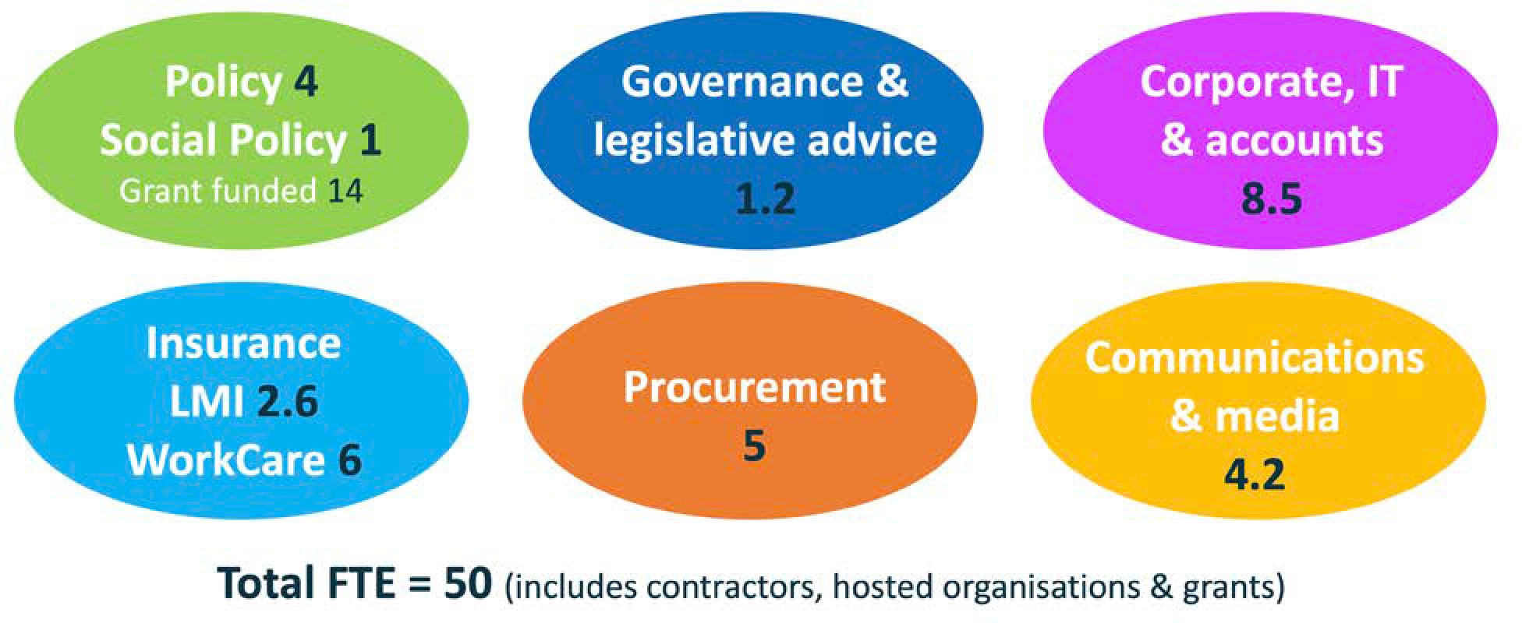

POLICY & ADVOCACY
MAV advocacy represents and advances the interests of councils; influences policy, legislation and funding decisions; and builds capability in councils across a range of policy areas:
- Community Services
- Emergency Management
- Environment
- Waste & Resource Recovery
- Governance & Finance
- Planning & Building
- Arts & Culture
- Public Health & Safety
- Transport & Infrastructure.
The MAV works to support the development, adoption and implementation of high-quality governance processes, protocols, conduct and relationships across the local government sector. We assist councils on a broad range of internal and external governance matters.
We advocate for local government’s economic and financial needs, and argue for greater recognition of local government’s role in a range of areas.

INSURANCE & PROCUREMENT
MAV Insurance and procurement services help to improve the efficiency and productivity of councils by providing best practice policy advice, and cost-saving collaborative opportunities in areas including:
- Liability Mutual, Commercial Crime, LGE Health and WorkCare insurance
- Procurement
- Local Government Funding Vehicle

TRAINING & EVENTS
MAV Events increase the capability and effectiveness of the sector by providing professional development opportunities, collaboration opportunities for member councils and creating awareness of emerging services.
We deliver a Councillor Fundamentals program to metropolitan, rural and regional locations; host Councillor Development Weekends; deliver in excess of 50 training programs; and work with key stakeholders to help councils address employment costs and workforce development challenges.

COMMUNICATIONS & MEDIA
The MAV influences commentary as the voice of local government and improves community understanding and appreciation of the value of
local government. We also communicate matters of importance and promote opportunities for knowledge sharing and collaboration to our members through multiple channels and publications.

CORPORATE SERVICES
MAV’s administration, ICT, human resources and corporate policy services ensure the MAV operates efficiently and transparently.

HOSTED ORGANISATIONS
- Public Libraries Victoria Network
- Council Alliance for a Sustainable Built Environment (CASBE)
- Association of Bayside Municipalities.
- MAV Technology

To effectively address member priorities, the MAV will explore options for building capability in three key areas identified as common enablers during consultation with member councils.

LEADERSHIP & GOVERNANCE
Lead the development of policy roadmaps and governance structures to support local government priorities.
ENGAGEMENT & SUPPORT
Improve awareness of and access to MAV services. Leverage networks to build capability and collaboration in local government.
EVIDENCE-BASED POLICY & ADVOCACY
Strengthen our advocacy voice for local government by increasing curation and analysis of data to inform business cases.

UNLOCK EVIDENCE TO
INFORM ACTIVITIES
Local government collects a huge amount of data. Part of our approach to implementing our priority activities will be to explore how we can better leverage this data to influence funding submissions, forge new partnerships, facilitate sector self-assessment and improve community sentiment. We will also seek to leverage data from sources outside of local government.

LEARN AND MAKE CORRECTIONS
We commit to be open and transparent as the strengths and weakness of our activities are assessed against agreed measures.
We will approach any disappointing results as opportunities for improvement, and build upon our successes to deliver maximum value to our members and the communities they serve.

INCREASE CONSULTATION
In addition to the information that can be provided by better quantitative data management and analysis, we will also investigate practical and affordable ways to draw insights from existing community sentiment consultation to improve outcomes across a range of local government issues.

ENGAGE RESIDENTS
As part of our approach in helping councils to manage community expectations and improve the perception of local government, we will investigate ways to help councils promote the role and importance of local government.
We will do this by exploring initiatives including service delivery co-design, open data provision, sharing of goals and objectives, and promoting council activities and achievements.

PROVIDE HIGH-VALUE SERVICES & RESOURCES
Using our small but capable team, we focus on providing a limited number of high-value services and resources for councils that will help them to improve customer experience, increase efficiency, save costs and improve customer understanding and appreciation of
local government.

ADVOCACY FOR COUNCIL PROGRAMS & PRIORITIES
In addition to developing and delivering advocacy and capacity building programs, the MAV will encourage and support campaigns and programs implemented by councils – particularly when they have the potential for replication by other councils.

IDENTIFY NEW COLLABORATION & FUNDING OPPORTUNITIES
We will seek to enhance our available resources by identifying new opportunities to partner with other levels of government, the private sector, civic society organisations and the community to provide tools, resources and community outcomes that are of mutual benefit to all stakeholders.

COORDINATE SECTOR ACTIVITIES
We will place a greater emphasis on collecting and sharing council case studies and planned activities to enable more promotion of council achievements and better opportunities to learn from the best practice developments underway across the sector.

The MAV will target and measure improvements in our effectiveness in delivering outcomes of value to our members and in our operational efficiency.

We will report annually on the value delivered to each member council through our advocacy efforts and their participation in our programs, activities and services. We will measure and report on efficiency gains achieved through process improvements at MAV; and on our progress in addressing the following objectives against their corresponding measures.
Council satisfaction will be assessed based on the survey method established during the consultation sessions for this Plan. It will be directed to councillors, executives
and operational staff, and the responses will be analysed by respondent, region and council type. This will provide greater insight into our perceived performance and help us to more directly target areas for improvement.

Purpose
Financial sustainability Waste & resource recovery Government relations Transport & infrastructure
Societal & social policy changes Planning & building
Business & digital transformation Climate impacts
& emergency management Population change
Measure effectiveness

Representation & advocacy Collaborative strategic procurement Resources & advice
Network support & collaboration Issue analysis & policy development Insurance & WorkCare services Sector promotion & communications Training & professional development
V
E
R
S
E
P
R
R
I
V
O
I
C
R
I
E
T
S
I
E
S
A
D
I
D
M
R
P
E
R
S
O
S
V
M
E
E
M
M
A
B

Objectives

Activities

Report Outcomes
Measure efficiency

1. FINANCIAL SUSTAINABILITY
OBJECTIVE
Lead the development of an evidence base and policy roadmap to inform a sustainable financial model for local government.
MEASURE | TARGET
Number of councils that contributed to the evidence base developed by the MAV. | Representative number
Councils are satisfied with the policy roadmap developed by the MAV. | 75%
Councils are satisfied with the evidence base developed by the MAV. | 75%
2. WASTE & RESOURCE RECOVERY
OBJECTIVE
Be a trusted advisor to councils and lead advocacy for investment and reform to the waste and resource recovery system to expedite the transition to a circular economy.
MEASURE | TARGET
Councils are satisfied with MAV advocacy effort and outcomes. | 75%
Councils are satisfied with MAV advice and policy development. | 75%
Number of councils that have adopted recycled content procurement targets. | 75%

3. GOVERNMENT RELATIONS
OBJECTIVE
Lead the agenda on sector priorities and elevate these with State and Federal Government to advance the interests of our communities.
MEASURE | TARGET
Councils are satisfied with MAV’s level of influence on other levels of government. | 75%
Councils are satisfied that MAV is leading the agenda on sector priorities. | 75%
Increase in number of engagements from state and federal government. | 10%
4. TRANSPORT & INFRASTRUCTURE
OBJECTIVE
Evaluate available evidence to develop a policy and advocacy framework that prioritises community connectedness and economic viability.
MEASURE | TARGET
Councils are satisfied with policy and advocacy framework. | 75%
Level of council engagement and participation in MAV activities. | 75%
Councils are satisfied with analysis of available evidence. | 75%
5. SOCIETAL & SOCIAL POLICY CHANGES
OBJECTIVE
Facilitate local government creation and support of resilient and cohesive communities, with fair and equitable access to universal community services.
MEASURE | TARGET
Councils are satisfied with MAV support for resilient and cohesive communities. | 75%
Level of council engagement and participation in MAV activities. | 75%
MAV activities increase access to fair and equitable universal community services. | 75%
6. PLANNING & BUILDING
OBJECTIVE
Planning and building regulatory systems serve the interests of communities and respect the role of local government.
MEASURE | TARGET
Councils are satisfied that MAV increases respect for the role of local government. | 75%
Councils are satisfied that MAV represents local government interests in planning and building reform. | 75%
Level of council engagement and participation in MAV activities. | 75%
7. BUSINESS & DIGITAL TRANSFORMATION
OBJECTIVE
To lead and facilitate sharing of best practice and innovation that improves community engagement, business efficiency and equity of infrastructure and access for all councils.
MEASURE | TARGET
Number of councils sharing best practice and innovation. | 75%
Level of council engagement and participation in MAV activities. | 75%
Councils are satisfied with MAV influence on digital engagement, equity and access. | 75%

8. CLIMATE IMPACTS & EMERGENCY MANAGEMENT
OBJECTIVE
Advocate for government leadership and investment that supports councils and communities to mitigate and remain resilient to climate-related impacts and emergencies.
MEASURE | TARGET
Councils are satisfied with MAV advocacy for government leadership and investment. | 75%
Councils are satisfied with MAV policy and partnership approach. | 75%
Level of council engagement and participation in MAV activities. | 75%
9. POPULATION CHANGE
OBJECTIVE
To advocate for assistance for councils to manage the impacts of population growth and decline.
MEASURE | TARGET
Councils are satisfied with MAV advocacy. | 75%
Councils are satisfied that MAV has promoted the viability of rural communities. | 75%
10. IMPROVE OUR PROCESSES
OBJECTIVE
Improve our business, governance and communication processes to increase efficiency, leverage partnerships, strengthen engagement, address capability gaps and prioritise member service offerings.
MEASURE | TARGET
Number of business, governance and communications processes reviewed. | 80%
Increases in efficiency and engagement. | 10%
Increases in number and value of partnerships. | 10%

We will use the survey methodology established to inform the Strategic Plan consultation sessions to determine baseline measures in July 2019. Outcomes for each objective will be assessed and reported annually.
We will also report on the delivery of specific actions and other factors influencing the outcomes, such as the indicative activities listed on the following page and process improvements undertaken by the MAV. We will consider the needs of all categories of member council and will ensure our activities are underpinned by the principles and values set out on page 7 of this Plan.

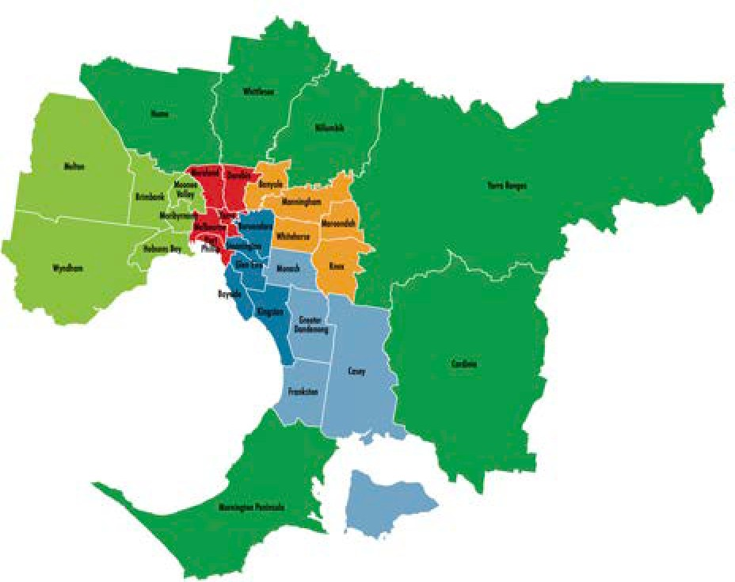
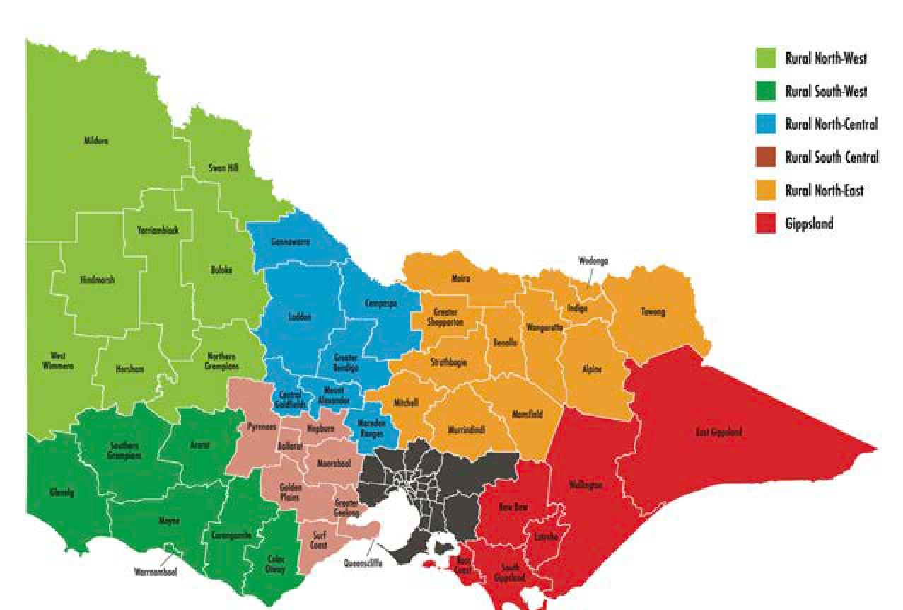

INDICATIVE ACTIONS*

Financial sustainability
  - Advocate nationally to increase funding for local government in partnership with the Australian Local Government Association.
  - Influence the scope of the Victorian Government Rating Review to include solutions for funding and rating constraints on local government.
  - Progress sustainable funding and resources for rural and regional councils, as identified in key reports including the Rural & Regional Councils Sustainability Reform Program.
  - Quantify the asset renewal gap and explore the establishment of a sustainability fund for local government.
  - Deliver an analysis of cost, risk and responsibility shifts affecting local government.

Waste & resource recovery
  - Influence State policy and investment decisions for waste and resource recovery.
  - Voice local government’s position on state-wide waste and resource recovery issues to state and federal governments.
  - Facilitate increased local government procurement of recycled materials.
  - Drive the development and adoption of a consistent sector- wide approach to waste service charges.

Government relations
  - Review and renew the Victorian State and Local Government Agreement, and investigate opportunities to increase partnership agreements with government departments and agencies.
  - Maximise benefits of Australian Local Government Association membership benefits to represent the interests of Victorian councils and communities.
  - Advocate for tripartite agreements with state and federal government.
  - Protect the civic leadership role of local government in the implementation of the new Local Government Act.

Transport & infrastructure
  - Review the STEP Asset Management Program.
  - Represent local government in Heavy Vehicle Law Review.
  - Work with the state government to help councils prepare for introduction of new transport technologies.
  - Advocate for safe and equitable access to public and active transport.

Societal & social policy changes
  - Improve local government outcomes for planning, funding, regulation and provision and access to universal and targeted community services.
  - Negotiate partnership agreements with the State and Commonwealth, placing councils in a position of influence to address social issues and collaborate in state wide community service system design.
  - Support and promote councils’ civic leadership role embracing diversity, reconciliation with Aboriginal and Torres Strait Islander peoples, gender equality and social cohesion initiatives; building creative communities and economic development opportunities for all population and age groups.
*Pending available resources.

Planning & building
- Develop and promote a local government position on reform of the building regulatory system that protects community safety and better aligns the responsibilities and resourcing of stakeholders.
- Advocate for better consideration of Ecologically Sustainable Development at a state level, building on the leadership already shown by local government.
- The impact of state-led planning policy on the workloads and policy objectives of local government is more closely considered.

Business & digital transformation
- Implement the MAV Discovery & Engagement Program, including a digital health report from which future initiatives are prioritised.
- Work with ALGA to advocate for equitable access to digital infrastructure and funding to support cultural change.
- Encourage and facilitate co-design, co-investment and co-creation and explore new strategic procurement opportunities.
- Develop governance structures and processes to de-risk multi-council collaborations enabled by technology.
- Better coordinate local government digital groups (business transformation, ICT, Geospatial, Information Management, Smart Cities, etc.) to facilitate sharing of skills, knowledge, services and resources.

Climate impacts & emergency management
- Represent and advance local government interests in policy and institutional reform processes for stormwater, environment protection and emergency management.
- Explore opportunities which will assist councils to implement regulatory reforms and policy for onsite domestic wastewater management, water security and integrated water management, flood mitigation and the new Environment Protection Act.
- Convene and participate in forums that facilitate cross- agency and inter-government collaboration for integrated water management, biodiversity conservation and emergency management.
- In partnership with the State, greenhouse alliances and others, support councils to understand and prepare for climate change risks and opportunities.

Population change
- Alert ALGA and the state government to opportunities and investment needs, informed by councils’ growth plans.
- Promote local, state, and federal policies that improve provision of adequate social and affordable housing.
- Promote the social, environmental and economic viability of smaller rural communities.

Improve our processes
- Align MAV Stategic Work Plan and State Council activities.
- Review organisational structure to address capability gaps.
- Rationalise and prioritise member service offerings.
- Complete a review of the MAV LMI Insurance Scheme.
- Transform our business processes and systems.
- Review communication and engagement strategy.

We gratefully acknowledge the contribution of the representatives from the following councils at the 2019-21 MAV Strategic Planning Consultation sessions.

Acknowledgements

CASTLEMAINE
Boroondara City Campaspe Shire Central Goldfields Shire Gannawarra Shire Greater Bendigo City Hepburn Shire
Loddon Shire Macedon Ranges Shire Manningham City Mount Alexander Shire Pyrenees Shire Wyndham City

SALE
Bass Coast Shire Baw Baw Shire Boroondara City Cardinia Shire
East Gippsland Shire Manningham City Pyrenees Shire
South Gippsland Shire Wellington Shire

MELBOURNE
Banyule City Bayside City Boroondara City Brimbank City Casey City Darebin City Hepburn Shire Hobsons Bay City Manningham City Maroondah City Moreland City
Mornington Peninsula Shire Port Phillip City
Pyrenees Shire Whitehorse City Wyndham City Yarra City

WARRACKNABEAL
Boroondara City Buloke Shire Hindmarsh Shire Horsham Rural City Mildura Rural City
Northern Grampians Shire Pyrenees Shire
Swan Hill Rural City West Wimmera Shire Yarriambiack Shire

WANGARATTA
Alpine Shire Boroondara City Indigo Shire Mansfield Shire Moira Shire Murrindindi Shire Pyrenees Shire Strathbogie Shire
Wangaratta Rural City Wodonga City

GEELONG
Boroondara City Golden Plains Shire Greater Geelong City Hepburn Shire Manningham City Pyrenees Shire
Borough of Queenscliffe Surf Coast Shire

PORTLAND
Ararat Shire Boroondara City Corangamite Shire Glenelg Shire Manningham City Moyne Shire Pyrenees Shire
Southern Grampians Shire Warrnambool City

MELBOURNE (EVENING)
THANK YOU
We acknowledge the participation of hundreds of council staff and elected officials in our other strategic planning consultation events.
Your input is fundamental to our success in helping councils to provide better outcomes for their communities.
Boroondara City Maroondah City Pyrenees Shire Whitehorse City

Alpine Shire Council Mayor Ron Janas

Council Representatives
Ararat Rural City Council Cr Peter Beales
Ballarat City Council Cr Belinda Coates
Banyule City Council Cr Tom Melican
Bass Coast Shire Council Cr Brett Tessari
Baw Baw Shire Council Cr Mikaela Power
Bayside City Council Cr Alex del Porto
Benalla Rural City Council Cr Scott Upston
Boroondara City Council Cr Coral Ross
Brimbank City Council Cr Lucinda Congreve
Buloke Shire Council Cr Carolyn Stewart
Campaspe Shire Council Cr Adrian Weston
Cardinia Shire Council Cr Graeme Moore
Casey City Council Cr Amanda Stapledon
Central Goldfields Shire Council Mr Noel Harvey
City of Greater Bendigo Council Cr Rod Fyffe
Colac Otway Shire Council Cr Stephen Hart
Corangamite Shire Council Cr Ruth Gstrein
Darebin City Council Cr Trent McCarthy
East Gippsland Shire Council Cr Richard Ellis
Frankston City Council Cr Michael O’Reilly
Gannawarra Shire Council Cr Charlie Gillingham
Glen Eira City Council Cr Jim Magee
Glenelg Shire Council Cr Anita Rank
Golden Plains Shire Council Cr Nathan Hansford
Greater Dandenong City Council Cr Sean O’Reilly
Greater Geelong City Council Cr Kylie Grzybek
Greater Shepparton City Council Cr Dinny Adem
Hepburn Shire Council Cr John Cottrell
Hindmarsh Shire Council Mayor Ron Ismay
Hobsons Bay City Council Cr Sandra Wilson
Horsham Rural City Council Cr Mark Radford
Hume City Council Cr Joseph Haweil
Indigo Shire Council Cr Bernard Gaffney
Kingston City Council Cr Georgina Oxley
Knox City Council Cr Peter Lockwood
Latrobe City Council Cr Sharon Gibson
Loddon Shire Council Cr Gavan Holt
Macedon Ranges Shire Council Cr Jennifer Anderson
Manningham City Council Cr Andrew Conlon
Mansfield Shire Council Cr Harry Westendorp
Maribyrnong City Council Cr Cuc Lam
Maroondah City Council Cr Mike Symon
Melbourne City Council Cr Rohan Leppert
Melton City Council Cr Kathy Majdlik
Mildura Rural City Council Cr Simon Clemence
Mitchell Shire Council Cr Bill Chisholm
Moira Shire Council Cr Wendy Buck
Monash City Council Cr Rebecca Paterson
Moonee Valley City Council Cr Narelle Sharpe
Moorabool Shire Council Cr Tom Sullivan
Moreland City Council Cr Oscar Yildiz
Mornington Peninsula Shire Council Mayor David Gill
Mount Alexander Shire Council Cr Tony Cordy
Moyne Shire Council Cr Mick Wolfe
Murrindindi Shire Council Cr Sandice McAulay
Nillumbik Shire Council Cr Peter Perkins
Northern Grampians Shire Council Cr Murray Emerson
Port Phillip City Council Cr Dick Gross
Pyrenees Shire Council Cr David Clark
Queenscliffe Borough Council Cr Bob Merriman
South Gippsland Shire Council Cr Don Hill
Southern Grampians Shire Council Cr Mary-Ann Brown
Stonnington City Council Cr Jami Klisaris
Strathbogie Shire Council Cr Amanda McClaren
Surf Coast Shire Council Cr Brian McKiterick
Swan Hill Rural City Council Cr Les McPhee
Towong Shire Council Cr Aaron Scales
Wangaratta Rural City Council Cr Ken Clarke
Warrnambool City Council Cr Tony Herbert
Wellington Shire Council Cr Malcolm Hole
West Wimmera Shire Council Cr Jodie Pretlove
Whitehorse City Council Cr Andrew Davenport
Whittlesea City Council (Non-Financial) Vacant
Wodonga City Council Cr Anna Speedie
Wyndham City Council Cr Josh Gilligan
Yarra City Council Cr James Searle
Yarra Ranges Shire Council Cr Tony Stevenson
Yarriambiack Shire Council Cr Graeme Massey

MAV STRATEGIC PLAN 2019-21 I 1 5

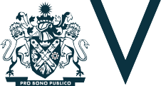

Municipal Association of Victoria Level 12, 60 Collins Street, Melbourne
GPO Box 4326, Melbourne 3001
Phone: 03 9667 5555
Fax: 03 9667 5550
Email: inquiries@mav.asn.au mav.asn.au
We acknowledge Aboriginal people as the traditional owners of the land and we pay our respects to their Elders, past, present and emerging.
We support local government’s capacity and knowledge to strengthen relationships with Victoria’s Aboriginal communities and for it to encourage greater unity, knowledge, cultural awareness and respect for the first occupants of our land – through its strong community links and local representation.

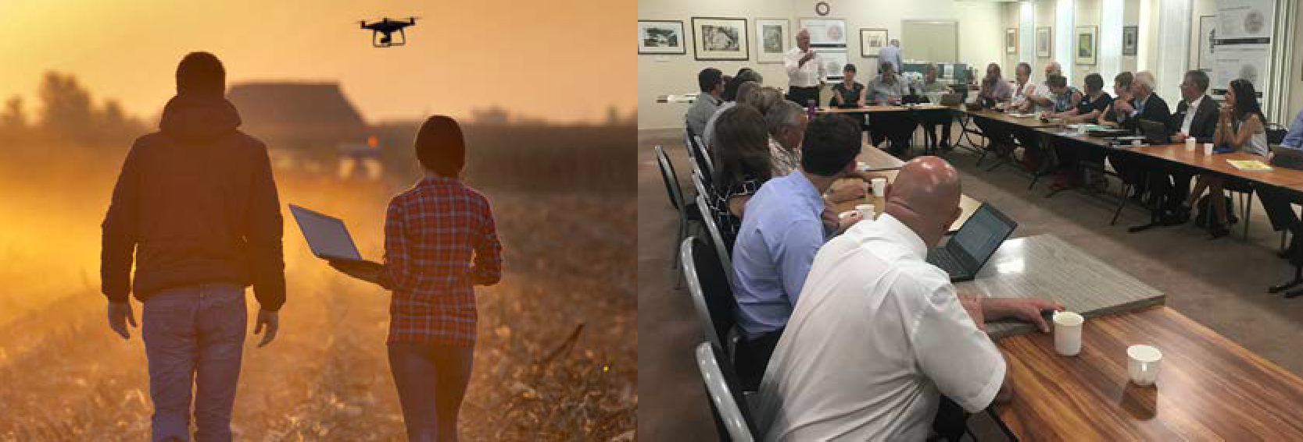

M A V S T R A T E G I C P L A N 2 0 1 9 - 2 1

