|  |  |  |
| --- | --- | --- |
| **Going Google**  **Northern Grampians  Shire Council** | | |
| Northern Grampians Shire Council has achieved a first for Victorian local government to become a fully-fledged ‘Google site’, operating in a Google Chrome environment through implementation of Google’s GSuite.  This initiative was recognised as winner in LG Pro’s Awards for Excellence under the ‘Innovative Management’ category. The move to Google has resulted in a productivity suite that is fast, reliable and easy to use. As the suite is web-based it is easily accessible anywhere, anytime and on any device.  All nine Council sites were finalised to a full conversion to a Chrome environment in 2017, which offered the best option with cloud-based productivity while being fast and reliable.  Embracing the digital future and a shift towards cloud technology has earned Northern Grampians Shire Council recognition as a leader in local government for digital solutions. Council’s Google initiatives were recognised in LG Pro’s 2018 Awards for Excellence under the ‘Innovative Management’ category.  The environment features strongly as a base for growth of the Gannawarra brand. |  |  | |

This project and the suite of Google solutions have resulted in outcomes well in excess of those originally predicted.

The award recognition was a testament to the staff dedication and enthusiasm in adapting to major change in work environments, leading to huge efficiency and productivity gains, along with cost benefits, disaster recovery improvements, video conferencing, real-time collaboration and simple website building functionality.

These elements have successfully set Council up to be a cloud-based organisation equipped for the opportunities and challenges of the future.

**Find out more about Vic Councils  
viccouncils.asn.au**

**For more information on this project:**  
Vaughan WilliamsDirector, Corporate Services  
Northern Grampians Shire Council  
E: vaughan.williams@ngshire.vic.gov.au  
P: (03) 5358 8700

Using the Google package, Northern Grampians Shire Council staff are able to work remotely if needed, at any time from any device. This ensures that council staff can deliver quality customer solutions far more effectively than previous technology approaches that were based on traditional desktop systems.

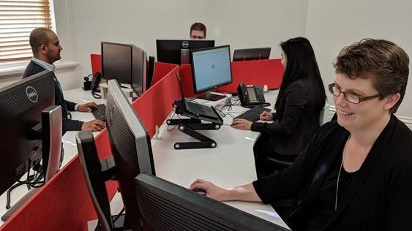

“This project has allowed us to increase our productivity by allowing staff to better collaborate and provide more flexible working solutions,” Council CEO Michael Bailey said.

Council has committed to continuous improvement thanks to Google’s commitment to business development, ensuring that Northern Grampians Shire Council will keep up the efforts to be at the forefront in local government when it comes to technology and digital efficiency.