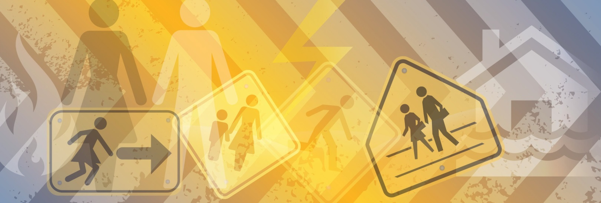
Gender and Bushfire Planning Case study

Rosie lives in a high bushfire risk area and is concerned about the possibility of there being a bushfire in her area. She is worried about the ramifications of a bushfire on both her and her family. She has lived in this area for over 20 years, has a basic understanding of bushfire planning and doesn’t believe her family is adequately prepared for a bushfire.
Rosie and her husband Peter do not agree on what action they should take on high fire days or in the event of a bushfire near their home. Rosie believes that her family should be leaving early however her husband believes they should stay and see what happens before deciding to either leave or defend their home. Rosie is faced with a dilemma as she does not want to be separated from her husband in the event of a bushfire. Her desire to stay with her husband may put Rosie and her children in unnecessary danger by delaying their decision to leave the area.

Research tells us
- Men strongly influence family decisions to stay and defend homes during bushfires, sometimes with tragic results.
- Men are more likely to die in flood and bushfires than women. This is because men are more willing to take risks or not consider the consequences of their actions during emergencies.
- Fire agencies in Victoria strongly promote the ‘leave early’ message, stating that ‘You should never wait and see what happens during a bushfire. Leaving late means you will be on the road when conditions are at their most dangerous or you may not be able to get out at all. The longer you wait to leave, the greater the risk to your life.

¹ Haynes K, Handmer J, McAneney J, Tibbits A, Coates L, 2010, Australian bushfire fatalities 1900-2008: exploring trends in relation to the “prepare, stay and defend or leave early” policy, 13 (3), Environmental Science and Policy, 185-194.
² Amanda Ripley, 2008, The Unthinkable: Who Survives When Disaster Strikes - and Why, New York, Three Rivers Press
³ http://www.cfa.vic.gov.au/plan-prepare/leave-early

Gender and Bushfire Planning

Case study

Action local government can take
- Create partnerships with CFA that address the issue of family conflict regarding bushfire plans that include ‘triggers’ for leaving that are agreed to by all members of the family.
- Partner with women’s health and men’s shed organisation and consider inviting them to be part of emergency management committees or programs.
- Take notice of who attends bushfire safety meetings. Consider community engagement strategies that are inclusive of gender. For example hold meetings at a time and location that is convenient for both women and men to attend and wherever possible provide child minding options. For example consider more child friendly locations for community meetings such as a community hall where there is a playground rather than the local CFA station.
- Ensure the community engagement format enables women and men to provide meaningful input, for example some people find ‘Town Hall’ style meetings confronting and would be more engaged in ‘Café’ style workshops.

Resources available
- Women specific planning and preparation for disasters. There are a number of tools available including:
  - Women Gathering Toolkit (www.whealth.com.au/publications_resources.html)
  - Weathering the Storm (www.nrwc.com.au/Projects/WeatherTheStorm)
  - Through Women’s Eyes process (www.whealth.com.au).
- Examples of programs engaging men are outlined in Volume 28, Issue 2 of the Australian Journal of Emergency Management (ajem.infoservices.com.au/items/AJEM-28-02).
- CFA: Leaving Early Bushfire Survival Planning Template (www.cfa.vic.gov.au/plan-prepare/leave-early).
- Be Ready Warrandyte video: Do you have a fire plan? (http://warrandyte.org.au/fire/).
- The gender and disaster pod website (www.genderanddisaster.com.au).

