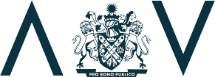



**Annual Report**

Board & Governance Reports

2019-20

**M U N I C I P A L**

**A S S O C I A T I O N**

**O F**

**V I C T O R I A**



**Our Charter**

We are the MAV – the voice of local government in Victoria since 1879. Our purpose is to advocate for local government interests; build the capacity of councils; protect and support the viability of councils and promote the role of local government.

**2**

M U N I C I P A L A S S O C I A T I O N O F V I C T O R I A

**We are successful when:**

* Our members receive a high value return for their subscription
* Our people are inspired by a sense of purpose and accomplishment
* Our members, consultation networks and suppliers value their relationship with us
* Our operational discipline and financial strength ensures our ongoing role in serving our members efficiently and effectively.

**Our role is to:**

Represent and advocate for local government interests

* Establish and maintain alliances with key stakeholders
* Respond to arising issues
* Mediate, facilitate and advise
* Lead sector development
* Support councillor development
* Host and facilitate educational and training events
* Provide collaborative procurement opportunities
* Provide insurance services.

**We value:**

* Integrity
* Collaboration
* Accountability
* Innovation
* Respect.



**Provenance**

The Parliament of Victoria passed the Municipal Association Act in 1907, officially recognising the MAV as the voice of local government in the state. Our role is to promote

the efficient carrying out of municipal government throughout the state of Victoria, and to watch over and protect the interests, rights and privileges of municipal corporations.

Today, the MAV is an influential force supporting a strong and strategically positioned local government sector. Our role is to represent

and advocate the interests of local government, lobby for a ‘fairer deal’ for councils, raise the sector’s profile, ensure its long-term security and provide policy advice, strategic advice, capacity building programs and insurance services to local government.

The MAV is a membership association, accountable to its constituent members through State Council and an elected Board. Membership

of the MAV is discretionary (at 30 June 2020, all 79 Victorian councils were current financial members), and participation in our insurance schemes, procurement program, events and other activities is voluntary.

**Our members**

Local government is interwoven in the fabric of community life. It is the most trusted level of government and has a vital leadership role to play in facilitating economic development and improving quality of life for the people it serves.

Victorian local government is made up of 79 councils representing more than 6.4 million people. They operate with a legislative and electoral mandate to manage local issues, plan for the community’s needs and advocate to realise their aspirations. In partnership with their communities, councils manage more than $110 billion worth

of community infrastructure and assets.

In 2019-20, Victorian local government annual revenue was $10.7 billion. Councils employed more than 37,000 people and provided more than 100 different services to people who visit, live and work in their area. Key functions include

health and community services; land use planning; environmental services; recreational and cultural services; local roads, footpaths and street lighting services; domestic animal management; and emergency management planning.

R E P O R T 2 0 2 0

**3**

B O A R D S

& G O V E R N A N C E – A N N U A L

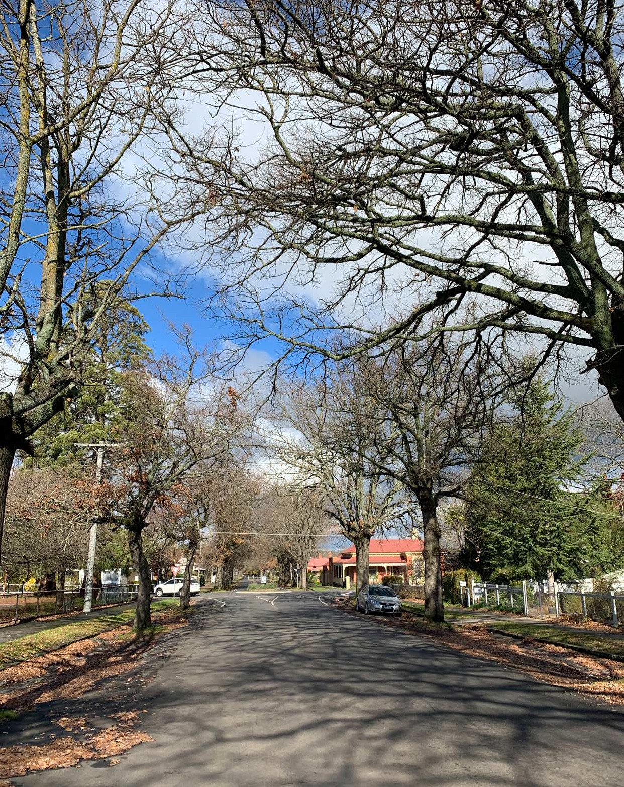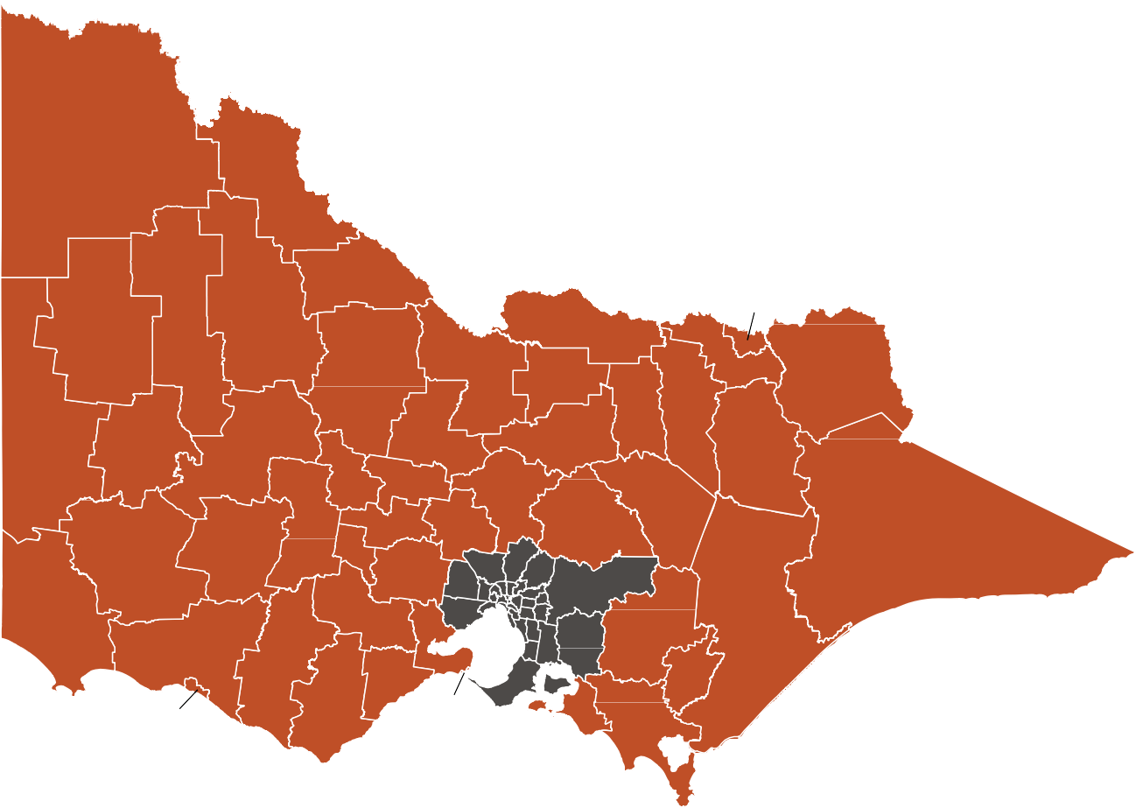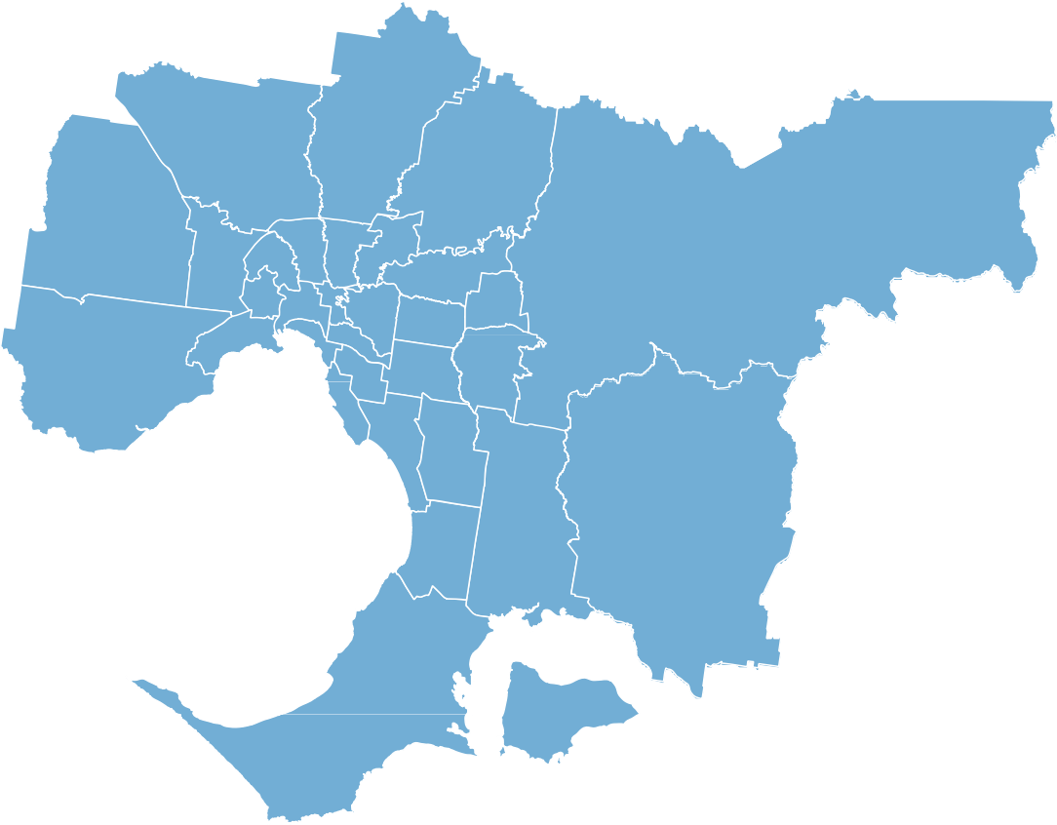

Mildura

Swan Hill

Yarriambiack

Gannawarra

Wodonga

Buloke

Moira

Hindmarsh

Campaspe

Indigo

Greater Shepparton

Towong

Loddon

Wangaratta

Benalla

West Wimmera

Northern Grampians

Greater Bendigo

Strathbogie

Horsham

Alpine

Mount Alexander

Central Goldfields

Pyrenees

Ballarat

Mitchell

Mansfield

Macedon Ranges

Hepburn

Murrindindi

East Gippsland

Ararat

Southern Grampians

Moorabool

Wellington

Golden Plains

Glenelg

Greater Geelong

Baw Baw

Moyne

Corangamite

Surf Coast

Latrobe

Colac Otway

Bass Coast

Queenscliffe

South Gippsland

Warrnambool

Whittlesea

Hume

Nillumbik

Melton

Moreland Moonee

Valley

Darebin

Banyule

Manningham

Yarra Ranges

Brimbank

Maribyrnong Yarra Melbourne

Maroondah

Boroondara

Whitehorse

Port

Hobsons Bay Phillip

Stonnington

Glen Eira

Wyndham

Knox

Monash

Bayside

Kingston

Greater Dandenong

Cardinia

Casey

Frankston

Mornington Peninsula

**4**

M U N I C I P A L A S S O C I A T I O N O F

V I C T O R I A



The MAV was incorporated in 1907 by an Act of State Parliament. The Act defines our purpose, sets out how we operate and empowers our members to make rules to further clarify our role and processes.

The Act requires the MAV to set rules for the regulation of proceedings, subscriptions and other matters affecting the management of the Association.

Each member council must appoint a councillor as its MAV representative. These representatives generally come together twice a year to form State Council, at which the policy direction of the MAV is set, including through the endorsement of a Strategic Work Plan. Details of State Council resolutions for the reporting period are available at mav.asn.au.

**MAV Board**

The MAV Board consists of 13 members who are elected for a two-year term. Twelve board members are elected to represent different

regions of Victoria. They are elected by the MAV representatives from the councils of each region. The 13th member of the board is the President, who is popularly elected by the representatives of all member councils.

The MAV Board sets and evaluates directions, priorities and performance standards for the MAV, appoints and monitors the performance of the CEO and defines the detail of policies, objectives and strategies determined by State Council. Board members liaise with the MAV representatives from their regions.

The current MAV Board was established in March 2019.

MAVIB members are appointed by the MAV Board from the insurance industry and local government. The MAV holds an Australian Financial Services Licence (AFSL No 27143). The MAV and MAV Insurance have AFSL-compliant processes and activities in place to maintain the highest standards of governance, provide operational efficiency and enhance the future viability of MAV Insurance.

The MAVIB carries out oversight and management of the operational activities of MAV Insurance. JLT provides claims, risk management and reinsurance placement services. Taylor Fry is the scheme’s actuary. Frontier Advisors provide investment consultant services.

**MAV WorkCare Board**

The MAV WorkCare local government workers’ compensation self-insurance scheme was approved by WorkSafe Victoria on 3 May 2017 for an initial three-year period that commenced on 1 November 2017. As the licence holder, the MAV seeks to deliver improved performance by supporting member councils to achieve better outcomes in injury/illness prevention and recovery.

In October 2017, the MAV Board appointed a WorkCare Board to oversee the operations of the Scheme in line with Participation Agreement requirements. The WorkCare Board is comprised of eight members with skills/backgrounds in local government, insurance and risk.

Jardine Lloyd Thompson (JLT) is the Scheme’s appointed agent for OHS, RTW and claims management services. Finity Consulting is the Scheme’s independent actuary. The Victorian Funds Management Corporation (VFMC) provide investment management services to the Scheme supported by specialist advice from Frontier Advisors.

**MAV Insurance Board (MAVIB)**

The MAV Board has delegated authority and responsibility for MAV Insurance to the MAV Insurance Board (MAVIB). The LMI scheme’s deed of establishment enables the formation of a management committee, formalises duties and powers of delegation by the Board and provides guidance on the day-to-day operation of the insurance business.

B O A R D S & G O V E R N A N C E – A N N U A L R E P O R T 2 0 2 0

**5**

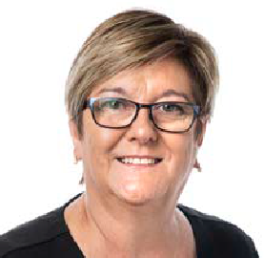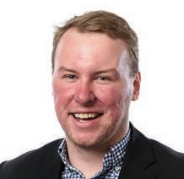

**MAV Board**

**As at 30 June 2020**

**Cr Coral Ross** City of Boroondara ***President***

* Councillor: 2002 - present
* Mayor: 2007-08, 2013-14, 2014-15
* Board Member, MAV Insurance
* Board Member, MAV WorkCare
* MAV Audit & Risk Committee Member
* Deputy Chair, MAV Human Services Advisory Committee
* Chair, MAV Professional Development Reference Group
* Board Member, Australian Local Government Association

**Cr Ruth Gstrein**

Corangamite Shire Council

***Deputy President Rural***

Rural South West Representative

* Councillor: 2002 - present
* Mayor: 2007-08, 2008-09,

2009-10

* Deputy Chair, MAV Planning Advisory Committee
* Chair, MAV Transport and Infrastructure Advisory Committee
* Board Member, Australian Local Government Association

**Cr Jennifer Anderson**

Macedon Ranges Shire Council

Rural North Central Representative

* Councillor: 2012 - present
* Mayor: 2014-15, 2016-17, 2017-18
* Chair, MAV Environment Advisory Committee

**Cr Murray Emerson**

Northern Grampians Shire Council

Rural North West Representative

* Councillor: 2012 - present
* Mayor: 2019 - present
* Board Member, MAV Insurance

**Cr Jami Klisaris**

City of Stonnington

***Deputy President Metropolitan***

Metropolitan South East Representative

* Councillor: 2012 - present
* Mayor: 2016-17

**Cr Josh Gilligan**

Wyndham City Council

Metropolitan West Representative

* Councillor: 2016 - present
* Mayor: 2019 - present

**6**

M U N I C I P A L A S S O C I A T I O N O F V I C T O R I A

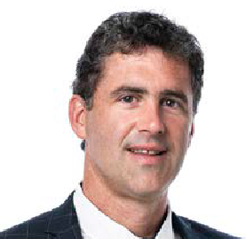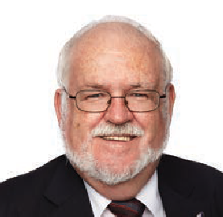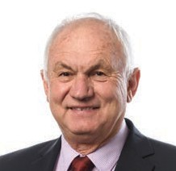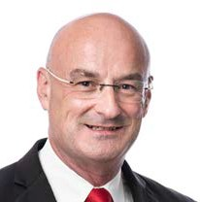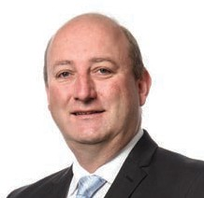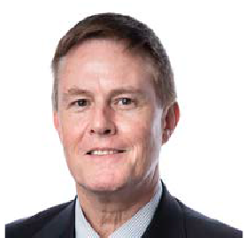

**Cr Ron Janas**

Alpine Shire Council

Rural North East Representative

* Councillor: 2012 - present
* Deputy Mayor: 2014-15
* Mayor: 2015-16, 2016-17, 2017-18,

2018-19

* Deputy Chair, Professional Development Reference Group

**Cr Sean O’Reilly**

City of Greater Dandenong

Metropolitan Southern Representative

* Councillor: 2012 - present
* Mayor: 2015-16

**Cr Nathan Hansford**

Golden Plains Shire Council

Rural South Central Representative

* Councillor: 2012 - present
* Board Member, MAV WorkCare
* Chair, MAV Emergency Management Advisory Committee
* Chair, MAV Human Services Advisory Committee

**Cr Peter Perkins**

Nillumbik Shire Council

Interface Representative

* Councillor: 2010- present
* Mayor: 2012-13

**Cr Rohan Leppert**

City of Melbourne

Metropolitan Central Representative

* Councillor: 2012 - present
* Deputy Chair, MAV Environment Advisory Committee
* Chair, MAV Planning Advisory Committee

**Cr Malcolm Hole**

Wellington Shire Council

Rural Gippsland Representative

* Councillor: 2000 - present
* Mayor: 2002-03, 2006-07
* Deputy Chair, MAV Emergency Management Advisory Committee

**Cr Mike Symon**

City of Maroondah

Metropolitan East Representative

* Councillor: 2016- present
* Deputy Mayor: 2017-18
* Mayor: 2019-20
* MAV Audit & Risk Committee Member
* Deputy Chair, MAV Transport and Infrastructure Advisory Committee

B O A R D S & G O V E R N A N C E – A N N U A L R E P O R T 2 0 2 0

**7**



**Board meeting attendance 2019-20**

No meeting held in January. * 16 October finance meeting.

**Board allowances and expenses**

The Board Allowance and Expense Policy provides for board members to receive an annual allowance, paid quarterly in advance. Board members are provided with a data allowance for accessing business papers via iPads and can claim out-of- pocket expenses for travel, parking, accommodation, meals and child-care when undertaking duties

as a board member. Expenses also reflect costs associated with representations on the Australian Local Government Association Board, Ministerial Advisory Council on Public Libraries, State Library Advisory Committee on Public Libraries and the Australian Packaging Covenant Council. The policy also allows for board members to attend MAV events including the Annual Conference, Councillor Development Weekend, Asset Management Conference and Future of Local Government Summit. Board expenses represent 0.33 per cent of the total expenditure of the MAV.

The amounts listed do not correlate to the allowance and expense payment figures in the financial statements as they include some payments made to board members for expenses incurred in 2018-19 and claimed in 2019-20. Some expenses are also charged to other areas in the MAV accounts.

Payments for expenses were made directly to board members, to their council for travel where they have utilised a council fleet vehicle, or directly to the hotel for some accommodation expenses. It should be noted that board members may lodge claims after 30 June 2020 for expenses incurred in the 2019-20 year, details of which will be reflected in the 2020-21 Annual Report.

**Audit & Risk Committee**

The Audit & Risk Committee is an advisory committee established at the direction of the MAV Board in 2004. The Committee operates under

a Charter approved by the Board, which was reviewed and updated in 2019. Its primary objective is to assist MAV management in maintaining

good governance, compliant financial reporting, management of risk, maintaining a reliable system of internal controls and monitoring organisational performance and facilitating the organisation's continued ethical development.

The Committee meets quarterly and additional meetings are convened as required. From 1 July 2019 members of the Committee included three independent members, the Chair John Watson, Sue Friend and Paul O'Connor, along with the

MAV President Coral Ross and MAV Board member Cr Mike Symon.

**8**

M U N I C I P A L A S S O C I A T I O N O F V I C T O R I A

Jul

Aug

Sep

Oct

Oct*

Nov

Dec

Feb

Mar

Apr

May

Jun

Coral Ross (President)

✓

✓

✓

✓ ✓

✓

✓

✗

✗

✓

✓

✓

Jennifer Anderson

✓

✓

✓

✓

✓

✓

✓

✓

✓

✓

✓

✓

Murray Emerson

✓

✓

✓

✓

✓

✓

✓

✓

✓

✓

✓

✓

Josh Gilligan

✗

✓

✗

✓

✓

✗

✓

✓

✓ ✓

✗

✓

Ruth Gstrein

✓

✗

✓

✓ ✓

✓

✓

✓

✓

✓

✓

✓

Nathan Hansford

✓

✓

✓

✓

✓

✓

✓

✓

✓

✓

✗

✓

Malcom Hole

✓

✓

✓

✓

✓

✓

✓

✓

✓

✓

✓

✓

Ron Janas

✓

✗

✓

✓

✓

✓

✓

✓

✓

✓

✓

✓

Jami Klisaris

✓

✗

✗

✓

✗

✓

✓

✓

✗

✓

✗

✓

Rohan Leppert

✓

✓

✓

✓

✗

✗

✓

✓

✓ ✓

✓

✓

Sean O’Reilly

✓

✓

✓

✓

✓

✓

✓

✓

✓

✓

✓

✓

Peter Perkins

✓

✓

✗

✓

✗

✓

✓

✓

✓ ✓

✓

✓

Mike Symon

✓

✓

✓

✓

✗

✓

✓

✓

✓

✓

✓

✓



^ President Cr Coral Ross was also provided with full private use of a motor vehicle at a cost of $23,770.75

* Deputy President

**Compliance**

In addition to the requirements of the *Municipal Association Act 1907* and MAV Rules, the MAV must comply with certain regulations and obligations applicable to statutory and public bodies. The MAV is also required to comply with the provisions of

its Australian Financial Services Licence (AFSL). The MAV has established a significant compliance and governance structure to ensure it meets its obligations under the AFSL. This structure includes a compliance and risk management strategy, plan and table, and disaster recovery and business continuity plan. An electronic risk management and compliance system operates within MAV Insurance to ensure compliance with its AFSL obligations.

Compliance with this system is audited annually by the MAV’s independent external auditor, and findings are reported to both the MAV Insurance Board and the MAV Board.

The work of the Committee is governed by an annual work program, aligned with the Audit & Risk Committee Charter, adopted at the start of

each year.

The Committee reviews and oversees the most current monthly financial statements for MAV’s operations.

Risk is a standing item on the agenda with the Chief Executive Officer reporting on emerging risks. Risk management is also a focus of the Committee’s financial oversight, Internal Audit Program and policy review.

In 2019-20, the Internal Audit Plan provided for the following audits:

* grants and project management
* JLT – IT General Controls.

In 2019-20 the sitting fees per meeting were:

**Chair –** $1,108.96

**Independent committee members –** $738.92.

A N N U A L R E P O R T 2 0 2 0

**9**

B O A R D S & G O V E R N A N C E –

Board member

Annual Allowance

Data Allowance

Expenses

TOTAL

Coral Ross (President)^

$69,590

$416

$5,642

$75,648

Jennifer Anderson

$9,769

$416

$5,065

$15,250

Murray Emerson

$9,769

$416

$5,353

$15,538

Josh Gilligan

$9,769

$416

$2,052

$12,237

Ruth Gstrein*

$14,347

$416

$8,469

$23,232

Nathan Hansford

$9,769

$416

$6,701

$16,886

Malcolm Hole

$9,769

$416

$5,257

$15,442

Ron Janas

$9,769

$416

$4,459

$14,643

Jami Klisaris*

$14,347

$416

$745

$15,508

Rohan Leppert

$9,769

$416

$1,904

$12,089

Sean O'Reilly

$9,769

$416

$1,071

$11,256

Peter Perkins

$9,769

$416

$2.300

$12,485

Mike Symon

$9,769

$416

$2,476

$12,661

**Total**

**$195,971**

**$5,410**

**$51,494**

**$252,875**

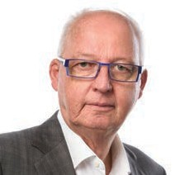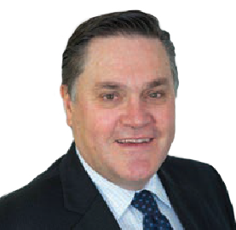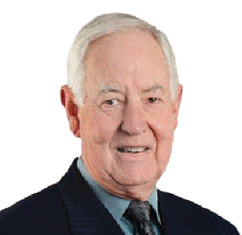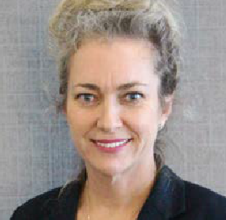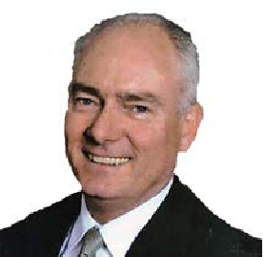

**MAV Insurance Board**

**As at 30 June 2020**

**Kate Reid**

Independent representative

- Appointed 2019

* General Counsel, Risk team, Corrs Chambers Westgarth
* Professional Standards & Indemnity Counsel,

Corrs Chambers Westgarth 2010-20

* Special/General Counsel Corrs Chambers Westgarth 2006-10

**Rob Spence**

***Chair*** *(appointed 21 August 2018)*

Independent representative

- Appointed 1997

* Board Member, MAV WorkCare
* Former Chief Executive Officer, Municipal Association of Victoria (until 20 August 2018)
* Trustee, Vision Super

**Cr Murray Emerson**

MAV Board representative

- Appointed 2019

* Board Member,

Municipal Association of Victoria

* Councillor: 2012 - present
* Mayor: 2019 - present

**Michael Guilmartin**

Independent representative

- Appointed 2009

* Chief Executive Officer, Victorian Managed Insurance Authority 1997-2007
* President,

Association of Risk Insurance Managers of Australia 1980

* Risk Manager,

Alcoa of Australia Ltd 1971-97

**John Bennie**

Victorian Council representative

- Appointed 2016

* Chief Executive Officer, City of Greater Dandenong
* Past Chair Southern Melbourne Regional Development Australia Committee
* State President, LGPro 2005-06
* National President, LGMA 2011
* Public Service Medal 2014

**Bruce Richards**

Independent representative

- Appointed 2019

* President, Richard Oliver Risk Managers - Chicago, 1993-95
* Director and Managing Principal Consulting Sedgwick/Marsh, 1995 -2000
* General Manager Operations and Client Services, VMIA , 2000-08
* National Manager - Risk Engineering - CGU Insurance, 2008-12

**1 0**

M U N I C I P A L A S S O C I A T I O N O F V I C T O R I A

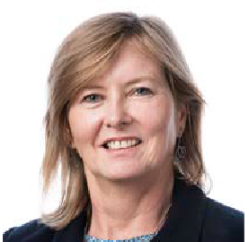

INSURANCE

**Cr Coral Ross**

MAV Board representative

- Appointed 2019

* President,

Municipal Association of Victoria

* Councillor: 2002 - present
* Mayor: 2007-08, 2013-14, 2014-15
* Board Member, MAV WorkCare
* MAV Audit & Risk Committee Member
* Deputy Chair, MAV Human Services Advisory Committee
* Chair, MAV Professional Development Reference Group
* Board Member, Australian Local Government Association

**Kerry Thompson**

Victorian Association representative

- Appointed 2018

* Chief Executive Officer, Municipal Association of Victoria
* Board Member, MAV WorkCare
* Member, State Crisis and Resilience Council
* Chair, cohealth
* Acting Chief Executive Officer, VicRoads 2018
* Deputy Secretary Investment and Business Transport for Victoria 2016-18
* Chief Executive Officer, Lost Dogs Home 2015-16
* Chief Executive Officer, Wyndham City Council 2010-15
* Chief Executive Officer, Maribyrnong City Council 2003-10

**Kerrie Williams**

Independent representative

- Appointed 2019

* Non-Executive Director, U Ethical Investors
* Member, Investment Committee, U Ethical Investors
* Member, People and Nominations Committee, U Ethical Investors
* Director of Strategy & People/ Head of Practice,

Frontier Advisors 2010-17

* Investment Consultant, Frontier Advisors 1997-2017

**Paul Woodhouse**

Independent representative

- Appointed 2019

* General Manager Corporate Services, Community Broker Network 2018
* General Manager Swann Insurance, Insurance Australia Group 2016-17
* Senior Manager Finance, Insurance Australia Group 2012-16

**Dr Katrena Stephenson** Tasmanian Association representative - Appointed 2015

* Chief Executive Officer,

Local Government Association of Tasmania

* Board Member (Observer), Local Government Professionals Tasmania

– A N N U A L R E P O R T 2 0 2 0

**1 1**

B O A R D S & G O V E R N A N C E



INSURANCE

**MAV Insurance Board attendance**

**Board sitting fees**

Independent Board members receive a sitting fee. In 2019-20 the annual sitting fee was:

**Chair**

$25,500

**Independent Board Member**

$15,300

**MAV Insurance Team**

**EXECUTIVE TEAM**

**Owen Harvey-Beavis**

General Manager

**Alison Lyon**

MAV Deputy CEO & General Counsel **Kristine Minghella**

MAV Insurance Counsel

**John Smith**

MAV Insurance Claims Adviser

**Kerry Thompson**

MAV Chief Executive Officer

**Olivia Boddeus**

Board Secretariat

**SERVICE PROVIDERS**

**Jardine Lloyd Thompson Taylor Fry Pty Ltd**

Actuary

**Frontier Advisors**

Investment Adviser

**EY**

Auditor

**National Australia Bank Asset Servicing** Custodian Services

**LEGAL PANEL**

**Minter Ellison DLA Piper Moray & Agnew Gilchrist Connell**

**Barry Nilsson**

(Tasmania)

**Shaun McElwaine**

(Tasmania)

**1 2**

M U N I C I P A L A S S O C I A T I O N O F V I C T O R I A

23 Aug

30 Sep

28 Oct

13 Dec

24 Apr

19 Jun

Rob Spence (Chair)

✓

✓

✓

✓

✓

✓

John Bennie

✓

✗

✓

✓

✓

✗

Murray Emerson

✓

✓

✗

✓

✓

✓

Michael Guilmartin

✓

✓

✓

✓

✓

✓

Kate Reid

n/a

n/a

n/a

✓

✓

✓

Bruce Richards

n/a

n/a

n/a

✓

✓

✓

Coral Ross

✗

✓

✓

✓

✓

✓

Katrena Stephenson

✓

✗

✓

✓

✓

✗

Kerry Thompson

✓

✓

✓

✓

✓

✓

Kerry Williams

n/a

n/a

n/a

✓

✓

✓

Paul Woodhouse

n/a

n/a

n/a

✓

✓

✓



INSURANCE

**Performance overview**

The MAV Insurance Liability Mutual Insurance (LMI) scheme offers public liability and professional indemnity insurance to Victorian and Tasmanian councils and other local government authorities.

The scheme is not-for-profit, which means any excess revenue is held in the fund to help keep premiums down for members – rather than paying income tax and dividends to shareholders like commercial providers.

The LMI scheme is tailored specifically to the local government sector. This is achieved using 25 years of claims data, and regular monitoring of

new and emerging risks and exposures facing local government. For example, the LMI scheme policy coverage was recently extended to include the use of drones, which has been identified as an emerging risk for local government. This demonstrates the LMI scheme’s ability to adapt to the changing needs of local government to ensure members have appropriate coverage.

**Financial summary**

The combined operating surplus for MAV Insurance for 2020 was $284,000, resulting in capital at

30 June 2020 of $200,000. The Commercial Crime scheme returned a modest operating deficit in line with budget. The LMI scheme produced a surplus of $280,000, strongly driven by administrative expense efficiencies and increased contributions

in line with actuarial advice. The scheme incurred

$32.7 million in claims for the year against a contribution pool of $26.6 million (inclusive of stamp duty), with a slight adverse movement in discount rates contributing $0.1 million.

**Liability Mutual Insurance Scheme**

After several years of intense market competition, we welcomed the nine councils that purchased public liability and professional indemnity insurance in the commercial market back into the LMI scheme on 30 June. This means the scheme has returned to full Victorian and Tasmanian local government

membership and continues LMI’s record of providing insurance to our sector irrespective of prevailing market conditions. The failure of the commercial market to provide adequate liability and indemnity coverage followed significant market hardening

over the past renewal cycles, which accelerated this year following the worldwide COVID losses, the southern-east Australian bushfires and increased concerns about the regulatory functions of local government all reducing the market’s appetite for the sector’s risk.

We strengthened the scheme’s governance structures, with the adoption of a revised policy for the composition of the MAV Insurance Board. Following the adoption of this policy, we recruited four new independent members with highly relevant expert skills across insurance operations, finance, investments and governance/legal. The MAV continued to work with its members and the Victorian Government to pursue structural reform to the scheme aimed at ensuring it can provide ongoing service to the sector into the future. Our consultation with members identified five potential reform options, with consultation continuing on the sector’s preferred structure.

B O A R D S & G O V E R N A N C E – A N N U A L R E P O R T 2 0 2 0

**1 3**



INSURANCE

**Service Delivery**

As COVID-19 removed our ability to directly provide a range of our services, we quickly moved to implement an online service model. These services ensured that MAV Insurance continued to deliver a significant service program, engaging with hundreds of council officers and responding to increased helpdesk queries. We supported members’ risk management activities through the implementation of a comprehensive package of risk and

legal services.

We commenced our new three-year risk management services plan that will continue to support councils’ operational staff to incorporate key risk controls into their work, with a particular focus on areas of high liability risk. These services also support member collaboration by supporting regional groupings to receive more comprehensive services. Once we moved to a work-from-home environment, we shifted these services to an videoconference model, with strong service continuity and member engagement. We provided additional Best Practice Forums across Victoria and Tasmania, which briefed members on key risk and claim issues, legal developments and information on the scheme and a conference in Tasmania. We continued to provide members with help desks for claims, legal, underwriting and risk and responded to over 1,000 queries in the year.

In total, $27.6 million was paid in claims for the 2020 year, with an additional $5.1 million in claim costs incurred by the scheme. 172new claims were received over the course of the year, which was a small reduction against the 2019 year claim lodgements.

**Implementation of Financial Strategy**

Over the 2019-20 year, we continued to implement the capital management strategy to secure and stabilise the financial position of the LMI scheme. We reviewed our Capital Management Plan to focus on stabilising the scheme through contribution increases, internal efficiencies and continuing cost negotiations with our commercial providers. We strongly targeted the retention and growth of our membership and were pleased to increase the number of Victorian councils that participate in the scheme to 70 in 2019-20 and 79 in 2020-21.

We developed a reinsurance strategy to provide financial security for the scheme, minimising

the capital requirements and protecting against deterioration in claims development. We fully implemented the reinsurance strategy, with underlying reinsurance costs moving by between

7.5 per cent to 15 per cent in a hardening market.

Our successful development and implementation of the financial strategy for LMI returned the scheme to a positive capital positon at 30 June 2020 and is expected to continue to strengthen the surplus capital position by the end of the upcoming year.

**Commercial Crime Scheme**

We continued to provide members with a cost efficient and effective fidelity insurance product through the Commercial Crime scheme, which has market-leading coverage and operates at low cost. Our review of the key risk areas for the sector indicate that members’ major areas of exposure will continue to be in the area of social engineering frauds, where frauds are occurring through fake invoices, fraudulent changes to the accounts and

through the online impersonation of council officers.

**1 4**

M U N I C I P A L A S S O C I A T I O N O F V I C T O R I A

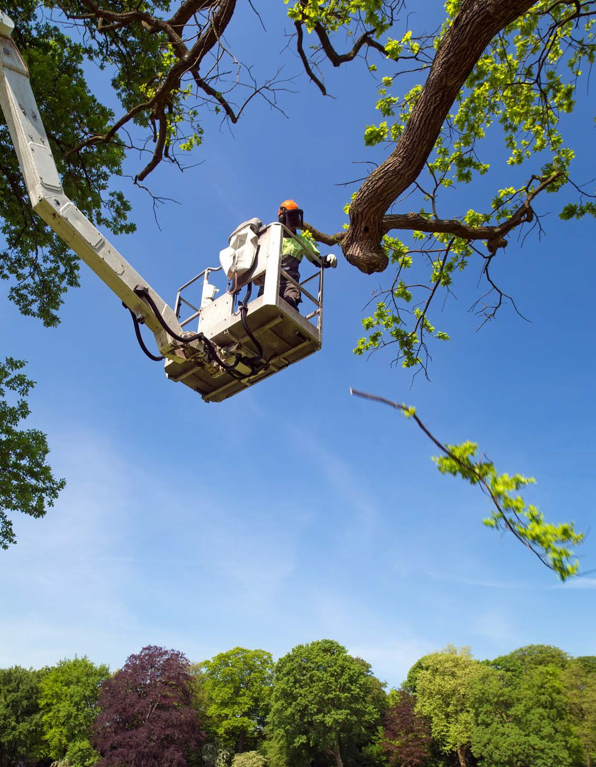

INSURANCE

B O A R D S & G O V E R N A N C E – A N N U A L R E P O R T 2 0 2 0

**1 5**

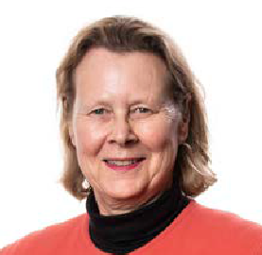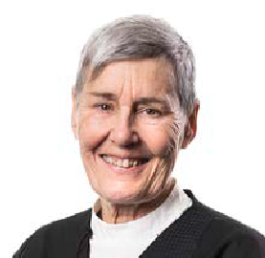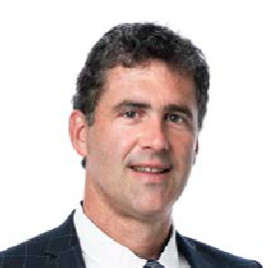

**MAV WorkCare Board**

**As at 30 June 2020**

**Marilyn Duncan**

***Chair***

**Prue Digby**

Independent representative

- Appointed 2017

* Board member, Chisholm TAFE
* Board member, Birrarung Council
* Board member, Hillview Quarries
* Board member, Ross Trust (Trustee)
* Former Municipal Monitor, Frankston City Council
* Former Chief Executive Officer, Victorian Building Authority
* Former Chief Executive Officer, City of Yarra
* Former Deputy Secretary, Department Environment, Land, Water and Planning

**Janet Dore**

Independent representative

- Appointed 2017

* Former Chief Executive Officer, City of Ballarat
* Former Chief Executive Officer, City of Newcastle
* Former Chief Executive Officer, Transport Accident Commission
* Former Non-Executive Director, nib Health Funds, Newcastle Airport and Institute for

Safety Compensation and Recovery Research

* Fellow Australian Institute of Company Directors (AICD)
* Former Municipal Monitor, Ararat Rural City Council

Independent representative

- Appointed 2017

* Former Chief Executive Officer, City of Brimbank
* President the Youth Junction Inc. Sunshine

**Cr Nathan Hansford**

MAV Board representative

- Appointed 2019

* Board Member,

Municipal Association of Victoria

* Councillor: 2012 - present
* Chair, MAV Emergency Management Advisory Committee
* Chair, MAV Human Services Advisory Committee

**1 6**

M U N I C I P A L A S S O C I A T I O N O F V I C T O R I A

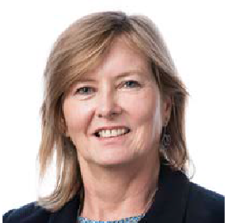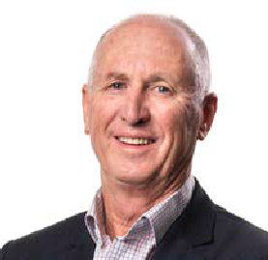

WORKCARE

**Cr Coral Ross**

MAV Board representative

- Appointed 2019

* President,

Municipal Association of Victoria

* Councillor: 2002 - present
* Mayor: 2007-08, 2013-14, 2014-15
* Board Member, MAV Insurance
* MAV Audit & Risk Committee Member
* Deputy Chair, MAV Human Services Advisory Committee
* Chair, MAV Professional Development Reference Group
* Board Member, Australian Local Government Association

**Kerry Thompson**

MAV representative

- Appointed 2018

* Chief Executive Officer, Municipal Association of Victoria
* Board Member, MAV Insurance
* Member, State Crisis and Resilience Council
* Chair, cohealth
* Acting Chief Executive Officer, VicRoads 2018
* Deputy Secretary Investment and Business Transport for Victoria 2016-18
* Chief Executive Officer, Lost Dogs Home 2015-16
* Chief Executive Officer, Wyndham City Council 2010-15
* Chief Executive Officer, Maribyrnong City Council 2003-10

**Michael Ulbrick**

Independent representative

- Appointed 2017

* Former Chief Executive Officer, Darebin City Council
* Former Chief Executive Officer, Surf Coast Shire Council
* Former Executive Director, WorkCover
* Independent member of a number of council and public sector audit and risk committees
* Independent member, Victoria Grants Commission

**Rob Spence**

Independent representative

- Appointed 2017

* Chair, MAV Insurance
* Former Chief Executive Officer, Municipal Association of Victoria (until 20 August 2018)
* Specialist Non-indigenous Director, WANTA Aboriginal Corporation

B O A R D S & G O V E R N A N C E – A N N U A L R E P O R T 2 0 2 0

**1 7**



WORKCARE

**MAV WorkCare Board attendance**

**Board sitting fees**

Independent Board members receive a sitting fee. In 2019-20 the annual sitting fee was:

**Chair**

$25,000

**Independent Board Member**

$15,000

**MAV WorkCare Team**

**EXECUTIVE TEAM**

**Kerry Thompson**

MAV Chief Executive Officer

**Chris Banks**

General Manager

**Anthony DeJong**

Chief Financial Officer

**Bernadette Brennan**

OHS Manager

**Nabeel Nizam**

Claims Manager

**Candice Lucas**

RTW Manager

**Derek Kan**

Senior Advisor, Performance Analytics

**David Kerwin** Senior Manager, Strategy and Service

**Katherine Bowman**

Senior Communications and Engagement Advisor

**Melissa Kuy**

Executive Assistant

**SERVICE PROVIDERS**

**Jardine Lloyd Thompson** Safety, RTW and claims management services

**Finity Consulting**

Scheme Actuary

**VFMC**

Investment Manager

**Frontier Advisors**

Investment Adviser

**EY**

Auditor

**National Australia Bank Asset Servicing** Custodian Services

**OCCUPATIONAL REHABILITATION PROVIDER (ORP) PANEL**

IPAR

Nabenet

Workable Consulting Rehab Management

**Private Investigation Provider Panel**

A Matter of Fact Macil Group SECA

**Claims Auditor**

BRM Risk Solutions

**LEGAL PANEL**

Hall and Wilcox Wisewould Mahony Minter Ellison Lander and Rogers

**OHS Auditor**

Verus Australia

**Surveys and Research**

Wallis Research Group

**1 8**

M U N I C I P A L

A S S O C I A T I O N O F V I C T O R I A

14 Aug

2 Oct*

16 Oct

19 Dec

27 Feb

23 Apr

25 Jun

Marilyn Duncan

✓

✓

✓

✓

✓

✓

✓

Prue Digby

✓

✓

✓

✓

✓

✓

✓

Janet Dore

✓

✓

✓

✓

✓

✓

✓

Nathan Hansford

✓

✓

✓

✓

✓

✓

✗

Coral Ross

✗

✓

✓

✓

✗

✓

✓

Rob Spence

✓

✓

✓

✓

✓

✓

✓

Kerry Thompson

✓

✓

✓

✓

✓

✓

✓

Michael Ulbrick

✓

✓

✓

✗

✗

✓

✓



WORKCARE

**Performance overview**

MAV WorkCare continued to deliver services and support to the Scheme’s 31 members throughout 2019-20, helping to improve workplace health, safety, wellbeing and quality of life outcomes

for member employees who have experienced workplace injury or illness.

In less than three years of operation, the Scheme has achieved significant results, with a particular focus on workplace health and safety and return to work (RTW). In March 2020, the MAV lodged a comprehensive application to WorkSafe Victoria for renewal of approval as a self-insurer and is

continuing to take steps to ensure a positive licence outcome for members. Promotion of the Scheme’s benefits and pursuit of new members remained key priorities for the MAV WorkCare team, reflecting our ambition to grow the Scheme until all 79 Victorian councils (and other eligible entities) are members of the mutual.

**COVID-19**

MAV WorkCare provided high quality support and services to members throughout the COVID-19 pandemic. To date, there have been no new claims lodged which have alleged COVID-19 as an injury/ illness sustained during employment which is testament to how well members have responded to the unique challenges posed by the pandemic.

Due to COVID-19 restrictions, some Scheme members required additional support to complete remedial action activity with Scheme-wide support also provided through the delivery of online information and training forums.

**Occupational health and safety (OHS)**

The Scheme’s suite of prevention services continued to evolve throughout the year with 420 on-site visits undertaken to support improvement in members’ OHS management system arrangements. Online OHS forums were delivered to all parts of Victoria focussing on key safety topics specific

to local government, including OHS roles and responsibilities, management systems development/ audit learnings, contractor management, hazard identification and risk control and legislative change (industrial manslaughter).

During 2019-20, eight Scheme members underwent an OHS audit, either by WorkSafe Victoria or the MAV’s independent auditor, with significant efforts

and improvements made to enhance overall systems maturity within each of organisations audited.

**Claims and return to work (RTW)**

In 2019-20, MAV WorkCare paid approximately

$12.4 million in entitlements to support injured and ill workers to recover and RTW safely and sustainably. The Scheme supported 90.16 per cent of injured workers (with at least one day of work

lost) to RTW within six months of claim lodgement.

A Scheme-wide RTW framework was rolled out in January 2020 (comprising tailored policy and procedural documentation/tools) designed to

establish and standardise ‘best practice’ processes and practices.

In 2019-20, MAV WorkCare achieved an overall result of 86 per cent in its WorkSafe Victoria ‘regulatory’ claims and RTW audit, with a compliance rate of 85.71 per cent achieved for the RTW component. The Scheme’s timeliness in delivering entitlements to injured workers contributed to these high compliance rates.

As part of the Scheme’s 2019-20 member and injured worker satisfaction survey, MAV WorkCare achieved an overall satisfaction rate of 91 per cent. This was supported by WorkSafe Victoria’s 2020 satisfaction survey results which placed MAV well above the self-insurer average, as well as the results achieved by WorkSafe Victoria’s claims management agents.

In terms of liability management, the Scheme’s independent actuarial valuation confirmed an overall claims liability improvement (i.e. release) of

$2.5 million for 2019-20.

**Financials**

MAV WorkCare revised its investment strategy in early-2020 electing to shift to a more conservative approach. As part of the change, all Scheme investments were placed with the Victorian Funds Management Corporation (VFMC). MAV WorkCare is now placing less emphasis on investment income as part of its overall budget, with the Scheme’s targeted income from investment for 2020-21 being 8% of total income, down from 17.5% in 2019-20.

Overall, the Scheme’s 2019-20 results bode well for the future in terms of supporting MAV’s longer-term objective to build a high-performing, sustainable workers’ compensation self-insurance scheme dedicated to delivering tailored benefit to the local government sector.

B O A R D S & G O V E R N A N C E – A N N U A L R E P O R T 2 0 2 0

**1 9**

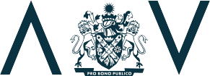



**Municipal Association of Victoria Level 12, 60 Collins Street, Melbourne**

**GPO Box 4326, Melbourne 3001**

**Phone: 03 9667 5555**

**Fax: 03 9667 5550**

[**Email: inquiries@mav.asn.au**](mailto:inquiries@mav.asn.au) **mav.asn.au**

**M A V**

**A N N U A L**

**R E P O R T**

**2 0 2 0**