Appendix 1 : Maternal and Child Health
COVID-19 Contingency Planning –
Staff shortages
28 February 2022
OFFICIAL

Purpose
The purpose of this document is to support Maternal and Child Health (MCH) services to implement prioritised service delivery during temporary changes to MCH services due to the impact of COVID-19.

Background
Due to the impact of the COVID-19 pandemic, health services in Victoria are experiencing significant workforce challenges and shortages that is impacting service delivery.
In recognition of these extreme pressures, on 18 January 2022, a Pandemic Code Brown was announced across public health services in metropolitan Melbourne and regional Victoria for a period of four to six weeks.
The Pandemic Code Brown has been implemented in recognition of the extreme pressures on the Victorian health system and health workforces due to COVID-19. A coordinated approach is considered necessary at this time to ensure our most vulnerable new mothers/caregivers, infants and families are supported in the face of overwhelming demand on health services.
Under the Stage 4 -Maternal and Child Health COVID-19 surge support for maternity and neonatal services guidance, developed in consultation with MAV, local government and the ANMF, to date three metropolitan health service Chief Operating Officers have requested a total of 31.6 FTE in MCH surge support for maternity services.
In parallel, some metropolitan MCH services are grappling with extreme workforce pressures, which is severely compromising essential MCH service delivery to local families. These services have exhausted all levers available to realise additional workforce capacity.
Regional and rural services are not as significantly impacted as metropolitan services at this stage.
To ensure that the most vulnerable new mothers/caregivers and babies receive timely and essential health support, a system wide, time-limited initial 6-week Metropolitan MCH COVID-19 surge response is required across all metropolitan Local Government MCH services. This coordinated approach will help to mobilise the required level of MCH Nursing resources to support overwhelmed metropolitan MCH services and maternity services, aligned with the Pandemic Code Brown announced on 18 January 2022.
At the request of the Department of Health and with the support of the Municipal Association of Victoria, maternity services and local government Maternal and Child Health services in Metropolitan areas will work together to deliver essential health services for new mothers and newborns in both hospital and community-based settings, effective from Friday 28 January 2022 for an initial period of 6 weeks.
This will ensure that care for mothers/caregivers and their newborns continues to be delivered:
- in acute hospital maternity settings
- on discharge from hospital into the community
- through community-based follow up support by MCH services.
This will impact the provision of other MCH Key Ages and Stages consultations for a short period of time.
Prioritising MCH services to vulnerable children and families
The time-limited Metropolitan MCH COVID-19 surge response is required across all metropolitan Local Government MCH services and is expected to be in place from Friday 28 January 2022 to Friday 11 March 2022.
During this period, MCH services will temporarily prioritise essential services to the most vulnerable children and families including:
- Infants aged 0-8 weeks and their mother/primary caregiver
- Aboriginal infants, children and families of all ages (0- school age)
- Children and families with additional needs or concerns including families on the Enhanced Maternal and Child Health Program or with COVID
- Families who contact MCH services with genuine concerns about deferring or delaying their MCH consultation
All vulnerable children and families will still be eligible for MCH appointments.
Alternative supports for families
Some parents or families will have concerns about missing their next appointment because of changed MCH service delivery arrangements.
MCH services should encourage families to access alternative supports including:
- Contacting their regular MCH service if they have significant concerns and need their MCH service to proceed.
- Calling the Maternal and Child Health Line on 13 22 29. The Line is staffed 24-hours, 7-days-a-week by qualified MCH Nurses and provides confidential support and advice about the care and health of children from birth to school age.
- Contacting their regular General Practitioner or other regular health professional.
- Visiting a SuperCare pharmacy which provides 24-hour, 7-day-a-week access to healthcare advice and pharmacy services, including a free, on-site nursing service from 6-10pm each night.
- Contacting an Optometrist for vision testing.

What minimum percentage of time is required to undertake levels of prioritised Universal service delivery?
The Universal MCH (UMCH) comprises two components.
- KAS consultations
- Flexible service capacity for those who require additional support outside the KAS visits including those with COVID-19 (additional visits, telephone consultations, group work and community strengthening activities).
As a general rule the split between the two components is 75/25, with 75 per cent of the UMCH program targeted towards KAS consultations and 25 percent to flexible service capacity.
The following provides guidance on the minimum percentage of time allocated to undertake prioritised Universal service delivery.

Universal KAS service delivery
Table 1. Allocation for KAS service delivery (* rounded percentages)
KAS Visit | Time in minutes | Time in hours | Percentage of total KAS time | Percentage of KAS time required to undertake age levels of KAS visits
HV | 60 | 1 | 15% | 15%
2wks | 30 | 0.5 | 7% | 22%
4wks | 60 | 1 | 15% | 37%
8wks | 30 | 0.5 | 7% | 44%
4mths | 30 | 0.5 | 7% | 52%
8mths | 45 | 0.75 | 11% | 63%
12mths | 30 | 0.5 | 7% | 70%
18mths | 45 | 0.75 | 11% | 81%
2years | 30 | 0.5 | 7% | 89%
3.5 years | 45 | 0.75 | 11% | 100%
 | 405 | 6.75

Prioritising 0-8 weeks and additional needs

To implement the Metropolitan MCH COVID-19 surge response, at a minimum, 44 per cent of time allocated to KAS service delivery is required to undertake routine KAS consultations for the 0-8 weeks priority age group (see Table 1).
In addition, to prioritising 0-8 weeks, there is a requirement to support Aboriginal infants and children and those with additional needs or concerns aged 4 months and above for their KAS visits. It is anticipated this would be 20 per cent of those scheduled for their visits 4 months and above. An additional 11 percent of time would be required to undertake these visits.
- 0-8 weeks - 44 percent
- Aboriginal children and those with additional needs (4mths - 3.5 years) – 11 percent
A total of 55 percent of KAS activity is required to undertake prioritised service delivery 0-8 weeks

A similar calculation for staffing can be applied for each KAS visit universally supported above 8 weeks of age
The level of MCH service prioritisation may need to be adjusted based on available staffing capacity,

Delivering services for 0-4 months and additional needs
At a minimum, 52 per cent of time allocated to KAS service delivery is required to undertake routine KAS consultations for the 0-4 months aged group (see Table 1).
In addition, to 0-4 months, there is a requirement to support Aboriginal infants and children and those with additional needs or concerns aged eight months and above for their KAS visits. It is anticipated this would be 20 per cent of those scheduled for their visits 8 months – 3.5 years. An additional 10 percent of time would be required to undertake these visits.
- 0-4 months – 52 percent
- Aboriginal children and those with additional needs (8mths – 3.5 years) – 10 percent.
A total of 62 percent of KAS activity is required to undertake prioritised service delivery 0-4 months

Delivering services for 0-8 months and additional needs
At a minimum 63 per cent of time allocated to KAS service delivery is required to undertake 0-8 months for routine KAS consultations (see Table 1).
In addition, to prioritising 0-8 months, there is a requirement to support Aboriginal infants and children and those with additional needs or concerns aged 12 months and above for their KAS visits. It is anticipated this would be 20 per cent of those scheduled for their visits 12 months – 3.5 years. An additional 7 percent of time would be required to undertake these visits.
- 0-8 months – 63 percent
- Aboriginal children and those with additional needs (12months -3.5 years) – 7 percent
A total of 70 percent of time allocated to KAS activity is required to undertake prioritised service delivery 0-8 months

Delivering services for 0-12 months and additional needs
At a minimum 70 per cent of time allocated to KAS service delivery is required to undertake 0-12 months for routine KAS consultations (see Table 1).
In addition, to prioritising 0-12 months, there is a requirement to support Aboriginal infants and children and those with additional needs or concerns aged 18 months and above for their KAS visits. It is anticipated this would be 20 per cent of those scheduled for their visits 18 months – 3.5 years. An additional 6 percent of staff would be required to undertake these visits.
- 0-12 months – 70 percent of staff
- Aboriginal children and those with additional needs (18 months – 3.5 years) – 6 percent
A total of 76 percent of time allocated to KAS activity is required to undertake prioritised service delivery 0-12 months

Calculations for prioritised levels of KAS service delivery are summarised in Table 2

Table 2. Summary of percentage of time allocated to KAS service delivery for each level of prioritisation
Level of prioritisation | Minimum % time for age level universal KAS support | Aboriginal children and those with additional needs (>than minimum age group – 3.5 years | Total % of KAS time for prioritised service delivery
0-8 weeks* | 44% | 11% | 55%
0-4 months* | 52% | 10% | 62%
0-8 months* | 63% | 7% | 70%
0-12 months* | 70% | 6% | 76%
0-18 months | 81% | 4% | 85%
0-2 years | 89% | 2% | 91%

Flexible service capacity
The flexible service capacity represents approximately 25 per cent of service provision of the UMCH program. During full-service capacity, it assumes 40 per cent of first-time mothers 0-12 months require additional support (3 hours) and 40 per cent of all enrolments 0-6 years require additional support (3 hours).
Based on the level of prioritisation of service delivery, reduction in the flexible service capacity will need to be considered. Reduction can be based on the percentage required for prioritised service delivery at each age level.

First time parent groups
During a prioritised response, MCH services should consider adjusting First time parent groups to free up MCH nurses to assist with staffing shortages and provide prioritised service delivery. Adjustments could include decrease in intensity (number and length of group sessions), pivoting to online support and cessation of groups.

Lactation support
During a prioritised response, services undertaking lactation support should continue to provide these services if possible. These services will support mothers, decrease the need for additional MCH visits and prevent additional pressure on hospital services.

Sleep and Settling outreach and groups (additional to flexible service capacity)
During a prioritised response, MCH services should consider adjusting Sleep and Settling outreach and groups to free up MCH nurses to assist with staffing shortages and provide prioritised service delivery. Adjustments could include decrease in intensity (number and length of group/individual sessions), pivoting to online support and cessation.

Family violence consultations (additional to flexible service capacity)
During a prioritised response, Universal MCH services should continue to provide these consultations as identified and/or direct clients to alternative supports through the Orange Door/Child FIRST or consider referral to the EMCH program if there is capacity to do so.

Calculation of staffing requirements for Enhanced MCH (EMCH) program service delivery
Due to the demands of COVID and the Code Brown health service response, the EMCH program may also be challenged with decreases in staffing capacity. The intensity of service delivery (referrals into, number and length of visits) will need to be considered within this context. KAS assessments due for these clients should be undertaken within the EMCH visits.
If services are unable to provide prioritised service delivery for 0-8 weeks and additional needs in Universal MCH, Enhanced MCH nurses will need to be allocated to the Universal program to support prioritised service delivery.

How to set hours in CDIS to reflect prioritised service delivery in Universal MCH

Working out approximate CDIS allocation for prioritised 0–8-week and additional needs MCH service delivery
NB: These calculations are simplified by utilising the number of Birth Notifications. It is understood the true measure of workload needs to be undertaken utilsing enrolments in each year cohort.
- Obtain annual number of birth notices
- Divide by 52 to approximate weekly number of birth notices (may need to calculate this on a shorter time period for areas where there has been significant growth in the previous 12 months)
  - This is the weekly number of HV/2w/4w/8w KAS to be put into CDIS calendars across the municipality
  - An annual report by site can be used to break this into individual sites/calendars
- Multiply the weekly number of birth notifications by 0.2 (representing 20 per cent) for each 4m+ KAS to accommodate for Aboriginal children and those with additional needs or concerns
  - This is the weekly number of 4mths, 8mths,12mths, 18mths, 2 years and 3.5 years to be put in the CDIS calendars across the municipality
  - An annual report by site can be used to break this into individual sites/calendars
- To calculate the approximate time for the flexible service capacity
  - Multiply the annual birth notifications by 0.4 (representing 40 per cent supported) to get the number supported by the flexible service capacity.
  - Then multiply this number by 6 hours (number of hours supported by the flexible service capacity) and then by the percentage of the level of prioritised service delivery time.
  - Divide this number by 52 to get the hours per week
  - This will provide the time for flexible service delivery per week at the prioritised service delivery level
- Allow two hours administration time per full day, plus 2.5 hours for meetings per week.
- 55 per cent service capacity set across KAS visits and the flexible service capacity with the addition of administration and meeting times during the week approximates the staffing capacity required to deliver the prioritised UMCH program.

To undertake 0-8 weeks and additional needs prioritisation, a minimum of 55 per cent of the UMCH program workforce is required.

Example of individual service and site calculations based on prioritised 0-8 weeks and additional needs service delivery
- This service is operative at 0-8 weeks prioritised service delivery (i.e., 55 per cent of KAS service capacity)
- The service has 1300 birth notifications per year and
- A 1 FTE individual site has 130 birth notices/year.

Service calculation (average)
- 1300 birth notifications
- 1300 ÷ 52 = 25 birth notifications per week.
25 - HV, 2wk, 4wk and 8wk visits need to be allocated across the service per week
- 25 birth notifications x 0.2 = 5
5 - 4mth, 8mth, 12mth, 18mth, 2yrs and 3.5 yrs. visits need to be allocated across the service per week
- 1300 x 0.4 = 520 (number supported by flexible service capacity)
  - 520 x 6 hrs. = 3120hrs (number of hours per year)
  - 3120hrs x 0.62 (representing 55% prioritised service) = 1716hrs per year
  - 1716 hrs. ÷ 52 = 33 hrs. per week
33 hrs. per week needs to be allocated across the service for flexible service capacity

Site calculation (average)
- 130 birth notifications
- 130 ÷ 52 = 2.5 birth notifications per week.
2.5 - HV, 2wk, 4wk and 8wk visits need to be allocated across the site per week which means 5 - HV, 2wk, 4wk and 8wk visits need to be allocated across the site per fortnight
- 2.5 birth notifications x 0.2 = 0.5
0.5 - 4mth, 8mth, 12mth, 18mth, 2yrs and 3.5 yrs. visits need to be allocated across the service per week which means 1 - 4mth, 8mth, 12mth, 18mth, 2yrs and 3.5 yrs. visit need to be allocated across the site per fortnight
- 130 x 0.4 = 52 (number supported by flexible service capacity)
  - 52 x 6 hrs. = 312hrs (number of hours per year)
  - 312hrs x 0.55 (representing 55% prioritised service) = 172 hrs. per year
  - 172hrs ÷ 52 = 3.3 hrs. per week (rounded)
3.3 hrs. per week needs to be allocated across the site for flexible service capacity
The complimentary excel spreadsheet – ‘Prioritised service delivery’ provides a template for calculations and can be utilised by services by adjusting the Birth Notification numbers to local needs.
The screenshot, on page 8, of a CDIS diary shows how KAS visits, the flexible service capacity, administration, and meeting times can be allocated over a two-week period/fortnight for 0-8 weeks prioritised service delivery.

Prioritised 0-8 weeks

Week 1 –
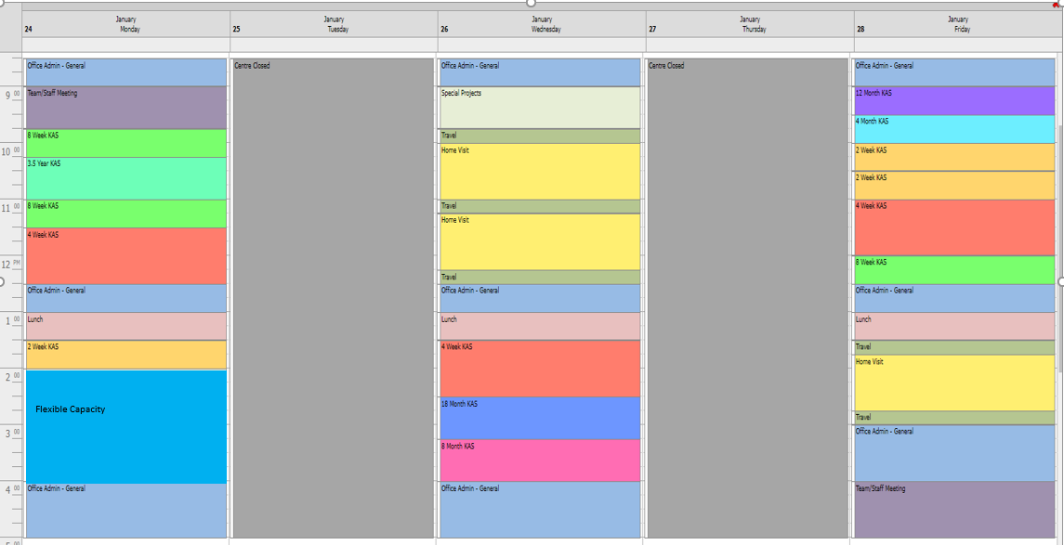

Week 2 –
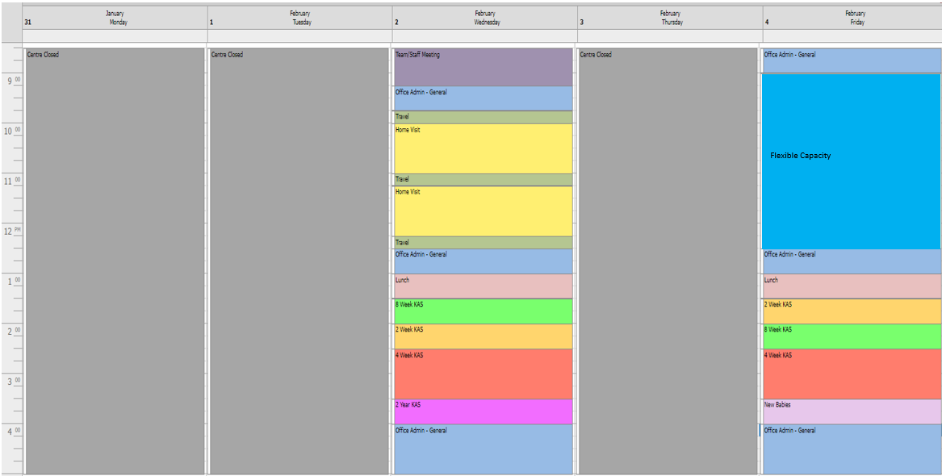

Example of individual service and site calculations based on prioritised 0-4 months and additional needs service delivery
- This service is operative at 0-4 months prioritised service delivery (i.e., 62 per cent of KAS service capacity)
- The service has 1300 birth notifications per year and
- A 1 FTE individual site has 130 birth notices/year.

Service calculation (average)
- 1300 birth notifications
- 1300 ÷ 52 = 25 birth notifications per week.
25 - HV, 2wk, 4wk, 8wk and 4-month visits need to be allocated across the service per week
- 25 birth notifications x 0.2 = 5
5 - 8mth, 12mth, 18mth, 2yrs and 3.5 yrs. visits need to be allocated across the service per week
- 1300 x 0.4 = 520 (number supported by flexible service capacity)
  - 520 x 6 hrs. = 3120hrs (number of hours per year)
  - 3120hrs x 0.62 (representing 62% prioritised service) = 1934 hrs per year
  - 1934 hrs. ÷ 52 = 37 hrs. per week
37 hrs. per week needs to be allocated across the service for flexible service capacity

Site calculation (average)
- 130 birth notifications
- 130 ÷ 52 = 2.5 birth notifications per week.
2.5 - HV, 2wk, 4wk, 8wk and 4-month visits need to be allocated across the site per week which means 5 - HV, 2wk, 4wk, 8wk and 4-month visits need to be allocated across the site per fortnight
- 2.5 birth notifications x 0.2 = 0.5
0.5 - 8mth, 12mth, 18mth, 2yrs and 3.5 yrs. visits need to be allocated across the service per week which means 1 - 8mth, 12mth, 18mth, 2yrs and 3.5 yrs. visit needs to be allocated across the site per fortnight
- 130 x 0.4 = 52 (number supported by flexible service capacity)
  - 52 x 6 hrs. = 312hrs (number of hours per year)
  - 312hrs x 0.62 (representing 62% prioritised service) = 193 hrs. per year
  - 193hrs ÷ 52 = 3.7 hrs. per week (rounded)
3.7 hrs. per week needs to be allocated across the site for flexible service capacity
The complimentary excel spreadsheet – ‘Prioritised service delivery’ provides a template for calculations and can be utilised by services by adjusting the Birth Notification numbers to local needs.
The screenshot, on page 10, of a CDIS diary shows how KAS visits, the flexible service capacity, administration, and meeting times can be allocated over a two-week period/fortnight for 0-4 months prioritised service delivery.

Prioritised 0-4 months

Week 1 –
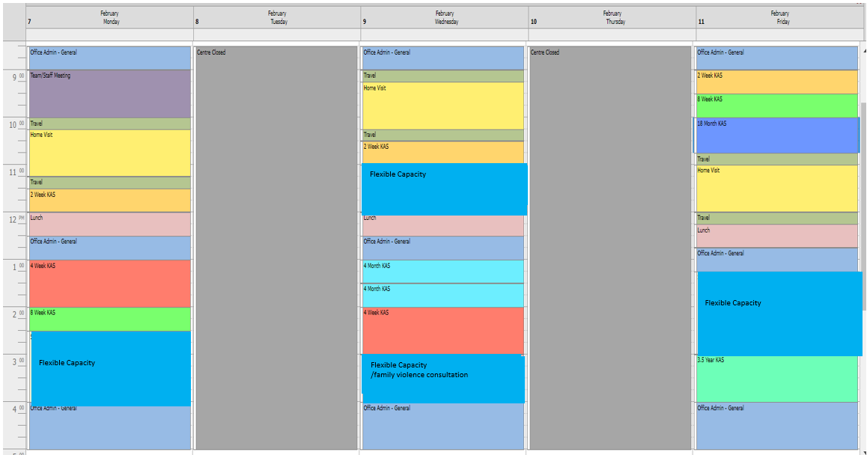

Week 2 –
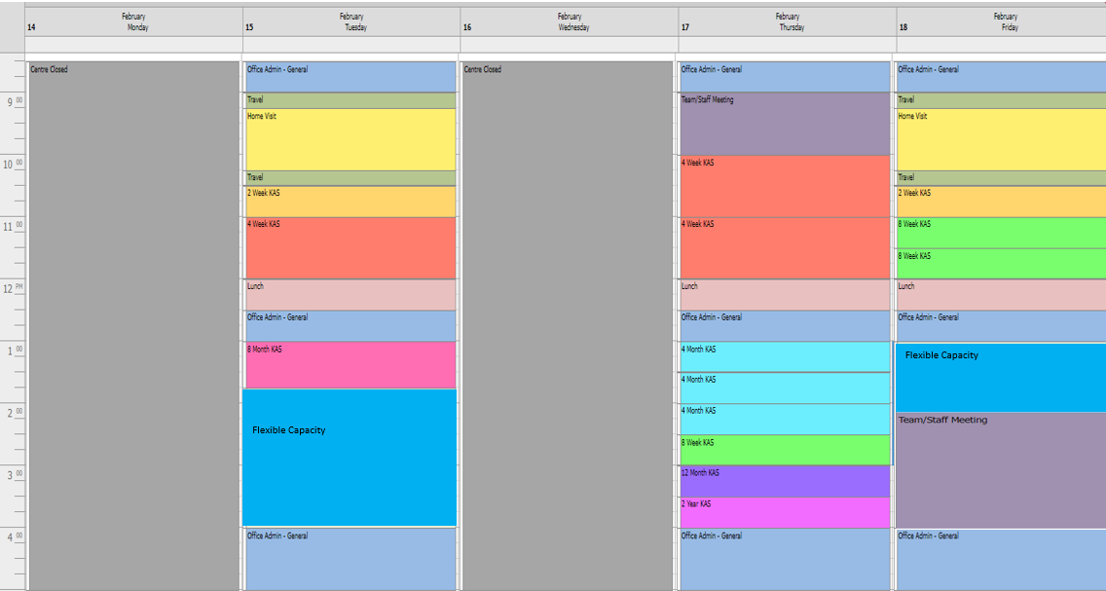

Example of individual service and site calculations based on prioritised 0-8 months and additional needs service delivery
- This service is operative at 0-8 months prioritised service delivery (i.e., 70 per cent of KAS service capacity)
- The service has 1300 birth notifications per year and
- A 1 FTE individual site has 130 birth notices/year.

Service calculation (average)
- 1300 birth notifications
- 1300 ÷ 52 = 25 birth notifications per week.
25 - HV, 2wk, 4wk, 8wk, 4mth, and 8-month visits need to be allocated across the service per week
- 25 birth notifications x 0.2 = 5
5 -12mth, 18mth, 2yrs and 3.5 yrs. visits need to be allocated across the service per week
- 1300 x 0.4 = 520 (number supported by flexible service capacity)
  - 520 x 6 hrs. = 3120hrs (number of hours per year)
  - 3120hrs x 0.70 (representing 70% prioritised service) = 2184 hrs per year
  - 2184 hrs. ÷ 52 = 42hrs. per week
42 hrs. per week needs to be allocated across the service for flexible service capacity

Site calculation (average)
- 130 birth notifications
- 130 ÷ 52 = 2.5 birth notifications per week.
2.5 - HV, 2wk, 4wk, 8wk, 4mth and 8-month visits need to be allocated across the site per week which means 5 - HV, 2wk, 4wk, 8wk, 4 month and 8-month visits need to be allocated across the site per fortnight
- 2.5 birth notifications x 0.2 = 0.5
0.5 - 12mth, 18mth, 2yrs and 3.5 yrs. visits need to be allocated across the service per week which means 1 - 12mth, 18mth, 2yrs and 3.5 yrs. visit needs to be allocated across the site per fortnight
- 130 x 0.4 = 52 (number supported by flexible service capacity)
  - 52 x 6 hrs. = 312hrs (number of hours per year)
  - 312hrs x 0.70 (representing 70% prioritised service) = 218hrs. per year
  - 218hrs ÷ 52 = 4.2 hrs. per week (rounded)
4.2 hrs. per week needs to be allocated across the site for flexible service capacity
The complimentary excel spreadsheet – ‘Prioritised service delivery’ provides a template for calculations and can be utilised by services by adjusting the Birth Notification numbers to local needs.
The screenshot, on page 12, of a CDIS diary shows how KAS visits, the flexible service capacity, administration, and meeting times can be allocated over a two-week period/fortnight for 0-8 months prioritised service delivery.

Prioritised 0-8 months

Week 1 –
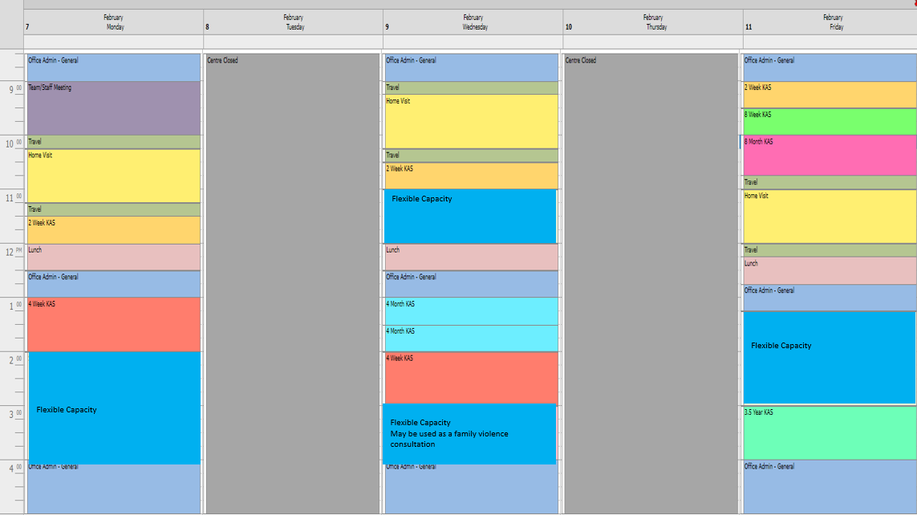

Week 2 –
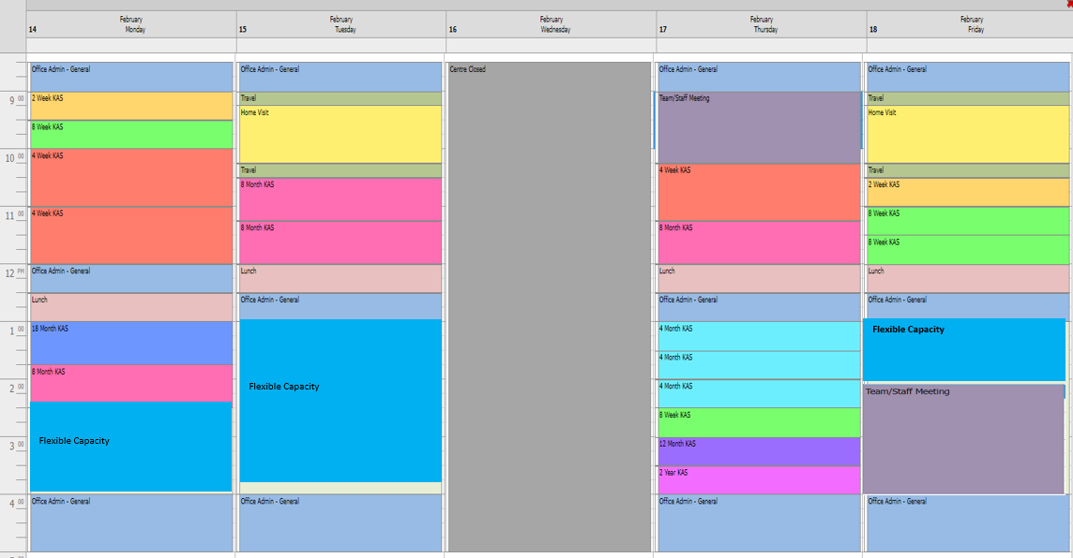

Example of individual service and site calculations based on prioritised 0-12 months and additional needs service delivery
- This service is operative at 0-12 months prioritised service delivery (i.e., 76 per cent of KAS service capacity)
- The service has 1300 birth notifications per year and
- A 1 FTE individual site has 130 birth notices/year.

Service calculation (average)
- 1300 birth notifications
- 1300 ÷ 52 = 25 birth notifications per week.
25 - HV, 2wk, 4wk, 8wk, 4mth, 8mth and 12-month visits need to be allocated across the service per week
- 25 birth notifications x 0.2 = 5
5- 18mth, 2yrs and 3.5 yrs. visits need to be allocated across the service per week
- 1300 x 0.4 = 520 (number supported by flexible service capacity)
  - 520 x 6 hrs. = 3120hrs (number of hours per year)
  - 3120hrs x 0.76 (representing 76% prioritised service) = 2371 hrs per year
  - 2371 hrs. ÷ 52 = 45.6hrs. per week
45.6 hrs. per week needs to be allocated across the service for flexible service capacity

Site calculation (average)
- 130 birth notifications
- 130 ÷ 52 = 2.5 birth notifications per week.
2.5 - HV, 2wk, 4wk, 8wk, 4mth, 8mth and 12-month visits need to be allocated across the site per week which means 5 - HV, 2wk, 4wk, 8wk, 4 mth, 8 mth and 12-month visits need to be allocated across the site per fortnight
- 2.5 birth notifications x 0.2 = 0.5
0.5 - 18mth, 2yrs and 3.5 yrs. visits need to be allocated across the service per week which means 1 - 18mth, 2yrs and 3.5 yrs, visit needs to be allocated across the site per fortnight
- 130 x 0.4 = 52 (number supported by flexible service capacity)
  - 52 x 6 hrs. = 312hrs (number of hours per year)
  - 312hrs x 0.76 (representing 76% prioritised service) = 237hrs. per year
  - 237hrs ÷ 52 = 4.5 hrs. per week (rounded)
4.5 hrs. per week needs to be allocated across the site for flexible service capacity
The complimentary excel spreadsheet – ‘Prioritised service delivery’ provides a template for calculations and can be utilised by services by adjusting the Birth Notification numbers to local needs.
The screenshot, on page 14, of a CDIS diary shows how KAS visits, the flexible service capacity, administration, and meeting times can be allocated over a two-week period/fortnight for 0-12 months prioritised service delivery.

Prioritised 0-12 months

Week 1 –
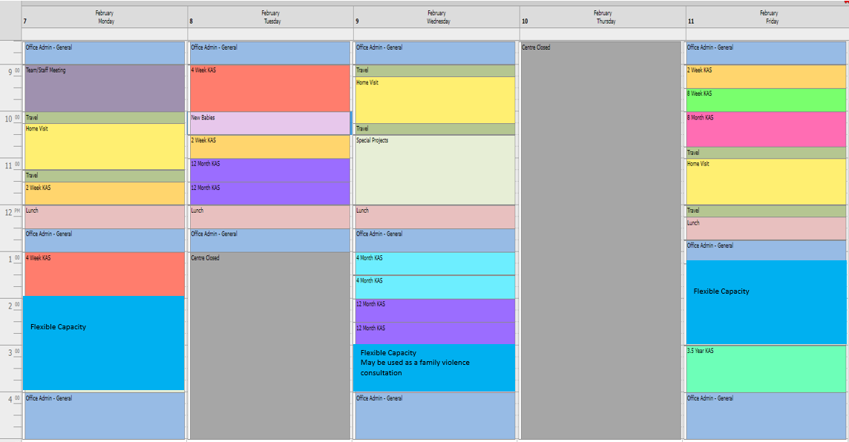

Week 2-
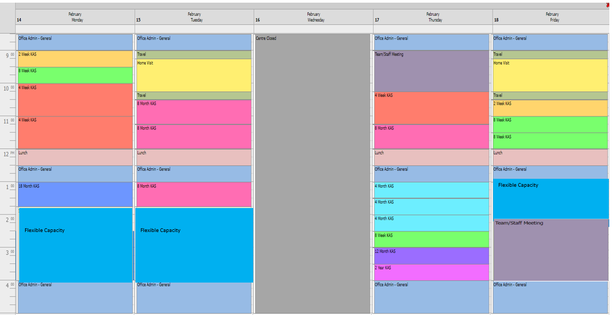

Example of individual service and site calculations based on prioritised 0-18 months and additional needs service delivery
- This service is operative at 0-18 months prioritised service delivery (i.e., 85 per cent of KAS service capacity)
- The service has 1300 birth notifications per year and
- A 1 FTE individual site has 130 birth notices/year.

Service calculation (average)
- 1300 birth notifications
- 1300 ÷ 52 = 25 birth notifications per week.
25 - HV, 2wk, 4wk, 8wk, 4mth, 8mth, 12 mth and 18month visits need to be allocated across the service per week
- 25 birth notifications x 0.2 = 5
5- 2yrs and 3.5 yrs. visits need to be allocated across the service per week
- 1300 x 0.4 = 520 (number supported by flexible service capacity)
  - 520 x 6 hrs. = 3120hrs (number of hours per year)
  - 3120hrs x 0.85 (representing 85% prioritised service) = 2652 hrs per year
  - 2652 hrs. ÷ 52 = 51hrs. per week
51 hrs. per week needs to be allocated across the service for flexible service capacity

Site calculation (average)
- 130 birth notifications
- 130 ÷ 52 = 2.5 birth notifications per week.
2.5 - HV, 2wk, 4wk, 8wk, 4mth, 8mth, 12 month and 18month visits need to be allocated across the site per week which means 5 - HV, 2wk, 4wk, 8wk, 4 mth, 8 mth, 12 month and 18month visits need to be allocated across the site per fortnight
- 2.5 birth notifications x 0.2 = 0.5
0.5 - 2yrs and 3.5 yrs. visits need to be allocated across the service per week which means 1 - 2yrs and 3.5 yrs, visit needs to be allocated across the site per fortnight
- 130 x 0.4 = 52 (number supported by flexible service capacity)
  - 52 x 6 hrs. = 312hrs (number of hours per year)
  - 312hrs x 0.85 (representing 85% prioritised service) = 265hrs. per year
  - 265hrs ÷ 52 = 5 hrs. per week (rounded)
5 hrs. per week needs to be allocated across the site for flexible service capacity
The complimentary excel spreadsheet – ‘Prioritised service delivery’ provides a template for calculations and can be utilised by services by adjusting the Birth Notification numbers to local needs.
The screenshot, on page 16, of a CDIS diary shows how KAS visits, the flexible service capacity, administration, and meeting times can be allocated over a two-week period/fortnight for 0-18 months prioritised service delivery.

Prioritised 0-18 months

Week 1-
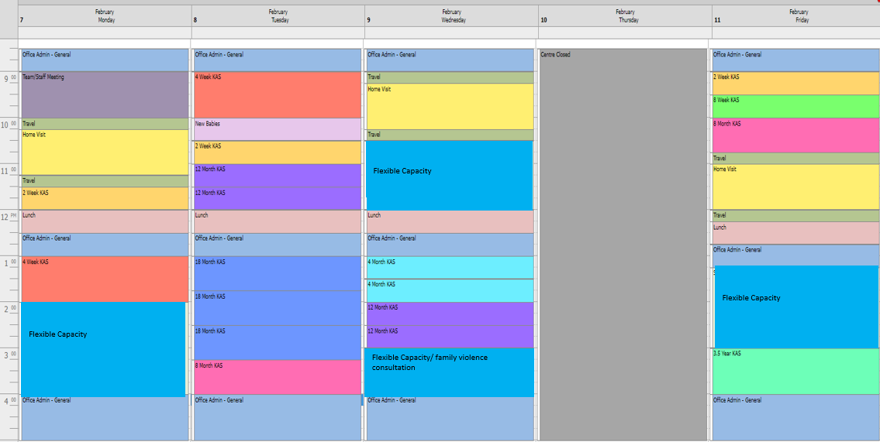

Week 2-
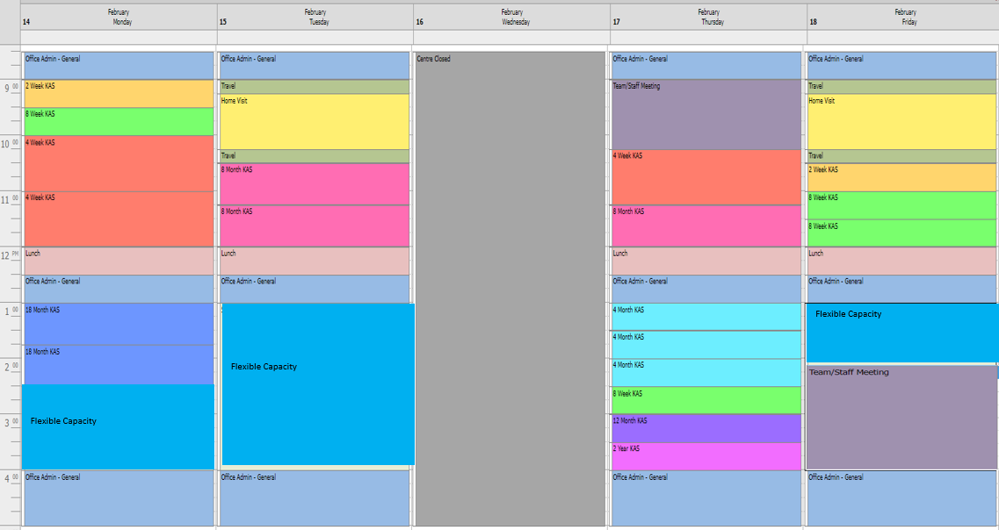

Example of individual service and site calculations based on prioritised 0-2 years and additional needs service delivery
- This service is operative at 0-2yrs prioritised service delivery (i.e., 91 per cent of KAS service capacity)
- The service has 1300 birth notifications per year and
- A 1 FTE individual site has 130 birth notices/year.

Service calculation (average)
- 1300 birth notifications
- 1300 ÷ 52 = 25 birth notifications per week.
25 - HV, 2wk, 4wk, 8wk, 4mth, 8mth, 12 mth, 18mth and 2yr visits need to be allocated across the service per week
- 25 birth notifications x 0.2 = 5
5- 3.5 yrs. visits need to be allocated across the service per week
- 1300 x 0.4 = 520 (number supported by flexible service capacity)
  - 520 x 6 hrs. = 3120hrs (number of hours per year)
  - 3120hrs x 0.91 (representing 91% prioritised service) = 2839 hrs per year
  - 2839 hrs. ÷ 52 = 54.6hrs. per week
54.6 hrs. per week needs to be allocated across the service for flexible service capacity

Site calculation (average)
- 130 birth notifications
- 130 ÷ 52 = 2.5 birth notifications per week.
2.5 - HV, 2wk, 4wk, 8wk, 4mth, 8mth, 12 mth, 18mth and 2yr visits need to be allocated across the site per week which means 5 - HV, 2wk, 4wk, 8wk, 4 mth, 8 mth, 12 mth, 18mth and 2yr visits need to be allocated across the site per fortnight
- 2.5 birth notifications x 0.2 = 0.5
0.5 - 3.5 yrs. visits need to be allocated across the service per week which means 1 - 3.5 yrs, visit needs to be allocated across the site per fortnight
- 130 x 0.4 = 52 (number supported by flexible service capacity)
  - 52 x 6 hrs. = 312hrs (number of hours per year)
  - 312hrs x 0.91 (representing 91% prioritised service) = 284hrs. per year
  - 284hrs ÷ 52 = 5.5 hrs. per week (rounded)
5.5 hrs. per week needs to be allocated across the site for flexible service capacity
The complimentary excel spreadsheet – ‘Prioritised service delivery’ provides a template for calculations and can be utilised by services by adjusting the Birth Notification numbers to local needs.
The screenshot, on page 18, of a CDIS diary shows how KAS visits, the flexible service capacity, administration, and meeting times can be allocated over a two-week period/fortnight for 0-2yrs prioritised service delivery.

Prioritised 0-2 years

Week 1-

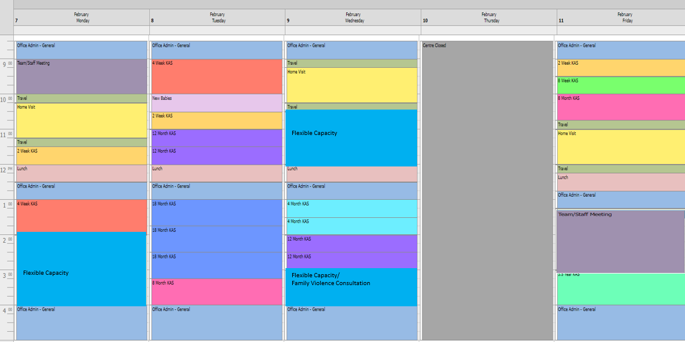

Week 2-

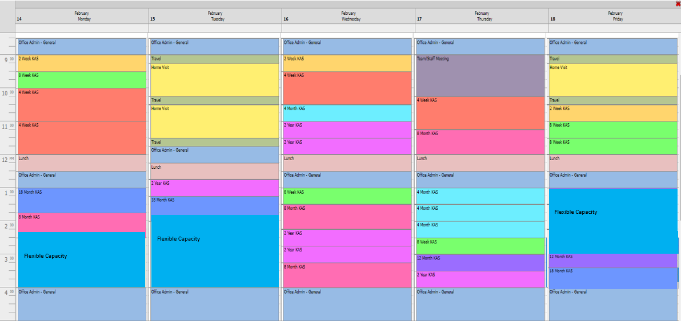

Example of individual service and site calculations based on 0-3.5 years’ service delivery

- This service is operative at 0-3.5yrs prioritised service delivery (i.e., 100 per cent of KAS service capacity)
- The service has 1300 birth notifications per year and
- A 1 FTE individual site has 130 birth notices/year.

Service calculation (average)
- 1300 birth notifications
- 1300 ÷ 52 = 25 birth notifications per week.
25 - HV, 2wk, 4wk, 8wk, 4mth, 8mth, 12 mth, 18mth, 2yr and 3.5yr visits need to be allocated across the service per week
- 1300 x 0.4 = 520 (number supported by flexible service capacity)
  - 520 x 6 hrs. = 3120hrs (number of hours per year)
  - 3120hrs x 1 (representing 100% prioritised service) = 3120 hrs per year
  - 3120 hrs. ÷ 52 = 60hrs. per week
60 hrs. per week needs to be allocated across the service for flexible service capacity

Site calculation (average)
- 130 birth notifications
- 130 ÷ 52 = 2.5 birth notifications per week.
2.5 - HV, 2wk, 4wk, 8wk, 4mth, 8mth, 12 mth, 18mth, 2yr and 3.5yr visits need to be allocated across the site per week which means 5 - HV, 2wk, 4wk, 8wk, 4 mth, 8 mth, 12 mth, 18mth, 2yr and 3.5yr visits need to be allocated across the site per fortnight
- 130 x 0.4 = 52 (number supported by flexible service capacity)
  - 52 x 6 hrs. = 312hrs (number of hours per year)
  - 312hrs x 1 (representing 100% prioritised service) = 312hrs. per year
  - 312hrs ÷ 52 = 6hrs. per week (rounded)
6 hrs. per week needs to be allocated across the site for flexible service capacity
The complimentary excel spreadsheet – ‘Prioritised service delivery’ provides a template for calculations and can be utilised by services by adjusting the Birth Notification numbers to local needs.
The screenshot, on page 20, of a CDIS diary shows how KAS visits, the flexible service capacity, administration, and meeting times can be allocated over a two-week period/fortnight for 0-3.5yrs service delivery.

0 - 3.5 years

Week 1-
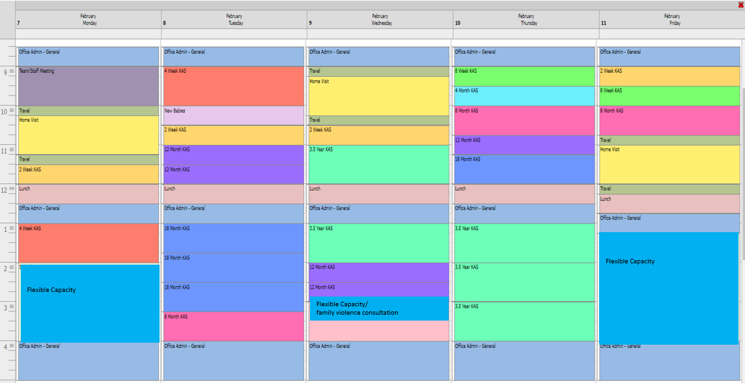

Week 2-
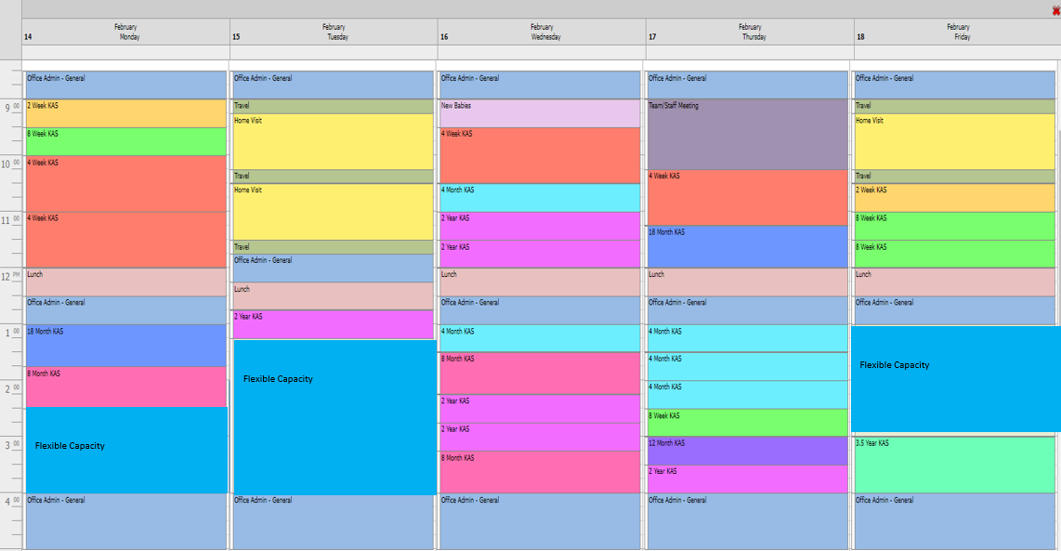

Calendar Tips

Reoccurring appointments
- Can be helpful in setting up non-client appointments (admin, pre-allocated KAS)
- Easier to set up KAS allocations at set times of the day (to allow for increased flexibility, could use two different reoccurrences as per screenshot)
- Can only delete all reoccurrence from the date selected (i.e., cannot move/edit them all at once). If a mistake/ need to bulk edit, often easier to delete all reoccurrences then re-book a new one.
- Recommended to set a shorter end date (i.e., 1 month), so each series of reoccurrences is more easily editable.

To receive this document in another format phone 1300 651 160 using the National Relay Service 13 36 77 if required, or email Maternal and Child Health and Parenting <mch@health.vic.gov.au>.
Authorised and published by the Victorian Government, 1 Treasury Place, Melbourne.
© State of Victoria, Australia, Department of Health, 28 February 2022.
In this document, ‘Aboriginal’ refers to both Aboriginal and Torres Strait Islander people. ‘Indigenous’ or ‘Koori/Koorie’ is retained when part of the title of a report, program or quotation.

